Station 1: WWI Poetry

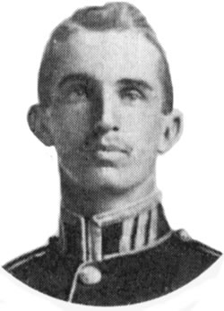
Inspiration for “In Flanders Fields”
Lieutenant Alexis Helmer, 1st Brigade Canadian Field Artillery. ⁽¹⁾
During the early days of the Second Battle of Ypres a young Canadian artillery officer, Lieutenant Alexis Helmer, was killed on 2nd May, 1915 in the gun positions near Ypres. An exploding German artillery shell landed near him. He was serving in the same Canadian artillery unit as a friend of his, the Canadian military doctor and artillery commander Major John McCrae.
As the brigade doctor, John McCrae was asked to conduct the burial service for Alexis because the chaplain had been called away somewhere else on duty that evening. It is believed that later that evening, after the burial, John began the draft for his now famous poem “In Flanders Fields”.
by John McCrae, May 1915
In Flanders fields the poppies blow
Between the crosses, row on row,
That mark our place; and in the sky
The larks, still bravely singing, fly
Scarce heard amid the guns below.
We are the Dead. Short days ago
We lived, felt dawn, saw sunset glow,
Loved and were loved, and now we lie
In Flanders fields.
Take up our quarrel with the foe:
To you from failing hands we throw
The torch; be yours to hold it high.
If ye break faith with us who die
We shall not sleep, though poppies grow
In Flanders fields.
http://www.greatwar.co.uk/poems/john-mccrae-in-flanders-fields.htm

Rudyard Kipling
At the beginning of WWI, like many other writers, Kipling wrote pamphlets and poems which enthusiastically supported the UK's war aims of restoring Belgium after that kingdom had been occupied by Germany together with more generalized statements that Britain was standing up for the cause of good. In September 1914, Kipling was asked by the British government to write propaganda, an offer that he immediately accepted. Kipling's pamphlets and stories were very popular with the British people during the war with his major themes being glorifying the British military as the place for heroic men to be, German atrocities against Belgian civilians and the stories of women being brutalized by a horrific war unleashed by Germany, yet surviving and triumphing in spite of their suffering.

"For All We Have And Are"
1914
For all we have and are,
For all our children's fate,
Stand up and take the war.
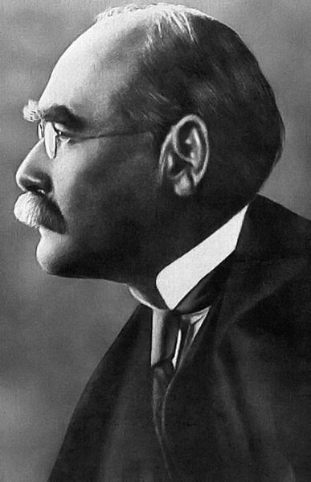
The Hun is at the gate!
Our world has passed away,
In wantonness o'erthrown.
There is nothing left to-day
But steel and fire and stone!
Though all we knew depart,
The old Commandments stand: --
"In courage keep your heart,
In strength lift up your hand."

Once more we hear the word
That sickened earth of old: --
"No law except the Sword
Unsheathed and uncontrolled."
Once more it knits mankind,
Once more the nations go
To meet and break and bind
A crazed and driven foe.

Comfort, content, delight,
The ages' slow-bought gain,
They shrivelled in a night.
Only ourselves remain
To face the naked days
In silent fortitude,
Through perils and dismays
Renewed and re-renewed.
Though all we made depart,
The old Commandments stand: --
"In patience keep your heart,
In strength lift up your hand."

No easy hope or lies
Shall bring us to our goal,
But iron sacrifice
Of body, will, and soul.
There is but one task for all --
One life for each to give.
What stands if Freedom fall?
Who dies if England live?
http://www.poetryloverspage.com/poets/kipling/for_all_we_have_and_are.html

Station 2: Henry Johnson
Who is this man and why is he smiling? Could it be that big old cross with the gold palm hanging on his chest?
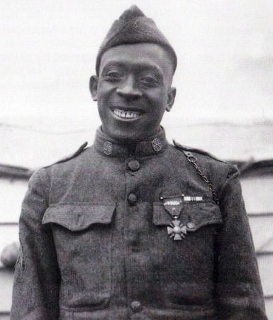
Henry Johnson was born in May, 1892, the son of Isaac and Maggie Johnson, a day laborer and a housemaid, and grew up on Sycamore Street in the town of Winston, NC in the late 19th and early 20th century. When he was in his teens, his father found a steady job and moved the family to Albany, the capitol of New York.
There, while working as a chauffeur, laborer and railway porter, Henry married and had three children. He was only 5 feet 4 inches tall and weighed about 130 pounds, but, as we shall see, he was about as big a man as anyone can be.
On 6 April 1917 the US declared war on Germany. Two months later, Henry Johnson enlisted in the US Army. He was assigned to the brand new segregated 369th Infantry Regiment. The officers were white, the troops were black.
The 369th received its basic infantry training in Spartanburg, SC. While there, they came very close to getting into their own war with a white Alabama regiment, whose members resented the fact that a bunch of young black guys were wearing US Army uniforms. The Alabama regiment never saw a moment of combat. The 369th certainly did.
On 15 May 1918, Henry Johnson and seventeen-year-old Needham Roberts of Trenton, New Jersey, were on sentry duty well in advance of the American lines. At around 1 a.m. a German sniper opened up from a bush fifty yards away. Johnson anticipated more trouble, so opened a box of thirty hand grenades and placed them in a row nearby. About 2 a.m. he heard the Germans cutting the wire that protected his post, so he sent Roberts, in an adjoining sentry post, to alert their troops. Johnson lobbed a grenade and the “surprised Dutchmen” began firing, so he recalled Roberts. Roberts was soon incapacitated by a German grenade. Two Germans tried to take Roberts prisoner but Johnson beat them off. Roberts could not stand but he sat upright and passed grenades to Johnson.
With grenades exhausted Johnson grabbed his rifle. He inserted an American clip in his French rifle but it jammed. At that point, a German platoon rushed him and the fighting became hand-to-hand. He then “banged them on the dome and the side and everywhere I could land until the butt of my rifle busted.” Next he resorted to his bolo knife. “[I] slashed in a million directions,” he said. “Each slash meant something, believe me.” He admitted that the Germans “knocked me around considerable and whanged me on the head, but I always managed to get back on my feet.” One German was “bothering” him more than the others, so he eventually threw him over his head and stabbed him in his ribs. “I stuck one guy in the stomach,” Johnson continued, “and he yelled in good New York talk: ‘That black —— got me.’” Johnson was still “banging them” when his friends arrived and repulsed the Germans. Johnson then fainted. The fight had lasted about an hour.
Johnson and Roberts were taken to a French hospital. Johnson had a total of 21 wounds to his left arm, back, feet, and face, most of them from knives and bayonets.
With daylight the Americans found four dead Germans on the battlefield and evidence of perhaps as many as thirty-two more killed and wounded who had been dragged away by the Germans as they retreated. The event almost immediately became known as the “Battle of Henry Johnson”.
A few weeks later, the French awarded both Henry Johnson and Needham Roberts their highest medal for bravery, the Croix de Guerre. They were the first US troops in WWI to receive the award. Henry’s had a gold palm attached, the highest possible award.
So you know what happened next. It’s Medal of Honor time from the US side. Not really. Henry and Needham got nothing at all. Not even a Purple Heart between them.
While they were recovering from their wounds, their unit, the 369th Infantry regiment, was undergoing 191 consecutive days of enemy fire, the most of any US unit in WWI. The French gave the entire unit a Croix de Guerre. From that time forth the 369th was known as the “Harlem Hellfighters”. But the US military ignored them.
When WWI ended, there was a huge ticker tape parade down Broadway for the returning troops. The 369th was not invited. But the citizens of New York gave them their own parade, which started in Manhattan and ended in Harlem. Most of the regiment marched. Henry Johnson rode in a car as the star of the show. In Harlem the paper shower turned to flowers.
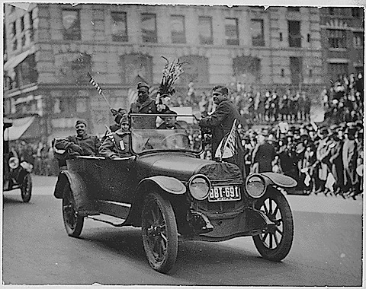
Henry Johnson on parade, 1919
But after mustering out, black troops didn’t even get disability benefits. Because he couldn’t work on a regular basis due to his wounds, Henry Johnson became dispirited, began drinking, separated from his family and died, destitute and drunk, in 1929 at the age of 37. He was, strangely enough, buried at Arlington National Cemetery.
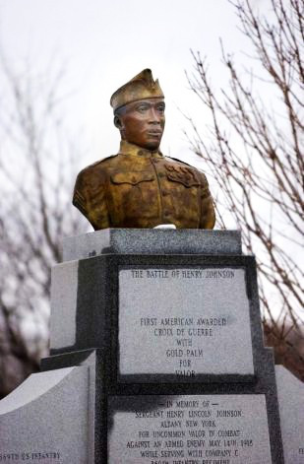
Until recent years, his children did not know that. In 1996, upon executive order of President Clinton, Henry Johnson finally was awarded a Purple Heart. At that point one of his sons, Herman, himself a Tuskeegee Airman during World War II and later a member of the Missouri legislature, began a campaign to get him a well deserved Medal of Honor. That campaign ended in failure in 2003, during the Bush administration, with the award of a Distinguished Service Cross, the second highest honor. That medal was awarded graveside at Arlington. But that fight is not over. Last year Senator Chuck Schumer of New York joined the effort to get Henry Johnson a Medal of Honor.
Until now, no one in Winston-Salem has had any memory of Henry Johnson. But, at least, the citizens of Albany, NY, his second home, finally came to give him his due. On Veteran’s Day, 1996, they erected a monument, with a bust of Henry Johnson, in historic Washington Park in that city.

Thank you for your service, Henry Johnson, one of our own.
http://northcarolinaroom.wordpress.com/2012/02/23/the-battle-of-henry-johnson/

Station 3: WWI Images

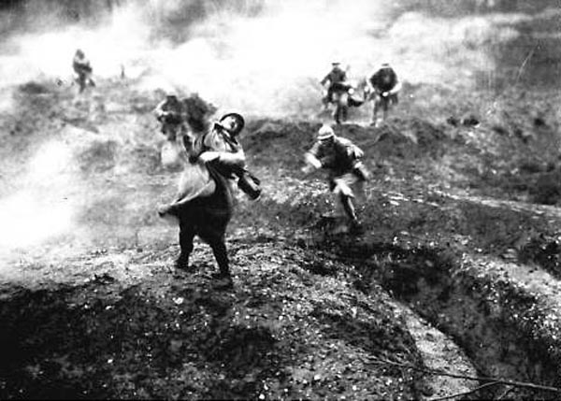
Image 1

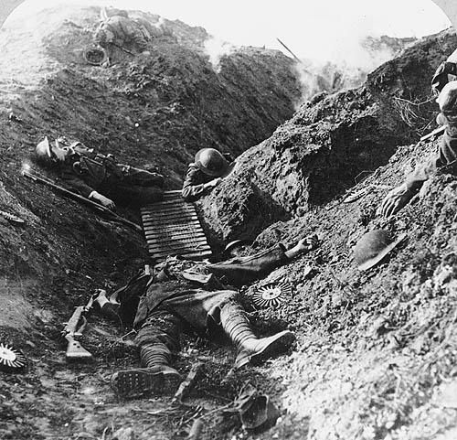
Image 2
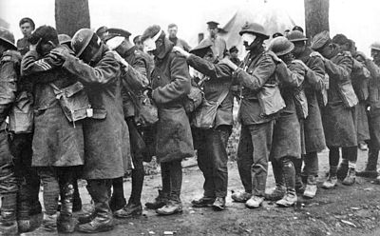

Image 3
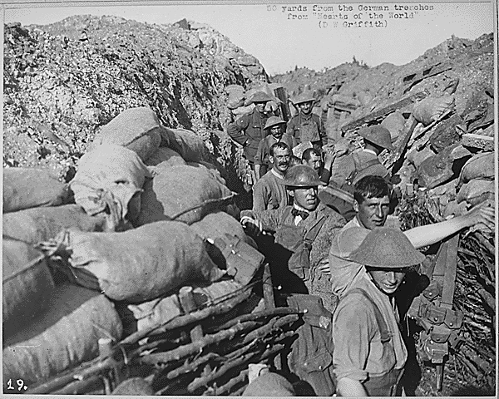

Image 4

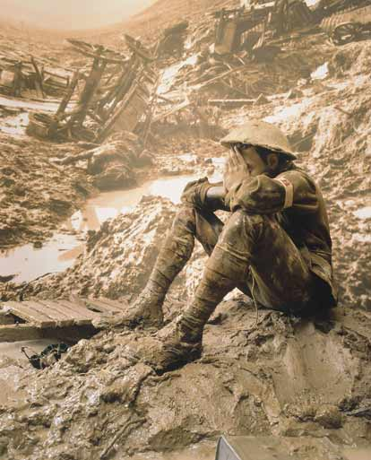
Image 5

