Source 1

CHAP. LXXV. —An Act to secure Homesteads to actual Settlers on the Public Domain.
Be it enacted by the Senate and House of Representatives of the United States of America in Congress assembled, That any person who is the head of a family, or who has arrived at the age of twenty-one years, and is a citizen of the United States, or who shall have filed his declaration of intention to become such, as required by the naturalization laws of the United States, and who has never borne arms against the United States Government or given aid and comfort to its enemies, shall, from and after the first January, eighteen hundred and. sixty-three, be entitled to enter one quarter section or a less quantity of unappropriated public lands, upon which said person may have filed a preemption claim, or which may, at the time the application is made, be subject to preemption at one dollar and twenty-five cents, or less, per acre; or eighty acres or less of such unappropriated lands, at two dollars and fifty cents per acre, to be located in a body, in conformity to the legal subdivisions of the public lands, and after the same shall have been surveyed: Provided, That any person owning and residing on land may, under the provisions of this act, enter other land lying contiguous to his or her said land, which shall not, with the land so already owned and occupied, exceed in the aggregate one hundred and sixty acres.
SEC. 2. And be it further enacted, That the person applying for the benefit of this act shall, upon application to the register of the land office in which he or she is about to make such entry, make affidavit before the said register or receiver that he or she is the head of a family, or is twenty-one years or more of age, or shall have performed service in the army or navy of the United States, and that he has never borne arms against the Government of the United States or given aid and comfort to its enemies, and that such application is made for his or her exclusive use and benefit, and that said entry is made for the purpose of actual settlement and cultivation, and not either directly or indirectly for the use or benefit of any other person or persons whomsoever; and upon filing the said affidavit with the register or receiver, and on payment of ten dollars, he or she shall thereupon be permitted to enter the quantity of land specified: Provided, however, That no certificate shall be given or patent issued therefor until the expiration of five years from the date of such entry ; and if, at the expiration of such time, or at any time within two years thereafter, the person making such entry ; or, if he be dead, his widow; or in case of her death, his heirs or devisee; or in case of a widow making such entry, her heirs or devisee, in case of her death ; shall. prove by two credible witnesses that he, she, or they have resided upon or cultivated the same for the term of five years immediately succeeding the time of filing the affidavit aforesaid, and shall make affidavit that no part of said land has been alienated, and that he has borne rue allegiance to the Government of the United States ; then, in such case, he, she, or they, if at that time a citizen of the United States, shall be entitled to a patent, as in other cases provided for by law: And provided, further, That in case of the death of both father and mother, leaving an Infant child, or children, under twenty-one years of age, the right and fee shall ensure to the benefit of said infant child or children ; and the executor, administrator, or guardian may, at any time within two years after the death of the surviving parent, and in accordance with the laws of the State in which such children for the time being have their domicil, sell said land for the benefit of said infants, but for no other purpose; and the purchaser shall acquire the absolute title by the purchase, and be en- titled to a patent from the United States, on payment of the office fees and sum of money herein specified.
SEC. 3. And be it further enacted, That the register of the land office shall note all such applications on the tract books and plats of, his office, and keep a register of all such entries, and make return thereof to the General Land Office, together with the proof upon which they have been founded.
SEC. 4. And be it further enacted, That no lands acquired under the provisions of this act shall in any event become liable to the satisfaction of any debt or debts contracted prior to the issuing of the patent therefor.
SEC. 5. And be it further enacted, That if, at any time after the filing of the affidavit, as required in the second section of this act, and before the expiration of the five years aforesaid, it shall be proven, after due notice to the settler, to the satisfaction of the register of the land office, that the person having filed such affidavit shall have actually changed his or her residence, or abandoned the said land for more than six months at any time, then and in that event the land so entered shall revert to the government.
SEC. 6. And be it further enacted, That no individual shall be permit- ted to acquire title to more than one quarter section under the provisions of this act; and that the Commissioner of the General Land Office is hereby required to prepare and issue such rules and regulations, consis- tent with this act, as shall be necessary and proper to carry its provisions into effect; and that the registers and receivers of the several land offices shall be entitled to receive the same compensation for any lands entered under the provisions of this act that they are now entitled to receive when the same quantity of land is entered with money, one half to be paid by the person making the application at the time of so doing, and the other half on the issue of the certificate by the person to whom it may be issued; but this shall not be construed to enlarge the maximum of compensation now prescribed by law for any register or receiver: Pro- vided, That nothing contained in this act shall be so construed as to im- pair or interfere in any manner whatever with existing preemption rights : And provided, further, That all persons who may have filed their applications for a preemption right prior to the passage of this act, shall be entitled to all privileges of this act: Provided, further, That no person who has served, or may hereafter serve, for a period of not less than fourteen days in the army or navy of the United States, either regular or volun- teer, under the laws thereof, during the existence of an actual war, do- mestic or foreign, shall be deprived of the benefits of this act on account of not having attained the age of twenty-one years.
SEC. 7. And be it further enacted, That the fifth section of the act en- titled" An act in addition to an act more effectually to provide for the punishment of certain crimes against the United States, and for other purposes," approved the third of March, in the year eighteen hundred and fifty-seven, shall extend to all oaths, affirmations, and affidavits, re- quired or authorized by this act.
SEC. 8. And be it further enacted, That nothing in this act shall be 80 construed as to prevent any person who has availed him or herself of the benefits of the fir8t section of this act, from paying the minimum price, or the price to which the same may have graduated, for the quantity of land so entered at any time before the expiration of the five years, and obtain- ing a patent therefor from the government, as in other cases provided by law, on making proof of settlement and cultivation as provided by exist- ing laws granting preemption rights. APPROVED, May 20, 1862.
http://www.ourdocuments.gov/doc.php?flash=true&doc=31&page=transcript

Source 2
Other Hardships
Walking 2,000 miles barefoot--and that was the easy part
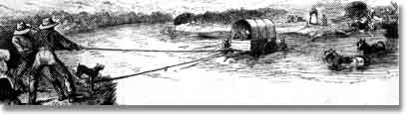

River Crossings
River crossings were a constant source of distress for the pioneers. Hundreds drowned trying to cross the Kansas, North Platte and Columbia Rivers--among others. In 1850 alone, 37 people drowned trying to cross one particularly difficult river--the Green.
Emigrant John B. Hill:
"The ferryman allowed too many passengers to get in the boat, and the water came within two inches of the gunwale. He ordered every man to stand steady as the boat was liable to swamp. When we were nearly across the edge of the boat dipped; I thought the boat would be swamped instantly and drowned the last one of us."
Those who didn't drown were usually fleeced. The charge ranged up to 16 dollars; almost the price of an oxen. One ferry earned $65,000 in just one summer. The emigrants complained bitterly.

Walking
Because most emigrants grossly overloaded their wagons, few could ride inside. Instead most walked--many made the entire 2,000 mile journey on foot.

Accidents
The emigrant wagons didn't have any safety features. If someone fell under the massive wagon wheels, death was instant. Many lost their lives this way. Most often, the victims were children.
Edward Lenox:
"A little boy fell over the front end of the wagon during our journey. In his case, the great wheels rolled over the child's head----crushing it to pieces."

Weather
Great thunderstorms took their toll. A half-dozen emigrants were killed by lightning strikes; many others were injured by hail the size of apples. Pounding rains were especially difficult for the emigrants because there was no shelter on the open plains and the covered wagons eventually leaked.

Cholera
Perhaps the biggest problem on the Trail was a mysterious and deadly disease--called cholera for which there was no cure. Often, an emigrant would go from healthy to dead in just a few hours. Sometimes they received a proper burial, but often, the sick would be abandoned, in their beds, on the side of the trail. They would die alone. Making matters worse were animals that regularly dug up the dead and scattered the trail with human bones and body parts.
Emigrant Agnes Stewart:
"We camped at a place where a woman had been buried and the wolves dug her up.Her hair was there with a comb still in it. She had been buried too shallow. It seems a dreadful fate, but what is the difference? One cannot feel after the spirit is flown."
Cholera killed more emigrants than anything else. In a bad year, some wagon trains lost two-thirds of their people.
Emigrant John Clark:
"One woman and two men lay dead on the grass and some more ready to die. Women and children crying, some hunting medicine and none to be found. With heartfelt sorrow, we looked around for some time until I felt unwell myself. Got up and moved forward one mile, so as to be out of hearing of crying and suffering."

http://www.isu.edu/~trinmich/Hardships.html

Source 3
I.
The first white men of your people who came to our country were named Lewis and Clark. They brought many things which our people had never seen. They talked straight and our people gave them a great feast as proof that their hearts were friendly. They made presents to our chiefs and our people made presents to them. We had a great many horses of which we gave them what they needed, and they gave us guns and tobacco in return. All the Nez Perce made friends with Lewis and Clark and agreed to let them pass through their country and never to make war on white men. This promise the Nez Perce have never broken.
II.
For a short time we lived quietly. But this could not last. White men had found gold in the mountains around the land of the Winding Water. They stole a great many horses from us and we could not get them back because we were Indians. The white men told lies for each other. They drove off a great many of our cattle. Some white men branded our young cattle so they could claim them. We had no friends who would plead our cause before the law councils. It seemed to me that some of the white men in Wallowa were doing these things on purpose to get up a war. They knew we were not stong enough to fight them. I labored hard to avoid trouble and bloodshed. We gave up some of our country to the white men, thinking that then we could have peace. We were mistaken. The white men would not let us alone. We could have avenged our wrongs many times, but we did not. Whenever the Government has asked for help against other Indians we have never refused. When the white men were few and we were strong we could have killed them off, but the Nez Perce wishes to live at peace.
On account of the treaty made by the other bands of the Nez Perce the white man claimed my lands. We were troubled with white men crowding over the line. Some of them were good men, and we lived on peaceful terms with them, but they were not all good. Nearly every year the agent came over from Lapwai and ordered us to the reservation. We always replied that we were satisfied to live in Wallowa. We were careful to refuse the presents or annuities which he offered.
Through all the years since the white man came to Wallowa we have been threatened and taunted by them and the treaty Nez Perce. They have given us no rest. We have had a few good friends among the white men, and they have always advised my people to bear these taunts without fighting. Our young men are quick tempered and I have had great trouble in keeping them from doing rash things. I have carried a heavy load on my back ever since I was a boy. I learned then that we were but few while the white men were many, and that we could not hold our own with them. We were like deer. They were like grizzly bears. We had a small country. Their country was large. We were contented to let things remain as the Great Spirit Chief made them. They were not; and would change the mountains and rivers if they did not suit them.
III.
[At his surrender in the Bear Paw Mountains, 1877]
Tell General Howard that I know his heart. What he told me before I have in my heart. I am tired of fighting. Our chiefs are killed. Looking Glass is dead, Tu-hul-hil-sote is dead. the old men are all dead. It is the young men who now say yes or no. He who led the young men [Joseph's brother Alikut] is dead. It is cold and we have no blankets. The little children are freezing to death. My people -- some of them have run away to the hills and have no blankets and no food. No one knows where they are -- perhaps freezing to death. I want to have time to look for my children and see how many of them I can find. Maybe I shall find them among the dead. Hear me, my chiefs, my heart is sick and sad. From where the sun now stands I will fight no more against the white man.

Source 4
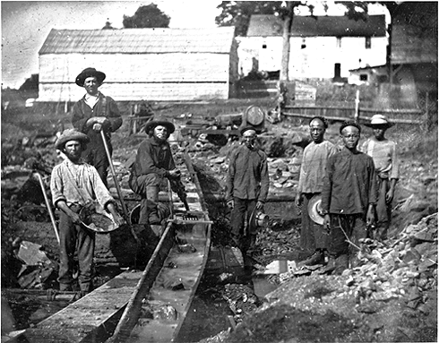
(California State Library [Daguerreotype collection #912])http://www.pbs.org/weta/thewest/resources/archives/three/63_02.htm
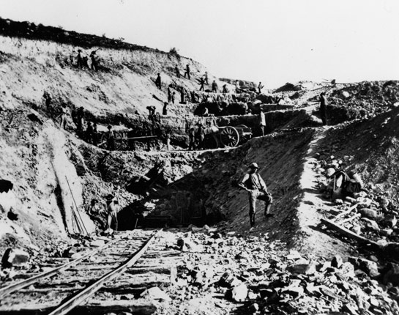
http://www.pbs.org/wgbh/americanexperience/features/photo-gallery/tcrr-gallery/

Source 5
While the west coast of North America was known to the Chinese, in particular those working as sailors, before the Gold Rush, our story begins in 1850, as the documentation from the Gold Rush provides the starting point with which to build a more substantial narrative. Most Chinese immigrants entered California through the port of San Francisco. From San Francisco and other ports, many sought their fortunes in other parts of California. The Chinese formed part of the diverse gathering of peoples from throughout the world who contributed to the economic and population explosion that characterized the early history of the state of California. The Chinese who emigrated to the United States at this time were part of a larger exodus from southeast China searching for better economic opportunities and fleeing a situation of political corruption and decline. Most immigrants came from the Pearl River Delta in Guangdong (Canton) Province.
Chinese immigrants proved to be productive and resourceful contributors to a multitude of industries and businesses. The initial group of Chinese argonauts sought their livelihood in the gold mines, calling CaliforniaGam Saan or Gold Mountain. For the mining industry, they built many of the flumes and roads, allowing for easier access and processing of the minerals being extracted. Chinese immigrants faced discrimination immediately upon arrival in California. In mining, they were forced to work older claims, or to work for others. In the 1850s, the United States Constitution reserved the right of naturalization for white immigrants to this country. Thus, Chinese immigrants lived at the whim of local governments with some allowed to become naturalized citizens, but most not. Without this right, it was difficult to pursue livelihoods. For example, Chinese immigrants were unable to own land or file mining claims. Also in the 1850s, the California legislature passed a law taxing all foreign miners. Although stated in general terms, it was enforced chiefly against the Mexicans and the Chinese through 1870. This discrimination occurred in spite of the fact that the Chinese often contributed the crucial labor necessary to the mining enterprise.
Discriminatory legislation forced many Chinese out of the gold fields and into low-paying, menial, and often arduous jobs. In many cases, they took on the most dangerous and least desirable components of work available. They worked on reclaiming marshes in the Central Valley so that the land could become agriculturally productive. They built the stone bridges and fences, constructed roads, and excavated storage areas for the wine industry in Napa and Sonoma counties. The most impressive construction feat of Chinese Americans was their work on the western section of the transcontinental railroad. Chinese-American workers laid much of the tracks for the Central Pacific Railroad through the foothills and over the high Sierra Nevada, much of which involved hazardous work with explosives to tunnel through the hills. Their speed, dexterity, and outright perseverance, often in brutally cold temperatures and heavy snow through two record breaking winters, is a testimony to their outstanding achievements and contributions to opening up the West.
http://memory.loc.gov/ammem/award99/cubhtml/theme1.html

Source 6
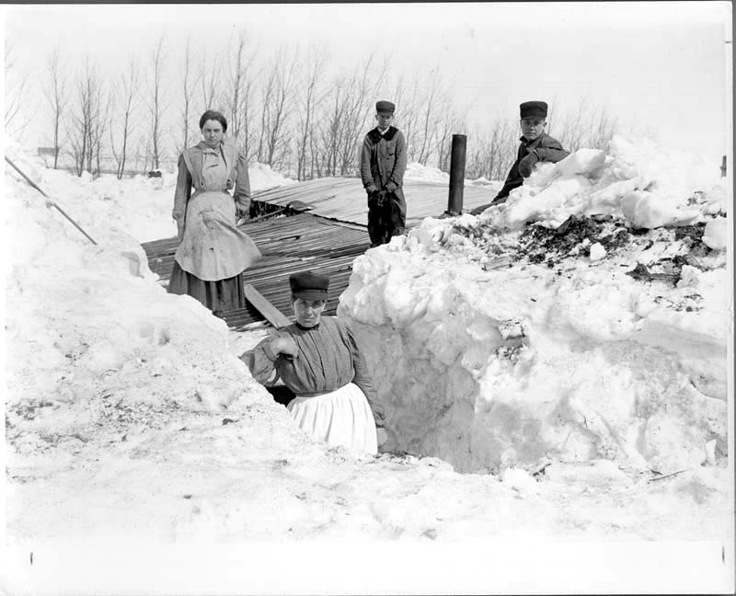
Digging out after a three-day snowstorm about 1913. McCarthy, John, 1861- photographer. CREATED/PUBLISHED
[1913?] SUMMARY
Two women and two men on roof of wooden house of James Ward of Milton, N.D., having dug out from entrance after snowstorm. Snow is higher than roof of house. A shovel and stovepipe are visible. In the background is a line of trees.
http://memory.loc.gov/cgi-bin/query/D?ngp:10:./temp/~ammem_Hrfn::
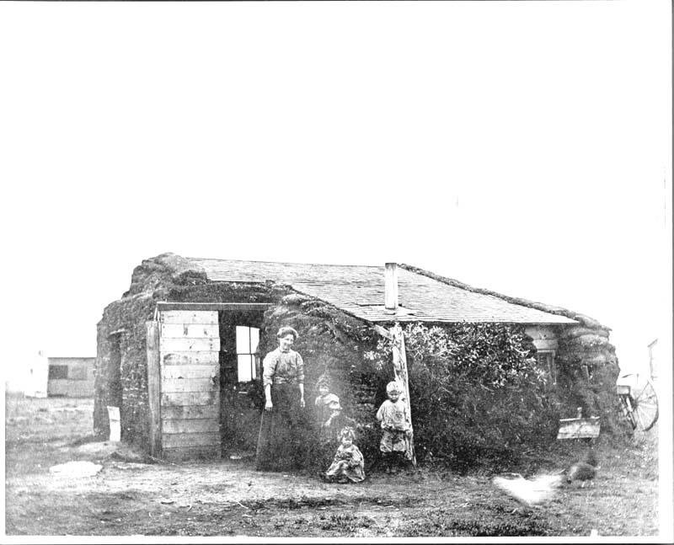
By their sod house on the homestead in Bottineau County, near Westhope, North Dakota. CREATED/PUBLISHED[190-?] SUMMARY
Mrs. John Talcott (Annie Carlson) and daughter Ruth (now Mrs. George Sandy, Park River, N.D.), unidentified son, and daughter Hope (Mrs. Ted Vedvig, Carpio, N.D.). Homestead is 9 miles west and 2 miles south of Westhope in Bentinck Township. Sod house with a shingled roof, and wooden walls with sod stacked up against the sides. Three windows, a doorway, and a stovepipe are visible. A heavy wooden beam is a support for the roof. There is a wooden building in the background, (a barn?). Image is blurry in areas.
http://memory.loc.gov/cgi-bin/query/D?ngp:7:./temp/~ammem_4oEo::
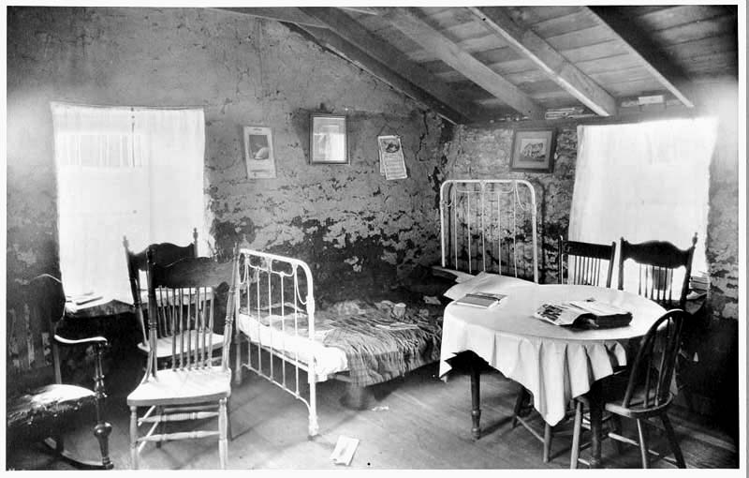
Interior of Elling O[h]nstad sod house, Fairdale, North Dakota, June 24, 1923. CREATED/PUBLISHED[1923] SUMMARY
Interior of a sod house, with two curtained windows showing, and a patch-work quilt on a metal frame bed. There is a book (face down) and a mail-order catalog on a round table with a tablecloth. There are also books in and above (in the rafters) a window, and a calendar. There are six wooden chairs, a wooden floor, and three pictures on the wall. http://memory.loc.gov/cgi-bin/query/D?ngp:11:./temp/~ammem_Hrfn::

Source 7

New trans-continental map of the Pacific R.R. and routes of overland travel to Colorado, Nebraska, the Black Hills, Utah, Idaho, Nevada, Montana, California and the Pacific Coast.
http://memory.loc.gov/cgibin/map_item.pl?data=/home/www/data/gmd/gmd405/g4051/g4051p/rr005110r.jp2&style=gmd&itemLink=r?ammem/gmd:@field(NUMBER+@band(g4051p+rr005110r))&title=New%20transcontinental%20map%20of%20the%20Pacific%20R.R.%20and%20routes%20of%20overland%20travel%20to%20Colorado,%20Nebraska,%20the%20Black%20Hills,%20Utah,%20Idaho,%20Nevada,%20Montana,%20California%20and%20the%20Pacific%20Coast.

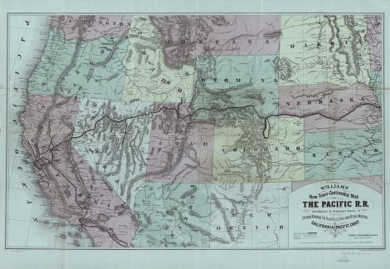

Source 8
In 1838 and 1839, as part of Andrew Jackson's Indian removal policy, the Cherokee nation was forced to give up its lands east of the Mississippi River and to migrate to an area in present-day Oklahoma. The Cherokee people called this journey the "Trail of Tears," because of its devastating effects. The migrants faced hunger, disease, and exhaustion on the forced march. Over 4,000 out of 15,000 of the Cherokees died.
This picture, The Trail of Tears, was painted by Robert Lindneux in 1942. It commemorates the suffering of the Cherokee people under forced removal. If any depictions of the "Trail of Tears" were created at the time of the march, they have not survived.
Image Credit: The Granger Collection, New York
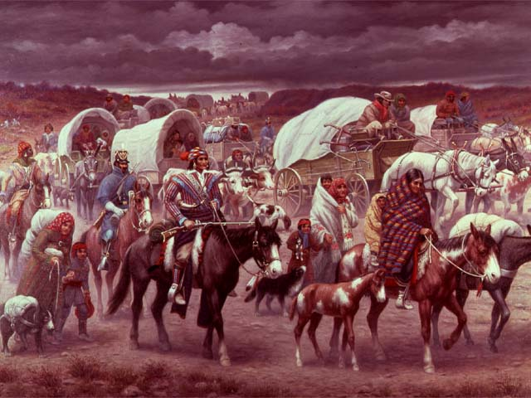

http://www.pbs.org/wgbh/aia/part4/4h1567.html

Source 9
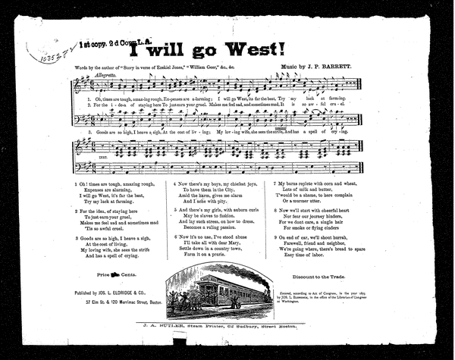

Source 10
Andrew Jackson's Second Annual Message
It gives me pleasure to announce to Congress that the benevolent policy of the Government, steadily pursued for nearly thirty years, in relation to the removal of the Indians beyond the white settlements is approaching to a happy consummation. Two important tribes have accepted the provision made for their removal at the last session of Congress, and it is believed that their example will induce the remaining tribes also to seek the same obvious advantages.
The consequences of a speedy removal will be important to the United States, to individual States, and to the Indians themselves. The pecuniary advantages which it promises to the Government are the least of its recommendations. It puts an end to all possible danger of collision between the authorities of the General and State Governments on account of the Indians. It will place a dense and civilized population in large tracts of country now occupied by a few savage hunters. By opening the whole territory between Tennessee on the north and Louisiana on the south to the settlement of the whites it will incalculably strengthen the southwestern frontier and render the adjacent States strong enough to repel future invasions without remote aid. It will relieve the whole State of Mississippi and the western part of Alabama of Indian occupancy, and enable those States to advance rapidly in population, wealth, and power. It will separate the Indians from immediate contact with settlements of whites; free them from the power of the States; enable them to pursue happiness in their own way and under their own rude institutions; will retard the progress of decay, which is lessening their numbers, and perhaps cause them gradually, under the protection of the Government and through the influence of good counsels, to cast off their savage habits and become an interesting, civilized, and Christian community.
What good man would prefer a country covered with forests and ranged by a few thousand savages to our extensive Republic, studded with cities, towns, and prosperous farms embellished with all the improvements which art can devise or industry execute, occupied by more than 12,000,000 happy people, and filled with all the blessings of liberty, civilization and religion?
The present policy of the Government is but a continuation of the same progressive change by a milder process. The tribes which occupied the countries now constituting the Eastern States were annihilated or have melted away to make room for the whites. The waves of population and civilization are rolling to the westward, and we now propose to acquire the countries occupied by the red men of the South and West by a fair exchange, and, at the expense of the United States, to send them to land where their existence may be prolonged and perhaps made perpetual. Doubtless it will be painful to leave the graves of their fathers; but what do they more than our ancestors did or than our children are now doing? To better their condition in an unknown land our forefathers left all that was dear in earthly objects. Our children by thousands yearly leave the land of their birth to seek new homes in distant regions. Does Humanity weep at these painful separations from everything, animate and inanimate, with which the young heart has become entwined? Far from it. It is rather a source of joy that our country affords scope where our young population may range unconstrained in body or in mind, developing the power and facilities of man in their highest perfection. These remove hundreds and almost thousands of miles at their own expense, purchase the lands they occupy, and support themselves at their new homes from the moment of their arrival. Can it be cruel in this Government when, by events which it can not control, the Indian is made discontented in his ancient home to purchase his lands, to give him a new and extensive territory, to pay the expense of his removal, and support him a year in his new abode? How many thousands of our own people would gladly embrace the opportunity of removing to the West on such conditions! If the offers made to the Indians were extended to them, they would be hailed with gratitude and joy.
And is it supposed that the wandering savage has a stronger attachment to his home than the settled, civilized Christian? Is it more afflicting to him to leave the graves of his fathers than it is to our brothers and children? Rightly considered, the policy of the General Government toward the red man is not only liberal, but generous. He is unwilling to submit to the laws of the States and mingle with their population. To save him from this alternative, or perhaps utter annihilation, the General Government kindly offers him a new home, and proposes to pay the whole expense of his removal and settlement.
A Compilation of the Messages and Papers of the Presidents 1789-1908, Volume II, by James D. Richardson, published by Bureau of National Literature and Art ,1908

http://www.pbs.org/wgbh/aia/part4/4h3437t.html

Source 11
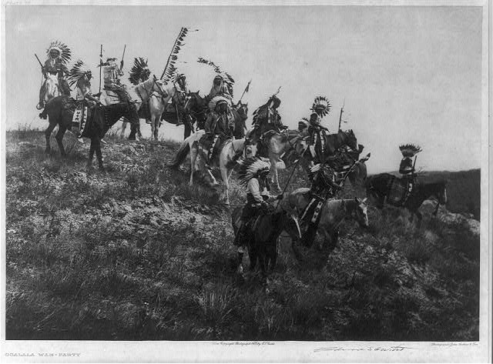

Oglala war party
- Digital ID: (b&w film copy neg.) cph 3b46977 http://hdl.loc.gov/loc.pnp/cph.3b46977
- Reproduction Number: LC-USZ62-52411 (b&w film copy neg.)
- Repository: Library of Congress Rare Books and Special Collections Division Washington, D.C. 20540 USA
http://www.loc.gov/pictures/resource/cph.3b46977/
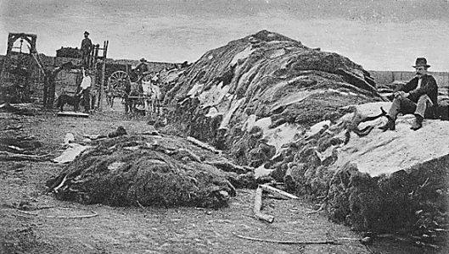

http://nationalhumanitiescenter.org/tserve/nattrans/ntecoindian/essays/buffalohideyardlg.htm
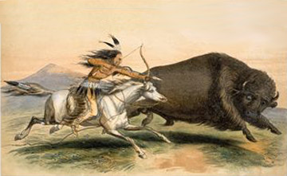
http://firstpeoplesofcanada.com/fp_furtrade/fp_furtrade4.html

