Cold War Name ______________________________________

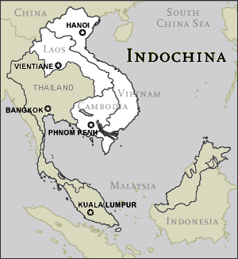
The Vietnam War
Outline of Events:
- The French had conquered Indochina (part of Southeast Asia) in the 1800s
  - Japanese took it over during WWII, and the French sought to re-establish their authority in 1946 after WWII.
- After WWII, Vietnamese nationalists and communists joined together to fight the French Armies.
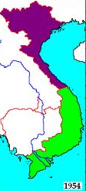
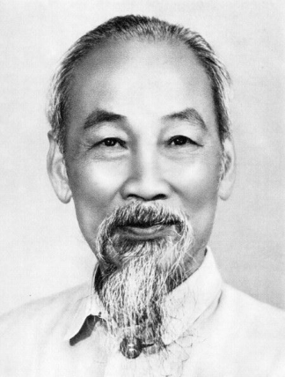
  - France’s toughest enemies were the guerillas (independent, irregular band of fighters) led by Ho Chi Minh, who was both a communist and a nationalist.
  - In 1954, the French surrendered to Ho Chi Minh.

- Vietnam was divided after the French surrender along the 17⁰ north latitude line
  - Ho Chi Minh’s communist government controlled North Vietnam.
  - A non-communist dictator, Ngo Dinh Diem, ruled South Vietnamese government. The U.S supported him.
Ho Chi Minh

- The US saw the French defeat as a threat to Asia
  - Developed the Domino Theory—if one nation falls to communism, so will its neighbors (they felt that if the communist succeeded in South Vietnam, all non-communist governments in Southeast Asia would also fall to communism, just as a row of dominoes)
    - New cold war policy: stop the domino theory from occurring

- Many Vietnamese preferred Ho Chi Minh (a national hero) over the South Vietnamese government, backed by the United States, a foreign power.
  - Ho’s communist government alienated many Vietnamese
  - Ngo Dinh Diem’s dictatorial regime alienated many because of its corruption and brutal tactics against political opponents.
- Ho Chi Minh was determined to unite all of Vietnam under communist rule. He continued to aid the National Liberation Front, or the Vietcong, a group of communist rebels trying to overthrow South Vietnam’s government. The Vietcong were also supported by the Soviet Union and China (gave money)
  - At first, the US only sent supplies and military advisors to South Vietnam.
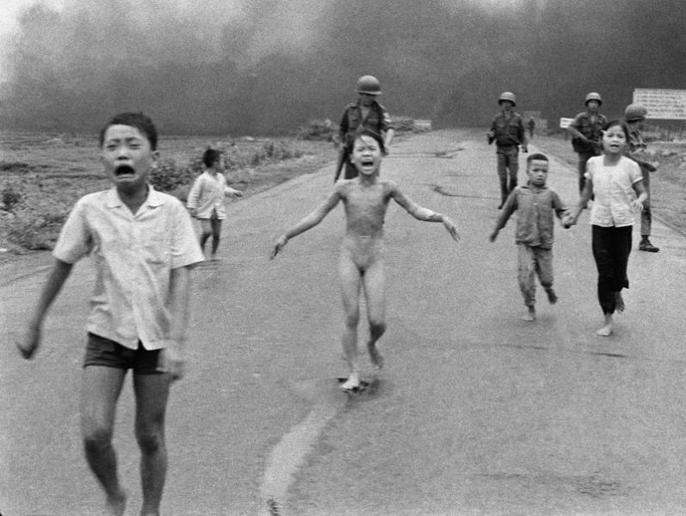
  - The Vietcong grew in the south in opposition to Diem.
    - Takeover by Communist Vietcong and Ho Chi Minh seemed inevitable
  - US troops enter to fight in 1964
    - US turned to air power and began bombing
      - Strengthened opposition to South Vietnamese government

- 1960s, war grew unpopular in US as a result of civilian deaths caused by the bombing of North Vietnam, as wellas the growing American casualties.
  - Nixon began withdrawing, left by ‘73
    - Bombed north, “Vietnamization” in south (turned rule over the south, and they would determine their own future)
- In 1975, two years after the US withdrew, the North overran the south, unifying Vietnam under one communist government.

Outcome of the War:
North Vietnamese won in 1975
- some “dominoes” did fall—Cambodia and Laos
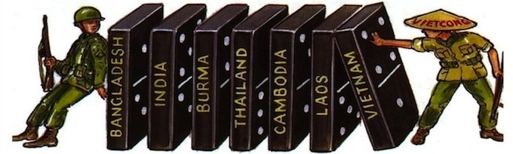

Rule in new Vietnam:
- Harsh rule/tight controls over south
- “reeducation” to train south in communist thought
- Nationalized industries and controlled business
- 1.5 million fled Vietnam
  - Hundreds of thousands fled their country in small boats. Many of these “boat people” drowned. Survivors landed in refugee camps and some settled in the US.
    - Description of the book, Boat People: 'They piled on top of one another in wooden boats, men, women and children. So desperate to escape their war-torn home, more than a million people would risk everything to tackle the high seas in search of safe haven. Many never made it to land. Those who did, endured unimaginable horrors. Told simply in their own words, Boat People gives voice to some of the survivors of the Vietnamese exodus, the largest mass migration in modern history.'
- Vietnam struggled to rebuild their land destroyed by war. The US put an embargo, or blockage on trade with Vietnam. For years, the country remained mired in poverty.

Communists still govern Vietnam today, but today relations with US are normalized (1995)
Name __________________________________________

Understanding the Vietnam War—Analyzing quotes

Read through the following quotes and articles regarding the Vietnam War to see how the war was viewed in its time and how its legacy is still impacting our world today. You will likely have to reference back to the Vietnam War Outline while trying to make sense of these quotes.

Document 1: From American President Lyndon B. Johnson
“If I let the communists take over South Vietnam, then my nation would be seen as an appeaser and we would find it impossible to accomplish anything…anywhere on the entire globe.”
-President Johnson, 1964

“Why must this nation hazard its ease, and its interest, and its power for the sake of a people so far away?...We are there because we have a promise to keep. Since 1954, every America president has offered support to the people of South Vietnam. We have helped to build, and we have helped to defend…we have made a national pledge to help South Vietnam defend its independence…we are also there to strengthen world order. Around the globe, from Berlin to Thailand, are people whose well being rests, in part, on the belief that they can count on us if they are attacked. To leave Vietnam to its fate would shake the confidence of all these people in the value of an American commitment and in the value of America’s word. - President Johnson, 1965

- Explain two reasons that President Johnson gives for continuing the war in Vietnam.

Document 2: President Ho Chi Minh’s Reply to President Johnson’s Letter
February 15, 1967

Excellency, on February 10, 1967, I received your message. Here is my response.

Viet-Nam is situated thousands of miles from the United States. The Vietnamese people have never done any harm to the United States. But, contrary to the commitments made by its representative at the Geneva Conference of 1954, the United States Government has constantly intervened in Viet-Nam, it has launched and intensified the war of aggression in South Viet-Nam for the purpose of prolonging the division of Viet-Nam and of transforming South Viet-Nam into an American neo-colony and an American military base. For more than two years now, the American Government, with its military aviation and its navy, has been waging war against the Democratic Republic of Viet-Nam, an independent and sovereign country.

- In this letter, Ho Chi Minh puts forth several accusations as to why the U.S. has stayed involved in Vietnam that contradict the previous document. Why does Ho Chi Minh claim the U.S. is involved there?

Document 3: Vietnam Declaration of Independence, 1945
“All men are created equal. They are endowed by their Creator with certain inalienable rights; among these are Life, Liberty, and the pursuit of Happiness."
This immortal statement was made in the Declaration of Independence of the United States of America in 1776. In a broader sense, this means: All the peoples on the earth are equal from birth, all the peoples have a right to live, to be happy and free.
The Declaration of the French Revolution made in 1791 on the Rights of Man and the Citizen also states: "All men are born free and with equal rights, and must always remain free and have equal rights."
Those are undeniable truths.
Nevertheless, for more than eighty years, the French imperialists, abusing the standard of Liberty, Equality, and Fraternity, have violated our Fatherland and oppressed our fellow­citizens. They have acted contrary to the ideals of humanity and justice.
In the field of politics, they have deprived our people of every democratic liberty.
They have enforced inhuman laws; they have set up three distinct political regimes in the North, the Center, and the South of Vietnam in order to wreck our national unity and prevent our people from being united.
They have built more prisons than schools. They have mercilessly slain our patriots; they have drowned our uprisings in rivers of blood.
They have fettered public opinion; they have practised obscurantism against our people.
To weaken our race they have forced us to use opium and alcohol.
In the field of economics, they have fleeced us to the backbone, impoverished our people, and devastated our land.
They have robbed us of our rice fields, our mines, our forests, and our raw materials. They have monopolized the issuing of bank­notes and the export trade.
They have invented numerous unjustifiable taxes and reduced our people, especially our peasantry, to a state of extreme poverty.
They have hampered the prospering of our national bourgeoisie; they have mercilessly exploited our workers.

- Why do the people of Vietnam want independence?

- Why would the Vietnamese Declaration of Independence include excerpts from the American and French Declarations?

Document 4: Quotes from Author, Historian, and Activist Howard Zinn, from his book,A People’s History of the United States(published in 1980)
“By the end of the Vietnam war, 7 million tons of bombs had been dropped in Vietnam, more than twice the total bombs dropped on Europe and Asia in World War II – almost one 500 pound bomb for every human being in Vietnam.” - Howard Zinn

“On March 16, 1968, a company of American soldiers went into the hamlet of My Lai, in QuangNgai province. They rounded up the inhabitants, including old people and women with infants in their arms. These people were ordered into a ditch, where they were methodically shot to death by American soldiers. When Army investigators reached the barren area in November 1969, in connection with the My Lai probe in the United States, they found mass graves at three sites, as well as a ditch full of bodies. It was estimated that between 450 and 500 people – most of them women, children and old men – had been slain and buried there. Several officers in the My Lai massacre were put on trial, but only Lieutenant William Calley was found guilty. He was sentenced to life imprisonment, but his sentence was reduced twice; he served in a regular prison – and then was paroled.”
- Howard Zinn

- Summarize the overall impact that American involvement had on Vietnam according to Howard Zinn’s quotes.

Document 5: Quote from historian Martha Gelhorn, 1986
“America has made no reparation to the Vietnamese, nothing. We are the richest people in the world and they are among the poorest. We savaged them, though they had never hurt us, and we cannot find it in our hearts, our honor, to give them help--because the government of Vietnam is Communist. And perhaps because they won.”
--Martha Gellhorn, 1986

- Based on Gehlhorn’s Quote, what do you think her argument, or opinion, is on how the US has dealt with Vietnam since our withdrawal in 1975. Do you agree with her? Explain.

