Name: US History
Partner’s Name: Miss Natalie
Period:

Inquiry Question: What is Theodore Roosevelt’s presidential legacy?
- What do you already know about Theodore Roosevelt? Brainstorm a list of everything you can think of:

 | Hypotheses | Evidence in Support of Hypothesis
Initial Hypothesis

 | Hypotheses | Evidence in Support of Hypothesis
Data Set 1

Data Set 2

 | Hypotheses | Evidence in Support of Hypothesis
Data Set 3
Data Set 4
 | Hypotheses | Evidence in Support of Hypothesis
Data Set 5

Conclusions:
1. Write a paragraph describing your Final Hypothesis of Theodore Roosevelt’s presidential legacy, and back up your argument with supporting data from the data sets.
________________________________________________________________________________________________________________________________________________________________________________________________________________________________________________________________________________________________________________________________________________________________________________________________________________________________________________________________________________________________________________________________________________________________________________________________________________________________________________________________________________________________________________________________________________________________________________________________________________________________________________________________________________________________________________________________________________________________________________________________________________________________________________________________________________________________________________________________________________________________________________________________________________________________________________________________________________________________________________________________________________________________________________________________________________________________________________________________________________________________________________________________________________________________________________________________________________________________________________________________________________________________________________________________________________________________________________________________________________________________________
2. How did your hypotheses change as you looked at each data set?
________________________________________________________________________________________________________________________________________________________________________________________________________________________________________________________________________________________________________________________________________________________________________________________________________________________________________________________________________________________________________________________________________________________________________________________________________________________________________________________________________________________________________________________________________________________

3. Was there one data set that influenced you more than the others? If yes, what about that data set was so influential? What made the others less influential?
________________________________________________________________________________________________________________________________________________________________________________________________________________________________________________________________________________________________________________________________________________________________________________________________________________________________________________________________________________________________________________________________________________________________________________________________________________________________________________

4. In this lesson, it is apparent that the choices Theodore Roosevelt made during his presidency affect how he is remembered throughout history. Just like TR, the choices you will make throughout your life will influence how you are remembered in your own history. What might your own legacy be at this point in your life? What would you like your legacy to be?
__________________________________________________________________________________________________________________________________________________________________________________________________________________________________________________________________________________________________________________________________________________________________________________________________________________________________________________________________________________________________________________________________________________________________________________________________________________________________________________________________________________________________________________________________________________________________________________________________________________________________________________________________________________________________________________________________________________________________________________________________________________________________________________________________________________________________________________________________________________________________________________________________________________
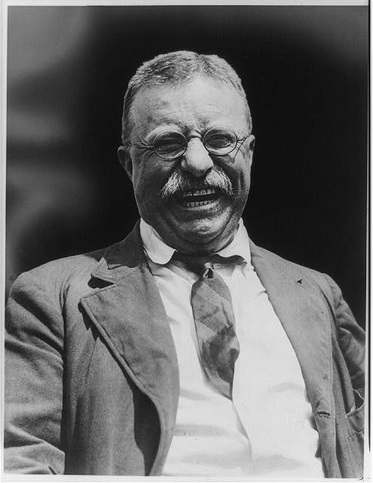
Data Set 2: Foreign Policy
“Roosevelt came to the presidency intent on expanding U.S. power abroad and with a belief that America should be strong and ready to defend its interests around the world. The former Rough Rider entertained boyishly romantic notions of glory on the battlefield. And it was only near the end of his life, when he experienced great personal tragedy during World War I, that Roosevelt truly realized the brutal nature of war.
Fond of quoting the African proverb "Speak softly and carry a big stick," the militaristic Roosevelt was also capable of shrewd diplomacy and peace making. When Japan went to war with Russia over control of Manchuria and Korea in 1905, Roosevelt arbitrated the dispute. TR secretly agreed to Japanese annexation of Korea; in return the Japanese promised to keep their hands off China, Hawaii, and the Philippines. The combatants laid down their arms, Roosevelt won the Nobel Peace Prize -- the first American to win the award -- and the U.S. strengthened its position in Asia and the Pacific.” (PBS, 2002).
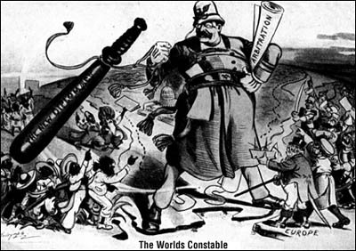 political cartoon accessed from: http://www.pbs.org/wgbh/amex/presidents/26_t_roosevelt/psources/ps_toons_01.html Theodore Roosevelt, head-and-shoulders portrait, facing front Accessed from: http://www.loc.gov/pictures/item/2010645494/
Data Set 3: Foreign Policy
“Following President McKinley's assassination in September, 1901, Roosevelt, then vice president, ascended to the presidency, bringing his imperialistic philosophy with him. Roosevelt had long advocated the building of a Central American canal, linking the Pacific to the Atlantic. In 1903, when negotiations with Colombia for a canal zone lease broke down, Roosevelt quietly supported a revolution in that country. Fighting began on November 3. Days later, with tacit support from TR, the independent country of Panama emerged from Colombian control, sporting an American-made declaration of independence, constitution, and flag. Panama rapidly agreed to American terms on a canal zone lease, and the U.S. Army Corps of Engineers began digging the following year.
In 1904, when the Dominican Republic defaulted on its European debt, Roosevelt drafted the Roosevelt Corollary to the Monroe Doctrine: the U.S. would freely intervene in any nation in the Western Hemisphere guilty of "brutal wrongdoing." When the Italian Navy steamed into the Caribbean to collect its due, Roosevelt enforced the corollary. Under pressure from Roosevelt, the Dominicans requested U.S. assistance. The U.S. took over collection of Dominican customs revenue, and set up a debt repayment plan, forestalling European intervention.” (PBS, 2002).
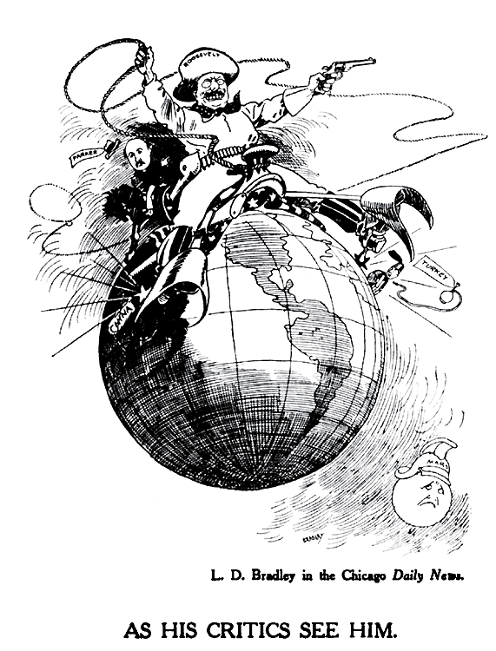
political cartoon accessed from: http://www.pbs.org/wgbh/amex/presidents/26_t_roosevelt/psources/ps_toons_01.html
An excerpt from: Theodore Roosevelt (1858–1919). An Autobiography. 1913.
XIV
THE MONROE DOCTRINE AND THE PANAMA CANAL

“To have acted otherwise than I did would have been on my part betrayal of the interests of the United States, indifference to the interests of Panama, and recreancy to the interests of the world at large. Colombia had forfeited every claim to consideration; indeed, this is not stating the case strongly enough: she had so acted that yielding to her would have meant on our part that culpable form of weakness which stands on a level with wickedness. As for me personally, if I had hesitated to act, and had not in advance discounted the clamor of those Americans who have made a fetish of disloyalty to their country, I should have esteemed myself as deserving a place in Dante's inferno”
“Colombia was then under a one-man government, a dictatorship, founded on usurpation of absolute and irresponsible power. She eagerly pressed us to enter into an agreement with her, as long as there was any chance of our going to the alternative route through Nicaragua. When she thought we were committed, she refused to fulfil the agreement, with the avowed hope of seizing the French company's property for nothing and thereby holding us up… I did not lift my finger to incite the revolutionists. The right simile to use is totally different. I simply ceased to stamp out the different revolutionary fuses that were already burning. When Colombia committed flagrant wrong against us, I considered it no part of my duty to aid and abet her in her wrongdoing at our expense, and also at the expense of Panama, of the French company, and of the world generally. There had been fifty years of continuous bloodshed and civil strife in Panama; because of my action Panama has now known ten years of such peace and prosperity as she never before saw during the four centuries of her existence—for in Panama, as in Cuba and Santo Domingo, it was the action of the American people, against the outcries of the professed apostles of peace, which alone brought peace. We gave to the people of Panama self-government, and freed them from subjection to alien oppressors.
Roosevelt, Theodore. An Autobiography. New York: Macmillan, 1913; Bartleby.com, 1998. www.bartleby.com/55/. [16, November, 2010].
Published February 1998 by Bartleby.com; © Copyright
Data Set 4: Domestic Policy
“TR filed an anti-trust action against J. P. Morgan's Northern Securities Company and shortly thereafter, the rambunctious Roosevelt intervened in a nationwide coal strike, threatening to use federal troops to operate the mines unless the strike was settled, and pushing the powers of the presidency to unprecedented -- and some said unconstitutional -- limits. TR made it clear that his interpretation of the Constitution allowed the president to wield broad powers in the face of national crises. "I am President of all the people of the United States," Roosevelt wrote, "without regard to creed, color, birthplace, occupation, or social condition. My aim is to do equal and exact justice among them all."
In seven years as president, he instituted numerous progressive reforms. The Hepburn Act gave the government power to set freight rates. The Bureau of Corporations took action against unscrupulous monopolies. The Pure Food and Drug Act and the Meat Inspection Act ushered in a new era of consumer protections. As an ex-president and Progressive Party candidate, Roosevelt lobbied for policies that would form the core of the future federal government -- old-age pensions, unemployment insurance, a graduated income tax, child labor laws, and women's suffrage.”
“Perhaps Roosevelt's most enduring legacy is an expanded national conservation system. As business interests ravaged America's natural resources, Roosevelt moved to protect them with scientific management techniques. Using his executive powers, TR created scores of national monuments, refuges, and parks, including the Tongass forest reserve, Grand Canyon National Monument, and Muir Woods. All told, he placed over 230 million acres under federal protection.” (PBS, 2002).
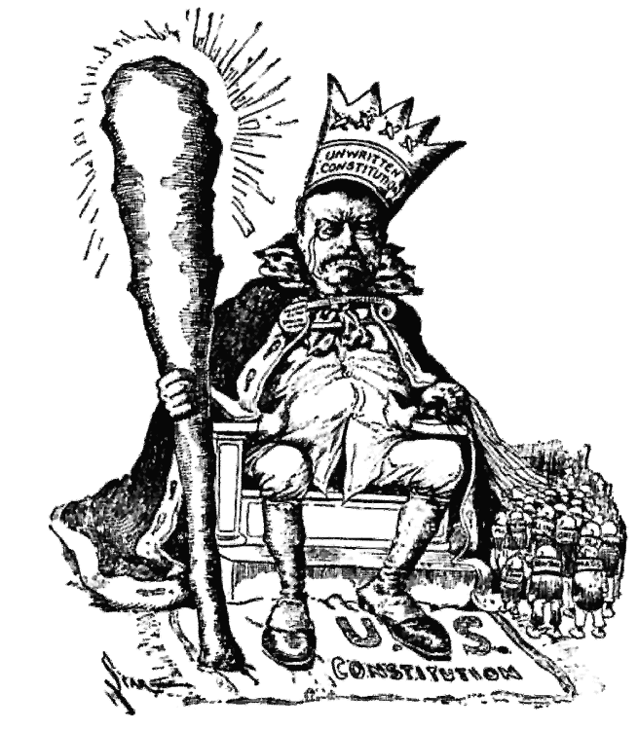 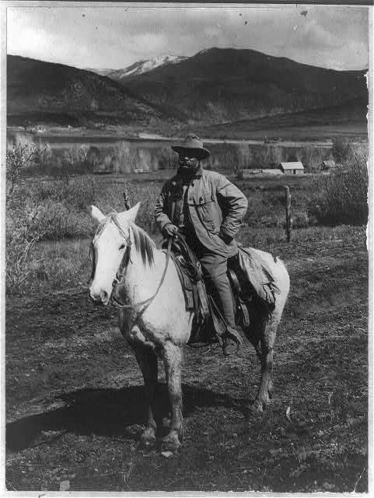
Title:Theodore Roosevelt on horseback between 1900 and political cartoon accessed from: http://www.pbs.org accessed wgbh/amex/presidents/26_t_roosevelt/psources/ps_toons_01.html from: http://www.loc.gov/pictures/item/95514637/

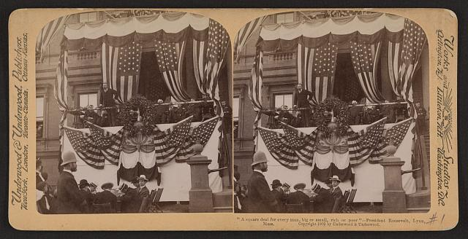
"A square deal for every man, big or small, rich or poor" - President Roosevelt, Lynn, Mass. Accessed from: http://www.loc.gov/pictures/item/2010647257/
Excerpt from a speech by Theodore Roosevelt: The New Nationalism
August 31, 1910
“I stand for the square deal…When I say I want a square deal for the poor man, I do not mean that I want a square deal for the man who remains poor because he has not got the energy to work for himself. If a man who has had a chance will not make good, then he has got to quit. And you men of the Grand Army, you want justice for the brave man who fought, and punishment for the coward who shirked his work. Is not that so?
Now, this means that our government, national and State, must be freed from the sinister influence or control of special interests. Exactly as the special interests of cotton and slavery threatened our political integrity before the Civil War, so now the great special business interests too often control and corrupt the men and methods of government for their own profit. We must drive the special interests out of politics. That is one of our tasks to-day…For every special interest is entitled to justice, but not one is entitled to a vote in Congress, to a voice on the bench, or to representation in any public office. The Constitution guarantees protections to property, and we must make that promise good But it does not give the right of suffrage to any corporation. The true friend of property, the true conservative, is he who insists that property shall be the servant and not the master of the commonwealth; who insists that the creature of man's making shall be the servant and not the master of the man who made it. The citizens of the United States must effectively control the mighty commercial forces which they have themselves called into being.
There can be no effective control of corporations while their political activity remains. To put an end to it will be neither a short nor an easy task, but it can be done…”
Text of speech courtesy of the Program in Presidential Rhetoric, Texas A&M -- University.

Data Set 5: Modern Opinions

David Grubin (PBS documentary filmmaker) on How TR Changed the Presidency
You have to remember that before TR, the president wasn't expected to play such a dominant role in our national life. TR, by the very nature of his character, took that role, made the presidency an active force. He couldn't help himself. He was a man who believed in action and he believed that the government needed to play a role in our national life. He believed that it was up to the government to give everybody, as he said, a square deal.
We forget that the government was small then, that business really ruled the country. Roosevelt said it's important for the government to regulate business, it's important for the government to step in and balance the power of business. Well, we face the same problems today. What should be the relationship of government to the economy, government to business? Roosevelt was grappling with those problems right at the beginning of the century and it's now the end of the century and we still grapple with that problem. Roosevelt was also an interesting President and relevant to our times. Roosevelt is a President relevant to our times because he deals with issues relevant to our times. The relationship between the government and business, the relationship between government and the environment.
No president has acted as vigorously to protect the national resources as Roosevelt. Before Roosevelt presidents really weren't concerned with the, with our national resources. He was really the greatest conservationist president in our history and he faced down special interests to save over 230 million acres of wilderness for us and our descendants. Well, today we face similar problems. What should the government's role be in protecting our environment? For TR, there wasn't a question there. He went out and acted in the interest of the environment.
TR's was also fascinating to me because he was a man of, rich in contradictions. Here was a man who showed courage and fortitude charging up San Juan Hill. Indeed, it was a noble action in his own mind and was fearless. On the other hand, he loved war. He thought war was good for a man's soul. I found that a little more difficult to sympathize with but then again here's a man, TR, who believed that war was a cleansing force in a man's life, that it was good for a man's soul, good for a nation's soul. Yet he won the Nobel Prize for Peace for settling the Sino-Japanese War. And in the end, the story of Theodore Roosevelt is a dark and tragic story. Here's a man who believes in the virtue of war and teaches his children that it's important to be warriors, to be soldiers, to fight for what they believe is right, and then his children go off to World War I and his youngest son is killed.

Accessed from: http://www.pbs.org/teachers/connect/resources/1184/preview/
A Model Conservative?
Theodore Roosevelt, whom some conservatives would make a patron saint, spread over the United States a federal regulatory blanket that has often smothered businesses and stifled entrepreneurship. TR’s broadening of executive power upset the constitutional checks and balances of our republic. His imperialism set a precedent for U.S. meddling abroad and entangling alliances—a policy unfortunately praised by today’s neoconservatives. Mark Twain, who knew Theodore Roosevelt, may have exaggerated when he described him as “clearly insane.” But there’s no doubt that TR was a poor friend of the Constitution, capitalism, and peace.
Excerpt from: CATO Policy Report, November/December 2002, Vol. XXIV No. 6
article: TR: No Friend of the Constitution by Michael Chapman

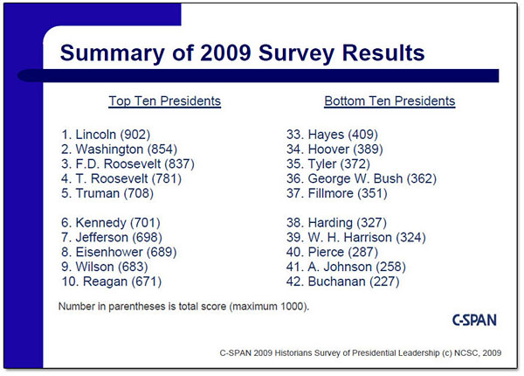

accessed from: http://www.c-span.org/PresidentialSurvey/presidential-leadership-survey.aspx

