US History-Miss Natalie Name ______________________________________ Hr ____

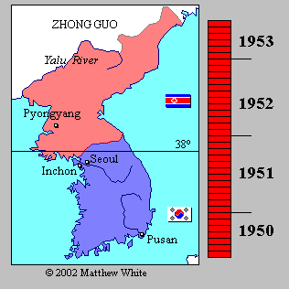
The Korean War
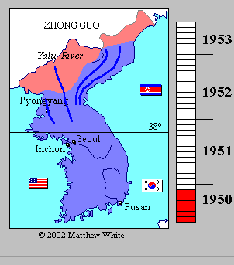
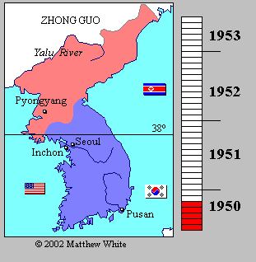
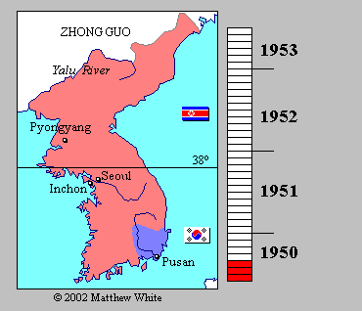
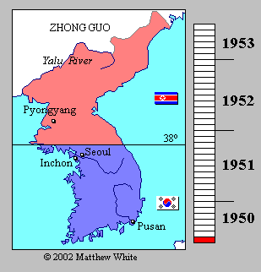
Outline of Events:
- Korea was occupied by the Japanese Empire for nearly 50 years

- After Japan’s defeat in WWII, Korea was occupied by Soviet and American troops.
  - Soviets occupied north (communist industrialized north)
  - Americans occupied south (non-communist rural south)
  - The 38th parallel marked the border between the two Koreas.

- By 1949, American and Soviet troops left.

- The rulers of both North and South Korea were not popular.
  - Both had desired to rule over all of Korea.

- 1950, Kim Il-Sung, the Communist leader of the North, ordered an attack on South Korea
  - South Korean army was in full retreat
  - President Truman was concern that this invasion was part of a larger communist plan to conquer the world.
    - Assumed Stalin had ordered the invasion from Moscow today, (many doubt this)
  - First major test of the Truman Doctrine—the US set out to help South Korea
    - Originally worked through the UN. 16 countries sent troops to help defend South Korea, but the United Sates sent 90% of the troops and most of the financial aid.

- American troops help to turn the tide of the war. Kim II-Sung’s forces had retreated north to the Chinese border.
  - In November, Chinese communist helped turn the tide again. They forced American and South Korean troops into a retreat back to South Korea.

- Front lines eventually stabilized near the 38th parallel for two years

- In 1953, UN forces and North Korea signed the Korean Armistice Agreement, which was a cease-fire designed to “insure a complete cessation of hostilities and of all acts of armed force in Korea until a final peaceful settlement is achieve.”
  - No “final peaceful settlement” has been achieved yet as of 2013.

- The Korean Armistice Agreement established the following:
  - Restored the border between the nations on the 38th parallel
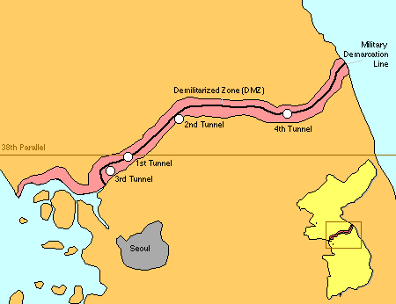
  - Established the Korean Demilitarized Zone (KDZ), which would serve as a buffer zone between the North and South along the 38th parallel.
    - It is one of the most heavily militarized borders in the world despite its name.
    - Troops may patrol the region, but they cannot cross the Military Demarcation Line which marks where the warfront was when the agreement was signed

Outcome of the Korean War:
Korea remained divided
- North Korea:
  - Communist dictator Kim Il Sung
  - After his death in 1994, his son Kim Jong-il took power; he died in 2011, leaving his son Kim Jong-un in power.
- South Korea:
  - Prospered from aid from US and others
  - Several dictators ruled until the late 80s and 90s when they got a democratic constitution

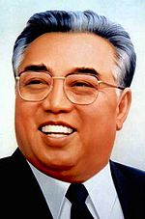
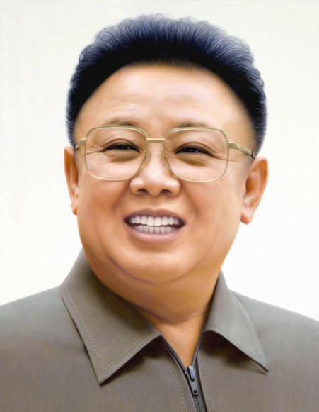
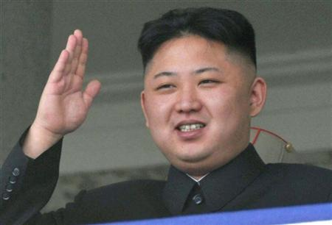
Pictured below are three generations of North Korean Dictators.
Kim Il Sung ruled from 1948—1994
Kim Jong-Un ruler from 2011—present
Kim Jong-Il ruled from 1994—2011
Understanding the Korean War—Analyzing quotes

A Historian by the name of Allan Millet once said, “Just how one views the Korean War depends upon where one stands in geographic space, cultural time, and Cold War historiography.” You will be reading through several quotes and articles regarding the Korean War to see how the war was viewed in its time and how its legacy is still impacting our world today. You will likely have to reference back to the Korean War Outline while trying to make sense of these quotes.

Document 1: The following is an excerpt from a Chinese-Soviet dispute during the summer on 1960 between the Soviet Secretary Nikita Khruschev and Chinese Communist Party leader Peng Zhen.
Khrushchev: Since we are all in this small meeting, we can say that the North Koreans started the Korean War and that the Soviet Union and China agreed.

Peng Zhen: that’s not right, we didn’t agree. I participated in the Politburo meetings and know something about this.

Khrushchev: I have seen the documents. Mao agreed.

Peng Zhen: There are two points that need clarification. First, we had no prior knowledge…

Khrushchev: … The Korean War was launched as the result of a joint decision by both Stalin and Mao Zedong.

Peng Zhen: What you say is not right. Mao Zedong opposed the attack.
- Explain the disagreement these two individuals have over who started, and supported, the Korean War. Why do you think they would disagree on this matter?

Document 2: The Following is an excerpt from a book published in 1999, “Why did Stalin Back the Korean War?” by a Chinese Historian named Yang Kuisong
…initially Stalin had no intention of starting a conflict with the United States in Korea. It was only because of the unexpected success of the Chinese revolution and then the Sino-Soviet treaty that Stalin changed his consistently cautious thinking with respect to policy in Asia
- According to this historian, what was the catalyst (motivation), behind Stalin’s support of a Korean War?

Document 3: excerpted from an essay “Love, Povertry, and War: Journeys and Essays,” Published in 2004 by Christopher Hitchens, a British-American author and journalist
“Even in former days, Korea was known as the 'hermit kingdom' for its stubborn resistance to outsiders. And if you wanted to create a totally isolated and hermetic society, northern Korea in the years after the 1953 'armistice' would have been the place to start. It was bounded on two sides by the sea, and to the south by the impregnable and uncrossable DMZ, which divided it from South Korea. Its northern frontier consisted of a long stretch of China and a short stretch of Siberia; in other words its only contiguous neighbors were Mao and Stalin. (The next-nearest neighbor was Japan, historic enemy of the Koreans and the cruel colonial occupier until 1945.) Add to that the fact that almost every work of man had been reduced to shards by the Korean War. Air-force general Curtis LeMay later boasted that 'we burned down every town in North Korea,' and that he grounded his bombers only when there were no more targets to hit anywhere north of the 38th parallel. Pyongyang [North Korea’s Capital] was an ashen moonscape. It was Year Zero. Kim Il Sung could create a laboratory, with controlled conditions, where he alone would be the engineer of the human soul.”
- Explain what Hitchens means when he refers to North Korea as a “hermit Kingdom,” why does he say the country grew to be a ‘hermit kingdom’?

Document 4: The following is an excerpt from the book, “Cold War Canada: The Making of a National Insecurity State, 1945-1957” by Reg Whitaker, a Canadian author.
The monstrous effects on Korean civilians of the methods of warfare adopted by the United Nations — the blanket fire bombing of North Korean cities, the destruction of dams and the resulting devastation of the food supply and an unremitting aerial bombardment more intensive than anything experienced during the Second World War. At one point the Americans gave up bombing targets in the North when their intelligence reported that there were no more buildings over one story high left standing in the entire country … the overall death toll was staggering: possibly as many as four million people. About three million were civilians (one out of every ten Koreans). Even to a world that had just begun to recover from the vast devastation of the Second World War, Korea was a man-made hell with a place among the most violent excesses of the 20th century.
- Based on the description given by Whitaker, what impression do you think most North Korean civilians had of the United Nations and the United States after the Korean War? Explain.

Document 5: The following is a quote from United States President Harry Truman
In my generation, this was not the first occasion when the strong had attacked the weak… Communism was acting in Korea just as Hitler, Mussolini, and the Japanese had acted ten, fifteen, and twenty years earlier. I felt certain that if South Korea was allowed to fall, Communist leaders would be emboldened to override nations closer to out own shores.
- According to this quote, why did Truman feel compelled to intervene (get involved) in the Korean conflict?

Document 6: The following is a British newspaper article published on March 5, 2013
http://www.guardian.co.uk/world/2013/mar/05/north-korea-korean-war-ceasefire
North Korea has said it will cancel the 1953 ceasefire that ended the Korean war, citing as reasons a US-led push for UN sanctions over Pyongyang's recent nuclear test and continuing US-South Korean joint military drills.
…
North Korea says its nuclear programme is a response to US hostility dating back to the 1950-53 Korean war, which ended with an armistice rather than a peace treaty, leaving the Korean peninsula still technically in a state of war.

North Korea warned it would cancel the Korean war ceasefire agreement on 11 March, pointing to US-South Korean military drills that began on 1 March.
…
Any fresh international sanctions are certain to infuriate North Korea, which has claimed the right to build nuclear weapons to deter [prevent] US aggression. Citing the US-led push for sanctions, the Korean people's army supreme command on Tuesday warned of "surgical strikes" meant to unify the divided Korean peninsula and of an indigenous, "precision nuclear striking tool".

- According to the article above, how is the Korean War still “alive” so to speak today?

