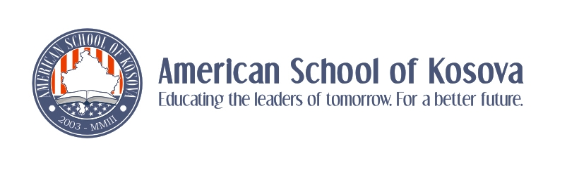
Introduction to the JMM-ASK Connection, 2013/14

Introduction:

This year we will engage in a joint learning partnership with several U.S. History 9 Honors classes at James Madison Memorial High School (JMM) in Madison, WI, USA. This is a school where Miss Natalie has worked and we have been doing this sort of project for two years now. Students at JMM and ASK will be paired for communication purposes and we will compile a list of email addresses, facebook names and skype user names to facilitate contact. Although we will not be starting anything until second quarter, we wanted to give you some general information about the combined activity so that you know what is coming up.

Activities:

1) Introduction: Our first interaction will be through a video presentation that you will prepare to introduce yourselves to your counterparts in Wisconsin. While each of you will be paired individually with someone in Wisconsin, these introductory presentations will take the form of a group video. When the time comes, you can decide whether you want to prepare a class video or break up into smaller groups to film your presentation. These videos will be due Friday October 25th, and will include information on your lives, on ASK, on living in Kosova and a tiny bit about each individual. More on this later.

2) Chats: From November to the end of the year (dates to be determined later) you will engage in a total of 3 discussions with your JMM partner, each about a specific topic (again, more later). One of these discussions MUST take place over skype, so sometime during first quarter you should set up a skype account (they are free) if you do not already have one, so that you are ready to share your skype user name by second quarter. The other 2 discussions can be over skype, or if that proves to be too difficult, through email or facebook chat, etc.

3) Final Mini-project: This will involve the selection of a cultural artifact (poem, art, music, etc.) that you will upload to a class website with a brief commentary. The topic of that artifact and summary will be discussed later, but it will be due in May.

