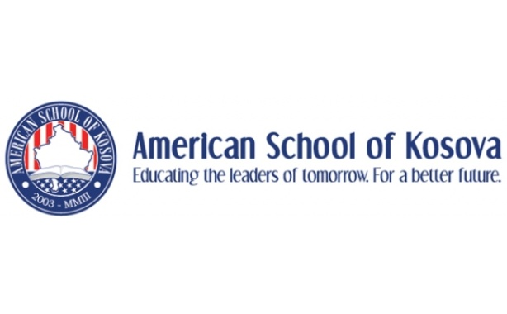
Comparative Government
Miss Natalie Kainz, Room R8
nataliek@askosova.org
Class Content
Welcome to our Comparative Government course for the 2013-2014 school year at ASK! This senior course is designed to help your son or daughter understand the history of political thought, development of government systems, and encourage him/her to become an active member of their own government system. The following is an overview of the units we will cover each semester.
1st Semester
-History of Western Political Thought
-Types of Government Systems
-Comparative Government Case Studies- US, Cuba, Iran, Mexico, Nigeria, UK, Germany, China, India, Kosova
-Social Issues Conference Research Study
Final: Multiple Choice/Writing Exam
2nd Semester
-Civics/Active Participation in Government – What does it mean to be involved in politics and the government here in Kosova?
-Politics by civil means- Voting Rights and Citizenship- What does it mean to be a responsible citizen of your country?-Politics by violent means- Terrorism, Revolutions, Arab Spring
-Politics without government- The role of globalization and global institutions such as the UN and EU in our world today.
Final: Presentation/Project Based along with volunteer work and response (We will present 5 volunteer opportunities throughout the second semester, students must attend 2)
Assessment:
Test and Unit Assessments 25%
Quiz 10%
Homework and Participation 25%
Papers and Projects 25%
Final Exams 15%
Class Website: http://askmissnatalie.weebly.com/
Please check my class website to keep updated on our daily lessons and upcoming assignments, tests, and projects!
Communication and Extra Help:
I am here before school, after school, and on my breaks to help your child if he or she needs it. I will often ask struggling students to stay after school for extra help, but it is up to them to show up. Please encourage your child to let me know when they need to talk or need help with something from class. I am also available via email if you have questions or want to arrange an appointment to discuss your child’s learning in more detail (nataliek@askosova.org)

