The Geography of the Cold War: What Was Containment?

It was a glorious meeting. On April 25, 1945, at the Elbe River in Germany, two powerful armies met. Coming from opposite ends of Europe, the Americans and Russians had cut Hitler’s Germany in two. Now at the Elbe, soldiers from the Red Army of the Soviet Union reached out their hands to their American counterparts. It was a time for great happiness. World War II, the deadliest war in all of human history, was nearly over.

Unfortunately, the warmth of the handshakes did not last. The Soviet Union and the United States had serious differences. Their greatest difference was over a political and economic system called communism.

In its pure form, communism is a belief that private property should be replaced by community ownership. In the Soviet Union this idea was not easily accepted by the people. Russian leaders Vladmir Lenin and Joseph Stalin were ruthless in their elimination of those who had different ideas about Russia’s future. It is estimated that in the 1930s, Stalin was responsible for killing more than 10,000,000 Soviet people who he believe were in his way.

Soviet communists did not like capitalism. They opposed private ownership economies of the United States and its allies. Russian leaders believed that capitalism was doomed and that communism would spread throughout the world. This caused great tension and the emergence of a new kind of war, a Cold War. Mistrust ran deep. In the words of Winston Churchill, it was as if an “iron curtain” had been drawn between the Soviet-controlled countries in Eastern Europe and the Western democracies.

The Soviets had suffered terribly in World War II, losing more than 27,000,000 soldiers and civilians. Stalin was determined that Germany would never be able to strike Russia again. To protect Russia, Stalin wanted a buffer zone in Eastern Europe. It was no secret that Stalin and his successors wanted to expand the Soviet Empire.

If the Soviet policy was expansion, then the American policy was containment. Containment was the idea that the Soviet Union and Soviet communism should not be allowed to spread. One example of containment was the Truman Doctrine. In 1947, President Harry Truman declared that the United States would support “free peoples,” like those in Greece and Turkey, who were being threatened by communists. The Truman Doctrine was followed by the Marshall Plan, which gave over 12 billion dollars in aid to help rebuild European democracies like France and West Germany. The idea was to give these countries resources so that communist ideas would not be so attractive.

By 1947 the United States and the Soviet Union were clearly on a collision course. Stalin and his successors were always looking for weak spots to push and probe, to test American commitment to containment.

(This lesson features three occasions where Soviets tested American containment policy.
Your task is to examine the maps, then answer the question, what was containment?)
Document A: Communist/Non-Communist Blocs

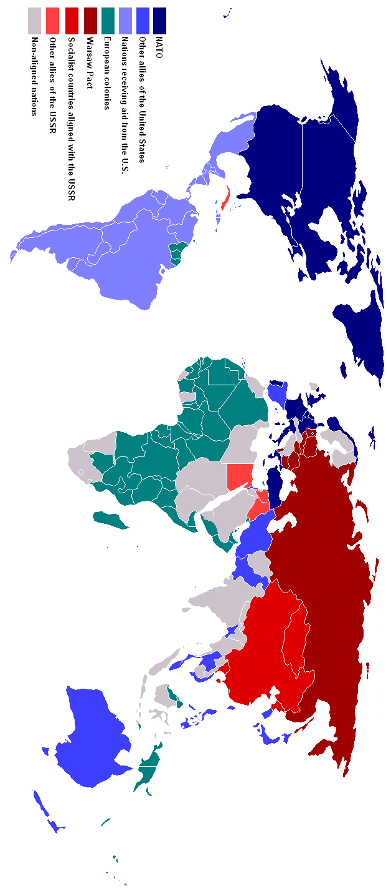

- Including the Soviet Union, list two European countries in the communist bloc (Warsaw Pact).

- Excluding the Soviet Union, list the Asian countries in the communist bloc.

- List five North American and European countries in the non-communist bloc (NATO Treaty).

- List three Asian countries in the non-communist bloc.

- Why was the formation of alliances so important during the Cold War?

- What role do you think European colonies played in the Cold War?

- Imagine seeing this map at the height of the Cold War. With a partner discuss why the geography of the world at this time might make both Americans and Russians very nervous. Record your ideas.

Russian Fears | American Fears
Document B: Berlin Airlift

Used from Mini Q’s in American History
(The DBQ Project)

- “In 1948, western Berlin was a pro-American island in a Soviet sea.” Explain.

- What did the Soviets do between June 27, 1948, and May 12, 1949?

- Why do you suppose the Soviets did what they did?

- How did Britain, the United States, and France respond to the June 27th action?

- How does this document demonstrate the American policy of containment?

Document C: 38th Parallel

Used from Mini Q’s in American History
(The DBQ Project)

- On what date did North Korea first invade South Korea?

- Who supported North Korea? Who supported South Korea?

- North Korea only invaded when Stalin, the Russian leader, gave his approval. From what you know about Stalin, what was his motive?

- Why might Communist China have decided to help North Korea?

- How does this document demonstrate the American policy of containment?
Document D: The Cuban Missile Crisis

Used from Mini Q’s in American History
(The DBQ Project)

- What was the date of Fidel Castro’s communist takeover in Cuba?

- What is a quarantine? (Note: The Soviets had to look the word up.)

- Using only information from the map, tell the Cuban Missile Crisis story.

- How does United States action in Cuba demonstrate the policy of containment?

