The Cold War- Historical Background Information

Allies to Adversaries
Just one month after President Harry S. Truman and Premiere Joseph Stalin met at Potsdam, two separate explosions were visible over the cities of Hiroshima and Nagasaki. These two atomic blasts ended the greatest war in the history of the world. World War II allies now became adversaries as they attempted to spread their influence over the rest of the world. The United States and the Union of Soviet Socialist Republics (USSR) had emerged from World War II as the world’s two superpowers.

In 1946, Winston Churchill proclaimed that an “Iron Curtain” had fallen over Eastern Europe. In response to the spread of communism in Europe, the North Atlantic Treaty Organization (NATO) was signed by the U.S., Canada, and eight western European nations. NATO was a defense pact between nations and stated that an attack against one nation was an attack against all nations. Six years later, the Soviet Union and its eastern satellites (leaders who said and did whatever the Soviet Union wanted them to say and do) signed the Warsaw Pact, countering the NATO Treaty. The two superpowers confronted each other in trouble spots around the world, but they didn’t get into a direct military fight. For this reason, their struggle was called the Cold War. From the 1950s to the early 1990s, the Cold War dominated global politics.

United States Influence
Europe was devastated by World War II, with millions dead and billions of dollars in damage. In the hopes of rebuilding Europe, United States Secretary of State George C. Marshall envisioned massive financial aid for European nations willing to work together. Congress passed the Marshall Plan and promised more than 20 billion dollars in relief. Marshall also offered money to the Soviet Union. Stalin however, refused any assistance from the United States. Shortly after Stalin’s rejection of American aid, United States ambassador to the USSR, George Kennan, wrote that the foreign policy of the United States must be one that will prevent the spread of communism to any part of the world. Kennan’s “containment” theory became the focus of American foreign policy for the next 45 years.

The first major test of containment came in Greece and Turkey in 1947. Both countries asked for economic assistance, so President Truman asked Congress for aid to these countries to defend against communist guerillas. This is known as the Truman Doctrine. The Truman Doctrine of aid to weakened countries began as one method of stopping communist influence. A year later, in 1948, the Soviets blocked all road and rail access to the western section of the city of Berlin. For the next 321 days, Allied planes flew over communist-held Germany and brought supplies to the citizens of West Berlin.

In 1949, Mao Zedong (also known as Mao Tse-tung) drove the government of Chiang Kai-Shek out of the Chinese mainland and proclaimed China as a new communist state. Now the containment of communism in Asia became an issue for the American government. President Dwight Eisenhower’s Secretary of State, John Foster Dulles, orchestrated the Southeast Asia Treat Organization (SEATO). Dulles also promoted the philosophy of “brinkmanship,” or taking the fight against communism all the way to the brink of possible nuclear war.

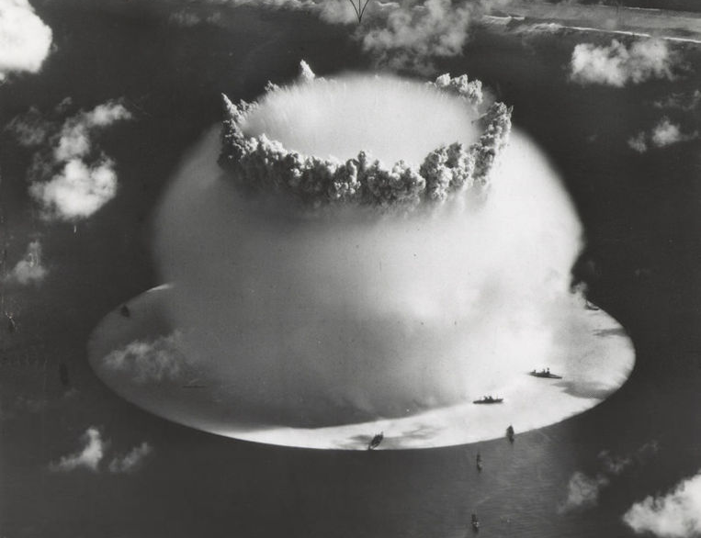
The Atomic Age
The bombs used against Japan were evidence that the Manhattan Project achieved the goals set out by Robert Oppenheimer, James Byrnes, and Leslie Groves. The development and use of the most aggressive military weapon of its time had been completed, rendering catastrophic results. The Soviets now needed to develop an atomic bomb to counter the Americans. In 1949, the Soviets exploded their first atomic bomb.
H-Bomb on Bikini Atoll (Library of Congress)

Since the Manhattan Project was no longer a secret, the United States feared spies from the Soviet Union. In March 1951, two Americans were tried for passing secret atomic information to the Russians. Julius and Ethel Rosenberg were found guilty and executed in June 1953.

Both countries had atomic weapons and the missile platforms for launching these weapons. The United States increased spending on the Strategic Air Command (SAC) as a defense against a Soviet nuclear attack. The United States also developed the triad system. The triad defense system used bombers, submarines, and missiles as a means of defense and a possible first strike attack system, if needed. Citizens feared attacks from the Soviet Union and air-raid practice drills were conducted nationwide. Bomb shelters were built in many urban areas and some shelters were even built by private citizens.

In 1964, the People’s Republic of China (PRC) detonated its first atomic bomb. That meant two enemies of the U.S. were now capable of launching an atomic attack against the country. Albert Einstein described the atomic age when he said, “I do not know with what weapons World War III will be fought, but World War IV will be fought with sticks and stones.” Fear of an atomic war was the centerpiece of government strategies and American fears.

Fighting Communism at Home
Prior to World War II, support for communism in the United States had been closely associated with the Socialist Party. Followers of Karl Marx’s ideology had organized labor groups. A socialist, Eugene Debs, ran for the American presidency multiple times from 1904 to 1920. However, after World War II the fear of a powerful Soviet Union and the spread of communism into the United States were frightening to the government and most citizens.

As early as 1947, the United States government passed the national Security Act, created the National Security Council (NSC) and the Central Intelligence Agency (CIA). The NSC was led by ardent anti-communist leaders and they used the CIA as their proactive spy tool. Just two months after the creation of the NSC, Congressman J. Parnell Thomas reinstituted the House Un-American Committee (HUAC) hearings. His committee began to interview Hollywood personalities that had attended Communist Party meetings during the 1930s and early 1940s. Some writers, directors, and actors named others in order to gain their own freedom. Other Hollywood personalities chose to say nothing. They refused to admit any ties to the Communist Party. Many of the latter group were sentenced to jail terms.

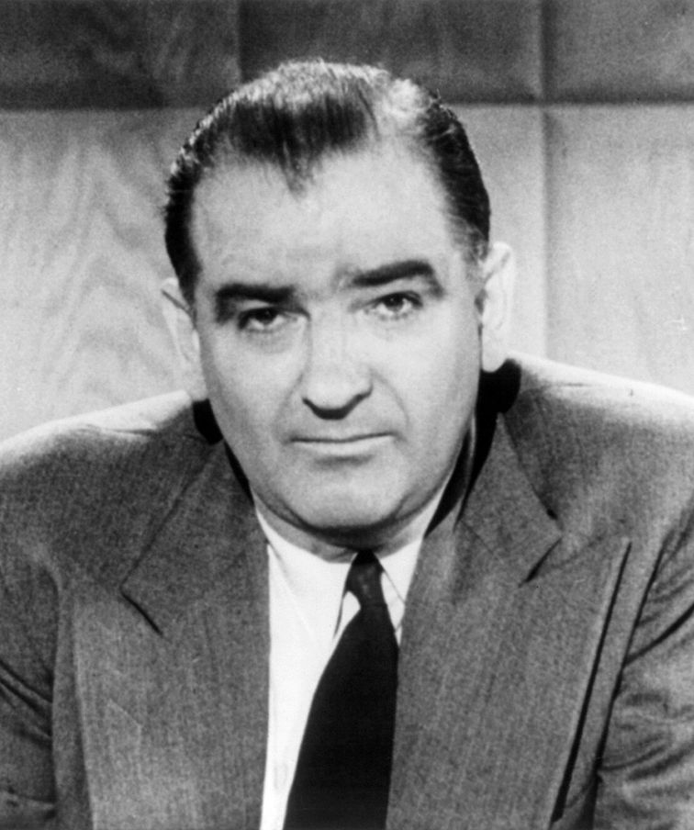
In 1948, Congressman Richard Nixon used HUAC to investigate and accuse Alger Hiss, a former government official under Franklin Roosevelt, of being a communist agent. Although not found to be a spy, Hiss was convicted of perjury and sentenced to five years in prison.

By early 1950, the hunt for communist agents in the United States had a new crusader, Joseph McCarthy. McCarthy claimed to have a list of known communist agents who were working in the U.S. State Department. Hearings began and nightly news reports kept McCarthy and the anti-communist fight in the public eye for months. In September 1950, Congress overrode President Truman’s veto and passed the McCarran Internal Security Act. Among other things, this act gave broad support to FBI programs of infiltrating and subduing members of “subversive” organizations. The most severe measure approved under the McCarran Act was the use of concentration camps to house subversive members in cases of “emergency situations.”
Senator Joseph McCarthy
(Library of Congress)

In 1954, President Eisenhower signed a congressional bill that outlawed the Communist Party in the United States. During the 1960s, the FBI used a program of counter-intelligence gathering on subversive groups. This program was code named COINTELPRO.

The FBI focused their infiltrations on black civil rights groups, anti-war organizations, college student groups, and American Indian organizations. Critics of the McCarran Act, the HUAC hearing, and the COINTELPRO program argued that the United States government was ignoring fundamental constitutional protections.

Armed Conflicts
During the years of the Cold War, the United States and its communist adversaries carried out numerous indirect armed conflicts. The U.S., USSR, and the People’s Republic of China supplied advisors, weapons, financial aid, and manpower to various parts of the world in support of communist and anti-communist governments. In April 1950, the National Security Council wrote NSC-68. This called for a change in foreign policy from one of politics to one of military usage. Just two months later, communist North Koreans invaded South Korea. The United States, under the flag of the United Nations, entered into a three-year battle against communist forces. After the Suez Canal uprising in 1956, Congress gave President Eisenhower the power to send troops to the Middle East to prevent any communist expansion into that region. This authorization became know n as the Eisenhower Doctrine.

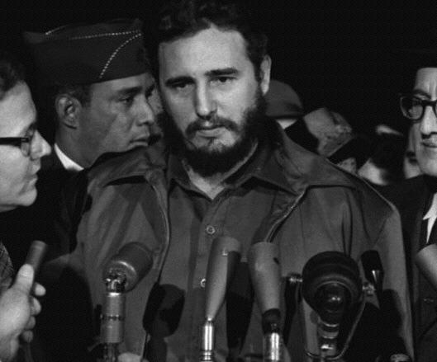
The fear of a war against the Soviets and an attack on the United States became prevalent in October 1962. The news reported that the communist leader of Cuba, Fidel Castro, was building nuclear missile sites on the island. President Kennedy ordered a blockade of Cuba. U.S. Navy ships turned back Soviet cargo ships loaded with materials and weapons. After two very tense weeks, President Kennedy and Soviet Premiere Nikita Khrushchev were able to reach a compromise that avoided any direct military action.
Fidel Castro
(Library of Congress)

As the tension between the Soviets and Americans subsided behind the walls of Eastern Europe, new hostility grew between communist and anti-communist forces in Asia. President Kennedy’s advisors argued that the United States needed to support the non-communist government of South Vietnam. In 1954, Vietnam had been divided under the Geneva Accords into a communist North and a non-communist South. The Domino Theory was the belief that if one Asian country fell to communism all countries in the region would be in danger of collapsing.

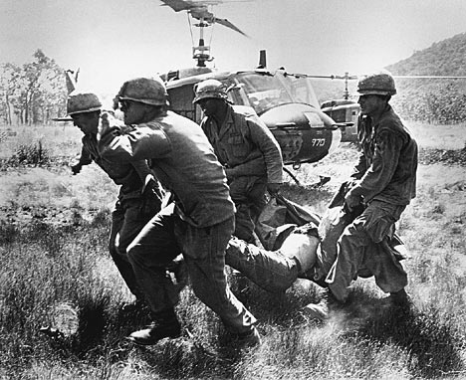
President Kennedy ordered military advisors to Vietnam in support of the South Vietnamese military. The first marine divisions landed in Vietnam in 1965. The Communist North was headed by Ho Chi Minh. The anti-communist South was led by Ngo Dinh Diem. Communist guerrillas called Viet Cong were supported by North Vietnam. They began fighting Diem’s troops. As the Viet Cong grew stronger American aid grew larger. President Johnson got Congress to pass the Tonkin Gulf Resolution.
It allowed the president to take whatever military action he needed in Vietnam.

At home in the United States, the war was very controversial. “Hawks” stressed the domino theory.
The Vietnam War
Some pushed for an even more aggressive land and air war
against both the Viet Cong and North Vietnam. “Doves” disputed the domino theory. They said the struggle between the Viet Cong and South Vietnamese forces was a civil war. The war kept escalating and body counts mounted. But the U.S. wasn’t winning the war.

In 1968, Richard Nixon was elected president. He began “Vietnamzing” the war. He withdrew U.S. troops from Vietnam in phases. At the same time, the U.S. built up South Vietnam’s own army. This actually escalated the war. Finally, in 1972, North Vietnam and the United States began peace talks. A treaty was arranged in January 1973. The Vietnam War was the longest military engagement in U.S. history.

From the late 1970s until the early 1990s, the U.S. and the USSR waged covert operations against each other as well. Each country supported governments and/or guerrilla freedom fighters throughout various regions of the world. In 1979, the Soviets invaded Afghanistan and President Jimmy Carter ordered a U.S. boycott of Soviet goods. President Carter also stopped U.S. grain sales to Russia and boycotted the Olympics held in Moscow. Carter also sent financial and military aid to the Taliban rebels fighting the Soviets.

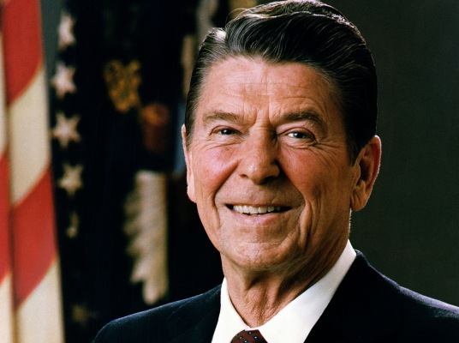
In 1980, President Reagan supported the rebel contras in their fight against the communist Sandinista government of Nicaragua. Presidents Ronald Reagan and George Bush also used U.S. troops to invade the island of Grenada and the country of Panama respectively in a response to a growing concern over new communist-influenced governments in the Latin American region. The 1980s also saw an increase in armed altercations between U.S. troops and Soviet-armed Arab terrorists throughout the Middle East. The most devastating attack against U.S. forces came in October of 1983, when 241 American servicemen were killed in a bombing in Beirut, Lebanon. During the 45 years of the Cold War, the world did not engage in a major conflict, yet many thousands of soldiers and civilians were killed in armed conflict between communist and anti-communist forces.

Détente and the End of the Iron Curtain
In 1968, Cold War leaders were looking for ways to ease tensions and make the world safer. The United States, Soviet Union, and other nations signed the Nuclear Arms Nonproliferation Treaty (NPT) beginning a concrete path toward dismantling nuclear arsenals. President Nixon also began open dialogue with Communist China. In 1971, the People’s Republic of China became the official United Nations representative for the Chinese people. In February of the following year, President Nixon made the first visit to China since it had become a communist foe. Beginning with Nixon,
President Ronald Reagan
(Library of Congress)
American presidents embraced détente, or easing relations, as
the new foreign policy. Presidents Ford, Carter, Reagan, and Bush continued arms reduction talks under the Strategic Arms Limitation Treaty (SALT) and the Strategic Arms Reduction Treaty (START) with the Soviet Union and the People’s Republic of China.

One major detour from reducing arms and limiting defense came in 1983 when President Reagan proposed the Strategic Defense Initiative (SDI). SDI proposed placing defensive or possibly offensive weapons in space. This was unacceptable to the Soviets and in December 1983, the USSR suspended the START talks. After the fall of the Soviet Union, the SDI plans had limited review within the U.S. government.

As détente moved ahead successfully, the next step to formalize good working relations came in the form of economic talks. Open trade and U.S. investment in communist nations became more frequent. In 1981, Lech Walesa, a Polish labor leader, defied the communist government of Poland and formed the Solidarity Union. Walesa organized the first worker’s strike in any communist country. Poland continued toward a more open economic reform program and by 1989, the government of Poland finally recognized the Solidarity Union as a political party. Other Soviet satellites now began to view the success of the solidarity movement and called for changes within their own countries. The next major action within the USSR was the selection of Mikhail Gorbachev as the new general secretary of the Communist Party in 1985. Gorbachev despised communism like it was under the ruthless totalitarian regime of Joseph Stalin. Like Khrushchev, Gorbachev criticized old communism and said that a new form of communism would emerge. To create a new communist state, Gorbachev promoted three changes: glasnost (openness), perestroika (restructure), and democratzia (new democracy). The Soviet empire began to unravel as citizens began to speak freely without fear of reprisal, started to use some forms of open market capitalism, and elected new local leadership. Only four years after Gorbachev’s election, the first satellite countries began a break from the Soviet hold.

Next, in November 1989, the Berlin Wall, the Cold War symbol of the 1960s came down. For the first time in over 25 years, relatives on both sides of Berlin visited together. Two years later, the Baltic states of the USSR sought their own independence from the Soviet Union. By December 1991, the USSR had transformed into the Commonwealth of Independent States. This commonwealth was a weak attempt by Gorbachev to hold some of the Soviet republics together. Realizing the commonwealth was doomed; Gorbachev resigned the presidency of the Soviet Union and transferred power to Boris Yeltsin, president of the Russian Federation. The commonwealth no longer exists and each of the 15 republics is now an independent country.

In 1989, as Berlin was unifying, Chinese students began demonstrations for democratic and capitalistic change. For weeks in June, students and workers began gathering and protesting in Tiananmen Square. On June 4, by order of Premiere Deng Xiaoping, the military cleared the square. Somewhere between 300 and 500 people died, tens of thousands were injured, and thousands more were arrested. As the former communist nations of Europe moved toward open democracies and capitalism, China’s communist leaders refused to bend. Today, China’s economic programs mirror capitalism, but the communist political leadership remains fully in place.

Domestic Life and Cold War Technology
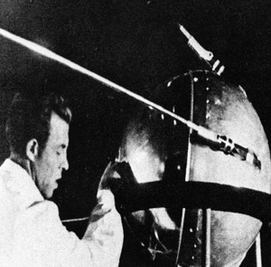
Life in the United States took a dramatic change during the post World War II years. American servicemen returned home to get married, find jobs, buy houses, and live more peaceful lives. The population of the U.S. increased and the children born between 1945 and 1964 became part of the post-war “baby boom” generation. The United States government supported the war veterans with lower home loan rates. Education for veterans was promoted through the GI Bill. For 10 years, beginning in 1948, the housing market exploded. Many families began moving to the suburbs. In 1956, Congress passed the Federal Aid Highway Act, which authorized the building of 41,000 miles of new highways. Driving became a favorite pastime for American families and the automobile industry in Detroit, Michigan, flourished.

In 1957, the entire world watched as the Soviet Union launched Sputnik, the first orbiting space satellite. The space race was on and the U.S. government was determined to eventually surpass the Soviets in space technology.
Sputnik I
(NASA)

Four years later, the Soviets sent the first person into space. A month after that, Alan Shepard became the first American in space. After that, President Kennedy publically stated that America would continue to move ahead with the space program and within the decade would place an American on the moon. Kennedy’s prediction was realized in July 1969, when Neil Armstrong and Edwin “Buzz” Aldrin took that “giant leap for mankind.” The research for NASA’s space program had an influence on the daily lives of American’s as
well. Some of the many space program inventions used in commercial products
were transistors, satellite communication for TV and radio, freeze-dried food, and fire-retardant clothing.

This era also saw a changing medical world. In 1955, Dr. Jonas Salk developed a vaccine for polio, which was the number one crippling disease of baby boom children. In 1967, the World Health Organization (WHO) began a worldwide vaccine program for another major disease, smallpox. By 1980, WHO reported that smallpox had been eradicated throughout the world. However, the euphoria for eradicating one disease would be short-lived because the following year the first case of Acquired Immunodeficiency Syndrome (AIDS) was reported. The lives of Americans changed greatly in the 45 years after World War II.

-Adapted from: The Cold War (Teacher Created Materials)
-Adapted from: The Era of World War II Through Contemporary Times (Walch Publishing)

Cold War Name ________________________________ Hr ___

The Beginnings of the Cold War

Directions: Complete the following table with information about each major event or policy of the Cold War. You will be describing the basic facts an goals of each policy, as well as explaining what CAUSED each of these events/policies, and what were the major EFFECTS of each of these events/policies.

CAUSE  (a reason something happens; what LED to this event happening?) | Facts of Goals of each Event/Policy | EFFECTS  (a result, or consequence of a certain event, or action)
 | Creation of the United Nations:
 | Churchill’s “Iron Curtain” Speech
 | Policy of Containment
Begins with “New Conflicts Develop” on page 592—594
 | The Truman Doctrine:
 | The Marshall Plan:
CAUSE | Facts/goals | EFFECTS
 | Divided Germany:
 | Berlin Airlift:
 | NATO:
 | Warsaw Pact:
 | Propaganda War:

