Cold War Name __________________________________________

By 1948, 3 years after WWII had ended and Soviet troops had pushed Nazi forces back across Eastern Europe, many of the countries along the Soviet border had turned to communism.
*Follow the color-coding directions belo

1. Communist Countries, 1948 (choose a color and make a key):

- Soviet Union
- Poland
- Eastern Germany
- Czechoslovakia
- Hungary
- Romania
- Yugoslavia
- Romania
- Albania
- Bulgaria

2. Non-Communist Countries, 1948 (choose a color and make a key):

- Finland
- Sweden
- Norway
- Denmark
- Netherlands
- Belgium
- Luxembourg
- Western Germany
- Austria
- Italy
- Switzerland
- Great Britain
- Ireland
- France
- Spain
- Portugal
- Italy
- Greece
- Turkey

3. Label the city of Berlin (p. 593)
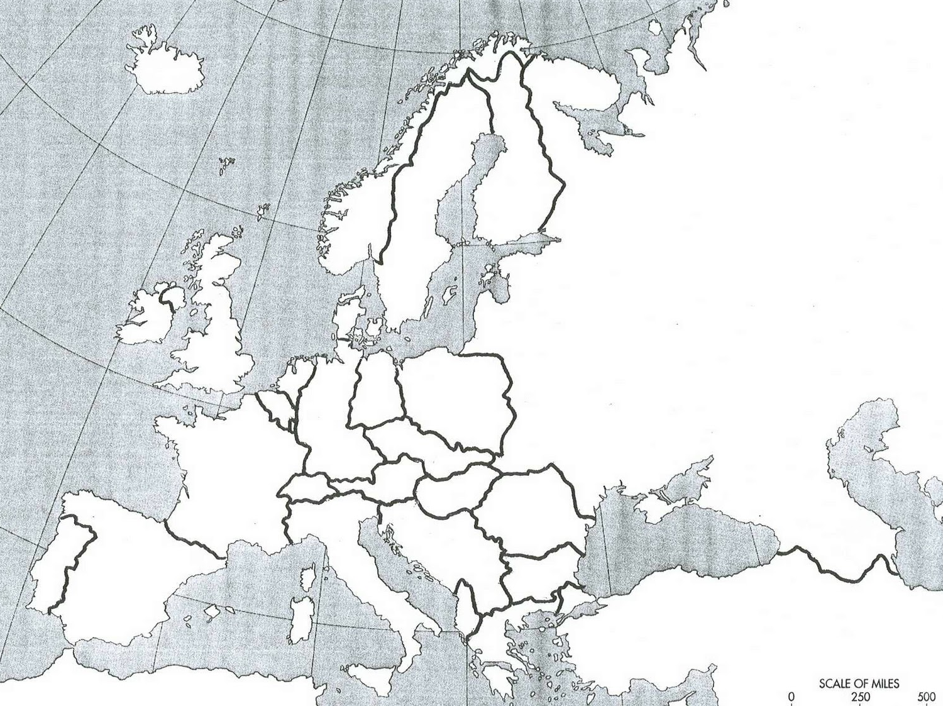
4. Draw and label the Iron Curtain

