Document Set A:
Excerpts from the Lewis and Clark journals
June 28, 1804
(about the Kansas Indians)...they have been reduced and banished by the Sauks and Ayauways, who being better supplies with arms have an advantage over the Kanzas, though the latter are not less fierce or warlike than themselves. This nation is now hunting in the plains for the buffalo which our hunters have seen for the first time.
July 20, 1804
For a month past the party have been troubled with boils, and occasionally with the dysentery. These boils were large tomours which broke out under the arms, on the legs, and, generally, in the parts most exposed to action, which sometimes became to painful to permit the men to work.
This disorder....has not affected the general health of the party, which is quite as good, if not better, than that of the same number of men in any other situation.
August 20, 1804
...we had the misfortune to lose one of our sergeants, Charles Floyd. He was yesterday seized with a bilious colic, and all our care and attention were ineffectual to relieve him: a little before his death, he said to Captain Clark, " I am going to leave you" his strength failed him as he added, "I want you to write me a letter;" but he died with a composure which justified the high opinion had formed of his firmness and good conduct. He was buried on the top of the bluff with the honours due to a brave soldier
September 17, 1804 Meriwether Lewis
Having for many days past confined myself to the boat, I determined to devote this day to amuse myself on shore with my gun and view the interior of the country lying between the river and the Corvus Creek. ... the shortness and virdu[r]e of grass gave the plain the appearance throughout it's whole extent of beatifull bowling-green in fine order. ... this senery already rich pleasing and beatiful was still farther hightened by immence berds of Buffaloe, deer Elk and Antelopes which we saw in every direction feeding on the hills and plains. I do not think I exagerate when I estimate the number of Buffaloe which could be compre[hend]ed at one view to amount to 3000. my object was if possible to kill a female Antelope ... it appeared reather the rappid flight of birds than the motion of quadrupeds. I think I can safely venture the asscertion that the speed of this anamal is equal if not superior to that of the finest blooded courser.
June 27, 1806 Meriwether Lewis
from this place we had an extensive view of these stupendous mountains principally covered with snow like that on which we stood; we were entirely surrounded by those mountains from which to one unacquainted with them it would have seemed impossible ever to have escaped; in short without the assistance of our guides I doubt much whether we who had once passed them could find our way to Travellers rest in their present situation for the marked trees on which we had placed considerable reliance are much fewer and more difficult to find than we had apprehended. ... we encamped for the night having traveled 28 miles over these mountains without releiving the horses from their packs or their having any food. ... our meat being exhausted we issued a pint of bears oil to a mess which with their boiled roots made an agreeable dish.
June 30, 1806
William Clark Weather Diary
Decended the mountain to Travellers rest leaveing these tremendious mountains behind us, in passing of which we have experienced cold and hunger of which I shall ever remember. ... our food was horses of which we eate three.

Document Set B:
The Homestead Act
Passed on May 20, 1862, the Homestead Act accelerated the settlement of the western territory by granting adult heads of families 160 acres of surveyed public land for a minimal filing fee and 5 years of continuous residence on that land.

The Homestead Act, enacted during the Civil War in 1862, provided that any adult citizen, or intended citizen, who had never borne arms against the U.S. government could claim 160 acres of surveyed government land. Claimants were required to “improve” the plot by building a dwelling and cultivating the land. After 5 years on the land, the original filer was entitled to the property, free and clear, except for a small registration fee. Title could also be acquired after only a 6-month residency and trivial improvements, provided the claimant paid the government $1.25 per acre. After the Civil War, Union soldiers could deduct the time they had served from the residency requirements.
Although this act was included in the Republican party platform of 1860, support for the idea began decades earlier. Even under the Articles of Confederation, before 1787, the distribution of government lands generated much interest and discussion.
The act, however, proved to be no panacea for poverty. Comparatively few laborers and farmers could afford to build a farm or acquire the necessary tools, seed, and livestock. In the end, most of those who purchased land under the act came from areas quite close to their new homesteads (Iowans moved to Nebraska, Minnesotans to South Dakota, and so on). Unfortunately, the act was framed so ambiguously that it seemed to invite fraud, and early modifications by Congress only compounded the problem. Most of the land went to speculators, cattlemen, miners, lumbermen, and railroads. Of some 500 million acres dispersed by the General Land Office between 1862 and 1904, only 80 million acres went to homesteaders. Indeed, small farmers acquired more land under the Homestead Act in the 20th century than in the 19th.
(Information excerpted from Teaching with Documents: Using Primary Sources From the National Archives. [Washington, D.C.: National Archives and Records Administration, 1998], p. 31. And from Milestone Documents [Washington, DC: The National Archives and Records Administration, 1995] pp 56-55.)

Transcript of Homestead Act (1862)

CHAP. LXXV. —An Act to secure Homesteads to actual Settlers on the Public Domain.
Be it enacted by the Senate and House of Representatives of the United States of America in Congress assembled, That any person who is the head of a family, or who has arrived at the age of twenty-one years, and is a citizen of the United States, or who shall have filed his declaration of intention to become such, as required by the naturalization laws of the United States, and who has never borne arms against the United States Government or given aid and comfort to its enemies, shall, from and after the first January, eighteen hundred and. sixty-three, be entitled to enter one quarter section or a less quantity of unappropriated public lands, upon which said person may have filed a preemption claim, or which may, at the time the application is made, be subject to preemption at one dollar and twenty-five cents, or less, per acre; or eighty acres or less of such unappropriated lands, at two dollars and fifty cents per acre, to be located in a body, in conformity to the legal subdivisions of the public lands, and after the same shall have been surveyed: Provided, That any person owning and residing on land may, under the provisions of this act, enter other land lying contiguous to his or her said land, which shall not, with the land so already owned and occupied, exceed in the aggregate one hundred and sixty acres.
SEC. 2. And be it further enacted, That the person applying for the benefit of this act shall, upon application to the register of the land office in which he or she is about to make such entry, make affidavit before the said register or receiver that he or she is the head of a family, or is twenty-one years or more of age, or shall have performed service in the army or navy of the United States, and that he has never borne arms against the Government of the United States or given aid and comfort to its enemies, and that such application is made for his or her exclusive use and benefit, and that said entry is made for the purpose of actual settlement and cultivation, and not either directly or indirectly for the use or benefit of any other person or persons whomsoever; and upon filing the said affidavit with the register or receiver, and on payment of ten dollars, he or she shall thereupon be permitted to enter the quantity of land specified: Provided, however, That no certificate shall be given or patent issued therefor until the expiration of five years from the date of such entry ; and if, at the expiration of such time, or at any time within two years thereafter, the person making such entry ; or, if he be dead, his widow; or in case of her death, his heirs or devisee; or in case of a widow making such entry, her heirs or devisee, in case of her death ; shall. prove by two credible witnesses that he, she, or they have resided upon or cultivated the same for the term of five years immediately succeeding the time of filing the affidavit aforesaid, and shall make affidavit that no part of said land has been alienated, and that he has borne rue allegiance to the Government of the United States ; then, in such case, he, she, or they, if at that time a citizen of the United States, shall be entitled to a patent, as in other cases provided for by law: And provided, further, That in case of the death of both father and mother, leaving an Infant child, or children, under twenty-one years of age, the right and fee shall ensure to the benefit of said infant child or children ; and the executor, administrator, or guardian may, at any time within two years after the death of the surviving parent, and in accordance with the laws of the State in which such children for the time being have their domicil, sell said land for the benefit of said infants, but for no other purpose; and the purchaser shall acquire the absolute title by the purchase, and be en- titled to a patent from the United States, on payment of the office fees and sum of money herein specified.
SEC. 3. And be it further enacted, That the register of the land office shall note all such applications on the tract books and plats of, his office, and keep a register of all such entries, and make return thereof to the General Land Office, together with the proof upon which they have been founded.
SEC. 4. And be it further enacted, That no lands acquired under the provisions of this act shall in any event become liable to the satisfaction of any debt or debts contracted prior to the issuing of the patent therefor.
SEC. 5. And be it further enacted, That if, at any time after the filing of the affidavit, as required in the second section of this act, and before the expiration of the five years aforesaid, it shall be proven, after due notice to the settler, to the satisfaction of the register of the land office, that the person having filed such affidavit shall have actually changed his or her residence, or abandoned the said land for more than six months at any time, then and in that event the land so entered shall revert to the government.
SEC. 6. And be it further enacted, That no individual shall be permit- ted to acquire title to more than one quarter section under the provisions of this act; and that the Commissioner of the General Land Office is hereby required to prepare and issue such rules and regulations, consis- tent with this act, as shall be necessary and proper to carry its provisions into effect; and that the registers and receivers of the several land offices shall be entitled to receive the same compensation for any lands entered under the provisions of this act that they are now entitled to receive when the same quantity of land is entered with money, one half to be paid by the person making the application at the time of so doing, and the other half on the issue of the certificate by the person to whom it may be issued; but this shall not be construed to enlarge the maximum of compensation now prescribed by law for any register or receiver: Pro- vided, That nothing contained in this act shall be so construed as to im- pair or interfere in any manner whatever with existing preemption rights : And provided, further, That all persons who may have filed their applications for a preemption right prior to the passage of this act, shall be entitled to all privileges of this act: Provided, further, That no person who has served, or may hereafter serve, for a period of not less than fourteen days in the army or navy of the United States, either regular or volun- teer, under the laws thereof, during the existence of an actual war, do- mestic or foreign, shall be deprived of the benefits of this act on account of not having attained the age of twenty-one years.
SEC. 7. And be it further enacted, That the fifth section of the act en- titled" An act in addition to an act more effectually to provide for the punishment of certain crimes against the United States, and for other purposes," approved the third of March, in the year eighteen hundred and fifty-seven, shall extend to all oaths, affirmations, and affidavits, re- quired or authorized by this act.
SEC. 8. And be it further enacted, That nothing in this act shall be 80 construed as to prevent any person who has availed him or herself of the benefits of the fir8t section of this act, from paying the minimum price, or the price to which the same may have graduated, for the quantity of land so entered at any time before the expiration of the five years, and obtain- ing a patent therefor from the government, as in other cases provided by law, on making proof of settlement and cultivation as provided by exist- ing laws granting preemption rights. APPROVED, May 20, 1862.
http://www.ourdocuments.gov/doc.php?flash=true&doc=31&page=transcript
Document Set C:
Diary excerpts from pioneer families
By 1900, homesteaders had filed 600,000 claims for 80 million acres. Most pioneers settled in the Western Plains states. Experienced farm workers from other states or Europe, they abandoned family and community ties for the isolation of pioneer life gambling that conditions would favor prosperity. Louise Lane Trace was sixteen when her family arrived in Nebraska. After navigating a series of disasters, they reached their homestead in the spring of 1866. Over seventy years later, WPA interviewer George Wartman recorded Mrs. Trace's memories of that difficult time:
Mr. Lane had arrived at his homestead with 30 head of cattle and several horses. He put out sod corn which gave all indication of being a wonderful crop, but the grasshoppers took the entire crop. There was an abundance of wild grass, but no way to harvest it. After winter set in with no feed for the stock they commenced to suffer. The horses became so weak from starvation [that?] they were not fit for traveling so Mr. Lane would walk 15 miles to what they called the "Dutch Settlement" and now known as Swanton, pay $2.00 per bushel for corn and carry a sack full on his shoulder making a thirty mile-round-trip for one sack of corn.
"Mrs. Wm. Trace," Lincoln, Nebraska, November 29, 1938.
American Life Histories, 1936-1940

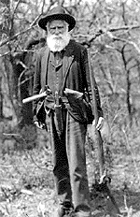
Charity Couch and her husband filed their homestead claim near the South Platte River in western Nebraska nearly twenty years later. Yet, the prairie remained an isolated place. Her WPA interviewer noted:
Mrs. Couch says she scarcely dared step outside the yard because there were so many long horned cattle and there were no neighbors between their place and Ogallala except the old Searle Ranch. There was no school for a year or so as their were no children in the district, and no social gatherings at that time such as church, Sunday school, literary, or dances, as people lived too far apart. There were a few buffalo, deer, antelope and gray wolves, and also large numbers of wild fowl such as prairie chickens, grouse, geese, and ducks.
"Charity B. Couch," Ogallala, Nebraska, November 16, 1938.
American Life Histories, 1936-1940
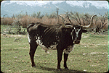
Longhorn Cattle, Ninety-Six Ranch (Home Ranch), Paradise Valley, Nevada,
Carl Fleischhauer, photographer, May 1978.
Prosperous ranchers, the Couch family added to their original homestead, eventually accumulating 1,800 acres. Like farming, successful ranching required hard work and more than a little luck. Nevertheless with ready access to railroads and a rising demand for beef, ranches proliferated across the Plains states. Between 1860 and 1880, cattle in Kansas, Nebraska, Colorado, Wyoming, Montana, and Dakota increased from 130,000 to 4.5 million head.

Document Set D:
Other Hardships
Walking 2,000 miles barefoot--and that was the easy part
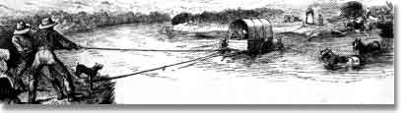

River Crossings
River crossings were a constant source of distress for the pioneers. Hundreds drowned trying to cross the Kansas, North Platte and Columbia Rivers--among others. In 1850 alone, 37 people drowned trying to cross one particularly difficult river--the Green.
Emigrant John B. Hill:
"The ferryman allowed too many passengers to get in the boat, and the water came within two inches of the gunwale. He ordered every man to stand steady as the boat was liable to swamp. When we were nearly across the edge of the boat dipped; I thought the boat would be swamped instantly and drowned the last one of us."
Those who didn't drown were usually fleeced. The charge ranged up to 16 dollars; almost the price of an oxen. One ferry earned $65,000 in just one summer. The emigrants complained bitterly.

Walking
Because most emigrants grossly overloaded their wagons, few could ride inside. Instead most walked--many made the entire 2,000 mile journey on foot.

Accidents
The emigrant wagons didn't have any safety features. If someone fell under the massive wagon wheels, death was instant. Many lost their lives this way. Most often, the victims were children.
Edward Lenox:
"A little boy fell over the front end of the wagon during our journey. In his case, the great wheels rolled over the child's head----crushing it to pieces."

Weather
Great thunderstorms took their toll. A half-dozen emigrants were killed by lightning strikes; many others were injured by hail the size of apples. Pounding rains were especially difficult for the emigrants because there was no shelter on the open plains and the covered wagons eventually leaked.

Cholera
Perhaps the biggest problem on the Trail was a mysterious and deadly disease--called cholera for which there was no cure. Often, an emigrant would go from healthy to dead in just a few hours. Sometimes they received a proper burial, but often, the sick would be abandoned, in their beds, on the side of the trail. They would die alone. Making matters worse were animals that regularly dug up the dead and scattered the trail with human bones and body parts.
Emigrant Agnes Stewart:
"We camped at a place where a woman had been buried and the wolves dug her up.Her hair was there with a comb still in it. She had been buried too shallow. It seems a dreadful fate, but what is the difference? One cannot feel after the spirit is flown."
Cholera killed more emigrants than anything else. In a bad year, some wagon trains lost two-thirds of their people.
Emigrant John Clark:
"One woman and two men lay dead on the grass and some more ready to die. Women and children crying, some hunting medicine and none to be found. With heartfelt sorrow, we looked around for some time until I felt unwell myself. Got up and moved forward one mile, so as to be out of hearing of crying and suffering."

http://www.isu.edu/~trinmich/Hardships.html

Document Set E: Indian Removal
Extract from Andrew Jackson's Seventh Annual Message to Congress
December 7, 1835
The plan of removing the aboriginal people who yet remain within the settled portions of the United States to the country west of the Mississippi River approaches its consummation. It was adopted on the most mature consideration of the condition of this race, and ought to be persisted in till the object is accomplished, and prosecuted with as much vigor as a just regard to their circumstances will permit, and as fast as their consent can be obtained. All preceding experiments for the improvement of the Indians have failed. It seems now to be an established fact they they can not live in contact with a civilized community and prosper. Ages of fruitless endeavors have at length brought us to a knowledge of this principle of intercommunication with them. The past we can not recall, but the future we can provide for. Independently of the treaty stipulations into which we have entered with the various tribes for the usufructuary rights they have ceded to us, no one can doubt the moral duty of the Government of the United States to protect and if possible to preserve and perpetuate the scattered remnants of this race which are left within our borders. In the discharge of this duty an extensive region in the West has been assigned for their permanent residence. It has been divided into districts and allotted among them. Many have already removed and others are preparing to go, and with the exception of two small bands living in Ohio and Indiana, not exceeding 1,500 persons, and of the Cherokees, all the tribes on the east side of the Mississippi, and extending from Lake Michigan to Florida, have entered into engagements which will lead to their transplantation.
The plan for their removal and reestablishment is founded upon the knowledge we have gained of their character and habits, and has been dictated by a spirit of enlarged liberality. A territory exceeding in extent that relinquished has been granted to each tribe. Of its climate, fertility, and capacity to support an Indian population the representations are highly favorable. To these districts the Indians are removed at the expense of the United States, and with certain supplies of clothing, arms, ammunition, and other indispensable articles; they are also furnished gratuitously with provisions for the period of a year after their arrival at their new homes. In that time, from the nature of the country and of the products raised by them, they can subsist themselves by agricultural labor, if they choose to resort to that mode of life; if they do not they are upon the skirts of the great prairies, where countless herds of buffalo roam, and a short time suffices to adapt their own habits to the changes which a change of the animals destined for their food may require. Ample arrangements have also been made for the support of schools; in some instances council houses and churches are to be erected, dwellings constructed for the chiefs, and mills for common use. Funds have been set apart for the maintenance of the poor; the most necessary mechanical arts have been introduced, and blacksmiths, gunsmiths, wheelwrights, millwrights, etc., are supported among them. Steel and iron, and sometimes salt, are purchased for them, and plows and other farming utensils, domestic animals, looms, spinning wheels, cards, etc., are presented to them. And besides these beneficial arrangements, annuities are in all cases paid, amounting in some instances to more than $30 for each individual of the tribe, and in all cases sufficiently great, if justly divided and prudently expended, to enable them, in addition to their own exertions, to live comfortably. And as a stimulus for exertion, it is now provided by law that "in all cases of the appointment of interpreters or other persons employed for the benefit of the Indians a preference shall be given to persons of Indian descent, if such can be found who are properly qualified for the discharge of the duties."
Such are the arrangements for the physical comfort and for the moral improvement of the Indians. The necessary measures for their political advancement and for their separation from our citizens have not been neglected. The pledge of the United States has been given by Congress that the country destined for the residence of this people shall be forever "secured and guaranteed to them." A country west of Missouri and Arkansas has been assigned to them, into which the white settlements are not to be pushed. No political communities can be formed in that extensive region, except those which are established by the Indians themselves or by the Untied States for them and with their concurrence. A barrier has thus been raised for their protection against the encroachment of our citizens, and guarding the Indians as far as possible from those evils which have brought them to their present condition. Summary authority has been given by law to destroy all ardent spirits found in their country, without waiting the doubtful result and slow process of a legal seizure. I consider the absolute and unconditional interdiction of this article among these people as the first and great step in their melioration. Halfway measures will answer no purpose. These can not successfully contend against the cupidity of the seller and the overpowering appetite of the buyer. And the destructive effects of the traffic are marked in every page of the history of our Indian intercourse. . . .
http://www.pbs.org/weta/thewest/resources/archives/two/removal.htm

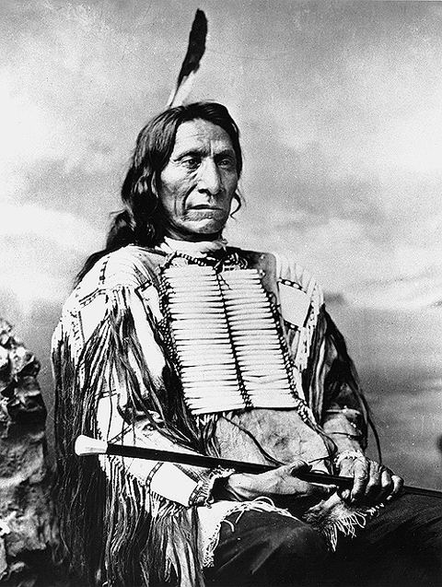
4.10 Red Cloud, a chief of the Oglala Lakota and leader of the 1866 attack on Fort Phil Kearny that ended in the Fetterman Massacre. Red Cloud's successful campaign against United States troops in Montana led to the Fort Laramie Treaty of 1868.
(Courtesy Smithsonian Institution, National Anthropological Archives [#3237-A]. Images from the National Anthropological Archives may not be reproduced without permission.)
http://www.pbs.org/weta/thewest/resources/archives/four/64_10.htm
Document on the Sand Creek Massacre
Congressional Testimony of Mr. John S. Smith
Washington, March 14, 1865
Mr. John S. Smith sworn and examined.
By Mr. Gooch:
Question. Where is your place of residence?
Answer. Fort Lyon, Colorado
Question. What is your occupation?
Answer. United States Indian interpreter and special Indian agent.
Question. Will you state to the committee all that you know in relation to the attack of Colonel Chivington upon the Cheyenne and Arapahoe Indians in November last?
Answer. Major Anthony was in command at Fort Lyon at the time. Those Indians had been induced to remain in the vicinity of Fort Lyon, and were promised protection by the commanding officer at Fort Lyon. The commanding officer saw proper to keep them some thirty or forty miles distant from the fort, for fear of some conflict between them and the soldiers or the traveling population, for Fort Lyon is on a great thoroughfare. He advised them to go out on what is called Sand creek, about forty miles, a little east of north from Fort Lyon. Some days after they had left Fort Lyon when I had just recovered from a long spell of sickness, I was called on by Major S.G. Colley, who asked me if I was able and willing to go out and pay a visit to these Indians, ascertain their numbers, their general disposition toward the whites, and the points where other bands might be located in the interior.
Question. What was the necessity for obtaining that information?
Answer. Because there were different bands which were supposed to be at war; in fact, we knew at the time that they were at war with the white population in that country; but this band had been in and left the post perfectly satisfied. I left to go to this village of Indians on the 26th of November last. I arrived there on the 27th and remained there the 28th. On the morning of the 29th, between daylight and sunrise - nearer sunrise than daybreak - a large number of troops were discovered from three-quarters of a mile to a mile below the village. The Indians, who discovered them, ran to my camp, called me out, and wanted to me to go and see what troops they were, and what they wanted. The head chief of the nation, Black Kettle, and head chief of the Cheyennes, was encamped there with us. Some years previous he had been presented with a fine American flag by Colonel Greenwood, a commissioner, who had been sent out there. Black Kettle ran this American flag up to the top of his lodge, with a small white flag tied right under it, as he had been advised to do in case he should meet with any troops out on the prairies. I then left my own camp and started for that portion of the troops that was nearest the village, supposing I could go up to the m. I did not know but they might be strange troops, and thought my presence and explanations could reconcile matters. Lieutenant Wilson was in command of the detachment to which I tried to make my approach; but they fired several volleys at me, and I returned back to my camp and entered my lodge.
Question. Did these troops know you to be a white man?
Answer. Yes, sir; and the troops that went there knew I was in the village.
Question. Did you see Lieutenant Wilson or were you seen by h im?
Answer. I cannot say I was seen by him; but his troops were the first to fire at me.
Question. Did they know you to be a white man?
Answer. They could not help knowing it. I had on pants, a soldier's overcoat, and a hat such as I am wearing now. I was dressed differently from any Indian in the country. On my return I entered my lodge, not expecting to get out of it alive. I had two other men there with me: one was David Louderbach, a soldier, belonging to company G, lst Colorado cavalry; the other, a man by the name of Watson, who was a hired hand of Mr. DD Coolly, the son of Major Coolly, the agent.
After I had left my lodge to go out and see what was going on, Colonel Chivington rode up to within fifty or sixty yards of where I was camped; he recognized me at once. They all call me Uncle John in that country. He said, "Run here, Uncle John; you are all right." I went to him as fast as I could. He told me to get in between him and his troops, who were then coming up very fast; I did so; directly another officer who knew me - Lieutenant Baldwin, in command of a battery - tried to assist me to get a horse; but there was no loose horse there at the time. He said, "Catch hold of the caisson, and keep up with us."
By this time the Indians had fled; had scattered in every direction. The troops were some on one side of the river and some on the other, following up the Indians. We had been encamped on the north side of the river; I followed along, holding on the caisson, sometimes running, sometimes walking. Finally, about a mile above the village, the troops had got a parcel of the Indians hemmed in under the bank of the river; as soon as the troops overtook them, they commenced firing on them; some troops had got above them, so that they were completely surrounded. There were probably a hundred Indians hemmed in there, men, women, and children; the most of the men in the village escaped.
By the time I got up with the battery to the place where these Indians were surrounded there had been some considerable firing. Four or five soldiers had been killed, some with arrows and some with bullets. The soldiers continued firing on these Indians, who numbered about a hundred, until they had almost completely destroyed them. I think I saw altogether some seventy dead bodies lying there; the greater portion women and children. There may have been thirty warriors, old and young; the rest were women and small children of different ages and sizes.
The troops at that time were very much scattered. There were not over two hundred troops in the main fight, engaged in killing this body of Indians under the bank. The balance of the troops were scattered in different directions, running after small parties of Indians who were trying to make their escape. I did not go so see how many they might have killed outside of this party under the bank of the river. Being still quite weak from my last sickness, I returned with the first body of troops that went back to the camp.
The Indians had left their lodges and property; everything they owned. I do not think more than one-half of the Indians left their lodges with their arms. I think there were between 800 and l,000 men in this command of United States troops. There was a part of three companies of the lst Colorado, and the balance were what were called 100 days men of the 3rd regiment. I am not able to say which party did the most execution on the Indians, because it was very much mixed up at the time.
We remained there that day after the fight. By 11 o'clock, I think, the entire number of soldiers had returned back to the camp where Colonel Chivington had returned. On their return, he ordered the soldiers to destroy all the Indian property there, which they did, with the exception of what plunder they took away with them, which was considerable.
Question. How many Indians were there there?
Answer. There were 100 families of Cheyennes, and some six or eight lodges of Arapahoes.
Question. How many persons in all, should you say?
Answer. About 500 we estimate them at five to a lodge.
Question. 500 men, women and children?
Answer. Yes, sir.
Question. Do you know the reason for that attack on the Indians?
Answer. I do not know any exact reason. I have heard a great many reasons given. I have heard that that whole Indian war had been brought on for selfish purposes. Colonel Chivington was running for Congress in Colorado, and there were other things of that kind; and last spring a year ago he was looking for an order to go to the front, and I understand he had this Indian war in view to retain himself and his troops in that country, to carry out his electioneering purposes.
Question. In what way did this attack on the Indians further the purpose of Colonel Chivington?
Answer. It was said - I did not hear him say it myself, but it was said that he would do something; he had this regiment of three-months men, and did not want them to go out without doing some service. Now he had been told repeatedly by different persons - by myself, as well as others - where he could find the hostile bands.
The same chiefs who were killed in this village of Cheyennes had been up to see Colonel Chivington in Denver but a short time previous to this attack. He himself told them that he had no power to treat with them; that he had received telegrams from General Curtis directing him to fight all Indians he met with in that country. Still he would advise them, if they wanted any assistance from the whites, to go to their nearest military post in their country, give up their arms and the stolen property, if they had any, and then they would receive directions in what way to act. This was told them by Colonel Chivington and by Governor Evans, of Colorado. I myself interpreted for them and for the Indians.
Question. Did Colonel Chivington hold any communciation with these Indians, or any of them, before making the attack upon them?
Answer. No, sir, not then. He had some time previously held a council with them at Denver city. When we first recovered the white prisoners from the Indians, we invited some of the chiefs to go to Denver, inasmuch as they had sued for peace, and were willing to give up these white prisoners. We promised to take the chiefs to Denver, where they had an interview with men who had more power than Major Wynkoop had, who was the officer in command of the detachment that went out to recover these white prisoners. Governor Evans and Colonel Chivington were in Denver, and were present at this council. They told the Indians to return with Major Wynkoop, and whatever he agreed on doing with them would be recognized by them.
I returned with the Indians to Fort Lyon. There we let them go out to their villages to bring in their families, as they had been invited through the proclamation or circular of the governor during the month of June, I think. They were gone some twelve or fifteen days from Fort Lyon, and then they returned with their families. Major Wynkoop had made them one or two issues of provisions previous to the arrival of Major Anthony there to assume command. Then Major Wynkoop, who is now in command at Fort Lyon, was ordered to Fort Leavenworth on some business with General Curtis, I think.
Then Major Anthony, through me, told the Indians that he did not have it in his power to issue rations to them, as Major Wynkoop had done. He said that he had assumed command at Fort Lyon, and his orders were positive from headquarters to fight the Indians in the vicinity of Fort Lyon, or at any other point in the Territory where they could find them. He said that he had understood that they had been behaving very badly. But on seeing Major Wynkoop and others there at Fort Lyon, he was happy to say that things were not as had been presented, and he could not pursue any other course than that of Major Wynkoop except the issuing rations to them. He then advised them to out to some near point, where there was buffalo, not too far from Fort Lyon or they might meet with troops from the Platte, who would not know them from the hostile bands. This was the southern band of Cheyennes; there is another band called the northern band. They had no apprehensions in the world of any trouble with the whites at the time this attack was made.
Question. Had there been, to your knowledge, any hostile act or demonstration on the part of these Indians or any of them?
Answer. Not in this band. But the northern band, the band known by the name of Dog soldiers of Cheyennes, had committed many depredations on the Platte.
Question. Do you know whether or not Colonel Chivington knew the friendly character of these Indians before he made the attack upon them?
Answer. It is my opinion that he did.
Question. On what is that opinion based?
Answer. On this fact, that he stopped all persons from going on ahead of him. He stopped the mail, and would not allow any person to go on ahead of him at the time he was on his way from Denver city to Fort Lyon. He placed a guard around old Colonel Bent, the former agent there; he stopped a Mr. Hagues and many men who were on their way to Fort Lyon. He took the fort by surprise, and as soon as he got there he posted pickets all around the fort, and then left at 8 o'clock that night for this Indian camp.
Question. Was that anything more than the exercise of ordinary precaution in following Indians?
Answer. Well, sir, he was told that there were no Indians in the vicinity of Fort Lyon, except Black Kettle's band of Cheyennes and Left Hand's band of Arapahoes.
Question. How do you know that?
Answer. I was told so.
By Mr. Buckalew:
Question. Do you know it of your own knowledge?
Answer. I cannot say I do.
Question. You did not talk with him about it before the attack?
Answer. No, sir.
By Mr. Gooch:
Question. When you went out to him, you had no opportunity to hold intercourse with him?
Answer. None whatever; he had just commenced his fire against the Indians.
Question. Did you have any communication with him at any time while there?
Answer. Yes, sir.
Question. What was it?
Answer. He asked me many questions about a son of mine, who was killed there afterwards. He asked me what Indians were there, what chiefs; and I told him as fully as I knew.
By Mr. Buckalew:
Question. When did you talk with him?
Answer. On the day of the attack. He asked me many questions about the chiefs who were there, and if I could recognize them if I saw them. I told him it was possible I might recollect the principal chiefs. They were terribly mutilated, lying there in the water and sand; most of them in the bed of the creek, dead and dying, making many struggles. They were so badly mutilated and covered with sand and water that it was very hard for me to tell one from another. However, I recognized some of them - among them the chief One Eye, who was employed by our government at $125 a month and rations to remain in the village as a spy. There was another called War Bonnet, who was here two years ago with me. There was another by the name of Standing-in-the-Water, and I supposed Black Kettle was among them, but it was not Black Kettle. There was one there of his size and dimensions in every way, but so tremendously mutilated that I was mistaken in him. I went out with Lieutenant Colonel Bowen, to see how many I could recognize.
By Mr. Gooch:
Question: Did you tell Colonel Chivington the character and disposition of these Indians at any time during your interviews on this day?
Answer. Yes, sir.
Question. What did he say in reply?
Answer. He said he could not help it; that his orders were positive to attack the Indians.
Question. From whom did he receive these orders?
Answer. I do not know; I presume from General Curtis.
Question. Did he tell you?
Answer. Not to my recollection.
Question. Were the women and children slaughtered indiscriminately, or only so far as they were with the warriors?
Answer. Indiscriminately.
Question. Were there any acts of barbarity perpetrated there that came under your own observation?
Answer. Yes, sir; I saw the bodies of those lying there cut all to pieces, worse mutilated than any I ever saw before; the women cut all to pieces.
By Mr. Buckalew:
Question. How cut?
Answer. With knives; scalped; their brains knocked out; children two or three months old; all ages lying there, from sucking infants up to warriors.
By Mr. Gooch:
Question. Did you see it done?
Answer. Yes, sir; I saw them fall.
Question. Fall when they were killed?
Answer. Yes, sir.
Question. Did you see them when they were mutilated?
Answer. Yes, sir.
Question. By whom were they mutilated?
Answer. By the United States troops.
Question. Do you know whether or not it was done by the direction or consent of any of the officers.
Answer. I do not; I hardly think it was.
By Mr. Buckalew:
Question. What was the date of that massacre?
Answer. On the 29th of November last.
Question. Did you speak of these barbarities to Colonel Chivington?
Answer. No sir; I had nothing at all to say about it, because at that time they were hostile towards me, from the fact of my being there. They probably supposed that I might be compromised with them in some way or other.
Question. Who called on you to designate the bodies of those who were killed?
Answer. Colonel Chivington himself asked me if I would ride out with Lieutenant Colonel Bowen, and see how many chiefs or principal men I could recognize.
Question. Can you state how many Indians were killed - how many women and how many children?
Answer. Perhaps one-half were men, and the balance were women and children. I do not think that I saw more than 70 lying dead then, as far as I went. But I saw parties of men scattered in every direction, pursuing little bands of Indians.
Question. What time of day or night was this attack made?
Answer. The attack commenced about sunrise, and lasted until between 10 and 11 o'clock.
Question. How large a body of troops?
Answer. I think that probably there may have been about 60 or 70 warriors who were armed and stood their ground and fought. Those that were unarmed got out of the way as they best could.
Question. How many of our troops were killed and how many wounded?
Answer. There were ten killed on the ground, and thirty-eight wounded; four of the wounded died at Fort Lyon before I came on east.
Question. Were there any other barbarities or atrocities committed there other than those you have mentioned, that you saw?
Answer. Yes, sir; I had a half-breed son there, who gave himself up. He started at the time the Indians fled; being a half-breed he had but little hope of being spared, and seeing them fire at me, he ran away with the Indians for the distance of about a mile. During the fight up there he walked back to my camp and went into the lodge. It was surrounded by soldiers at the time. He came in quietly and sat down; he remained there that day, that night, and the next day in the afternoon; about four o'clock in the evening, as I was sitting inside the camp, a soldier came up outside of the lodge and called me by name. I got up and went out; he took me by the arm and walked towards Colonel Chivington's camp, which was about sixty yards from my camp. Said he, "I am sorry to tell you, but they are going to kill your son Jack." I knew the feeling towards the whole camp of Indians, and that there was no use to make any resistance. I said, "I can't help it." I then walked on towards where Colonel Chivington was standing by his camp-fire; when I had got within a few feet of him I heard a gun fired, and saw a crowd run to my lodge, and they told me that Jack was dead.
Question. What action did Colonel Chivington take in regard to that matter?
Answer. Major Anthony, who was present, told Colonel Chivington that he had heard some remarks made, indicating that they were desirous of killing Jack; and that he (Colonel Chivington) had it in his power to save him, and that by saving him he might make him a very useful man, as he was well acquainted with all the Cheyenne and Arapahoe country, and he could be used as a guide or interpreter. Colonel Chivington replied to Major Anthony, as the Major himself told me, that he had no orders to receive and no advice to give. Major Anthony is now in this city.
By Mr. Buckalew:
Question. Did Chivington say anything to you, or you to him about the firing?
Answer. Nothing directly; there were a number of officers sitting around the fire, with the most of whom I was acquainted.
By Mr. Gooch:
Question. Were there any other Indians or half-breeds there at that time?
Answer. Yes, sir; Mr. Bent had three sons there; one employed as a guide for these troops at the time, and two others living there in the village with the Indians; and a Mr. Gerry had a son there.
Question. Were there any other murders after the first day's massacre?
Answer. There was none, except of my son.
Question. Were there any other atrocities which you have no mentioned?
Answer. None that I saw myself. There were two women that white men had families by ; they were saved from the fact of being in my lodge at the time. One ran to my lodge; the other was taken prisoner by a soldier who knew her and brought her to my lodge for safety. They both had children. There were some small children, six or seven years old, who were taken prisoners near the camp. I think there were three of them taken to Denver with these troops.
Question. Were the women and children that were killed, killed during the fight with the Indians?
Answer. During the fight, or during the time of the attack.
Question. Did you see any women or children killed after the fight was over?
Answer. None.
Question. Did you see any Indians killed after the fight was over?
Answer. No, sir.
By Mr. Buckalew:
Question. Were the warriors and women and children all huddled together when they were attacked?
Answer. They started and left the village altogether, in a body, trying to escape.
By Mr. Gooch:
Question. Do you know anything as to the amount of property that those Indians had there?
Answer. Nothing more than their horses. They were supposed to own ten horses and mules to a lodge; that would make about a thousand head of horses and mules in that camp. The soldiers drove off about six hundred head.
Question. Had they any money?
Answer. I understood that some of the soldiers found some money, but I did not see it. Mr. D. D. Colley had some provisions and goods in the village at the time, and Mr. Louderback and Mr. Watson were employed by him to trade there. I was to interpret for them, direct them, and see that they were cared for in the village. They had traded for one hundred and four buffalo robes, one fine mule, and two horses. This was all taken away from them. Colonel Chivington came to me and told me that I might rest assured that he would see the goods paid for. He had confiscated these buffalo robes for the dead and wounded; and there was also some sugar and coffee and tea taken for the same purpose.
I would state that in his report Colonel Chivington states that after this raid on Sand creek against the Cheyenne and Arapahoe Indians he traveled northeast some eighty miles in the direction of some hostile bands of Sioux Indians. Now that is very incorrect, according to my knowledge of matters; I remained with Colonel Chivington's camp, and returned on his trail towards Fort Lyon from the camp where he made this raid. I went down with him to what is called the forks of the Sandy. He then took a due south course for the Arkansas river, and I went to Fort Lyon with the killed and wounded, and an escort to take us in. Colonel Chivington proceeded down the Arkansas river, and got within eleven miles of another band of Arapahoe Indians, but did not succeed in overtaking them. He then returned to Fort Lyon, re-equipped, and started immediately for Denver.
Question. Have you spent any considerable portion of your life with the Indians?
Answer. The most of it.
Question. How many years have you been with the Indians?
Answer. I have been twenty-seven successive years with the Cheyennes and Arapahoes. Before that I was in the country as a trapper and hunter in the Rocky mountains.
Question. For how long time have you acted as Indian interpreter?
Answer. For some fifteen or eighteen years.
Question. By whom have you been so employed?
Answer. By Major Fitzpatrick, Colonel Bent, Major Colley, Colonel J.W. Whitfield, and a great deal of the time for the military as guide and interpreter.
By Mr. Buckalew:
Question. How many warriors were estimated in Colonel Chivington's report as having been in this Indian camp?
Answer. About nine hundred.
Question. How many were there?
Answer. About two hundred warriors; they average about two warriors to a lodge, and there were about one hundred lodges.
http://www.pbs.org/weta/thewest/resources/archives/four/sandcrk.htm

Chief Joseph Speaks
Selected Statements and Speeches
by the Nez Percé Chief
I.
The first white men of your people who came to our country were named Lewis and Clark. They brought many things which our people had never seen. They talked straight and our people gave them a great feast as proof that their hearts were friendly. They made presents to our chiefs and our people made presents to them. We had a great many horses of which we gave them what they needed, and they gave us guns and tobacco in return. All the Nez Perce made friends with Lewis and Clark and agreed to let them pass through their country and never to make war on white men. This promise the Nez Perce have never broken.
II.
For a short time we lived quietly. But this could not last. White men had found gold in the mountains around the land of the Winding Water. They stole a great many horses from us and we could not get them back because we were Indians. The white men told lies for each other. They drove off a great many of our cattle. Some white men branded our young cattle so they could claim them. We had no friends who would plead our cause before the law councils. It seemed to me that some of the white men in Wallowa were doing these things on purpose to get up a war. They knew we were not stong enough to fight them. I labored hard to avoid trouble and bloodshed. We gave up some of our country to the white men, thinking that then we could have peace. We were mistaken. The white men would not let us alone. We could have avenged our wrongs many times, but we did not. Whenever the Government has asked for help against other Indians we have never refused. When the white men were few and we were strong we could have killed them off, but the Nez Perce wishes to live at peace.
On account of the treaty made by the other bands of the Nez Perce the white man claimed my lands. We were troubled with white men crowding over the line. Some of them were good men, and we lived on peaceful terms with them, but they were not all good. Nearly every year the agent came over from Lapwai and ordered us to the reservation. We always replied that we were satisfied to live in Wallowa. We were careful to refuse the presents or annuities which he offered.
Through all the years since the white man came to Wallowa we have been threatened and taunted by them and the treaty Nez Perce. They have given us no rest. We have had a few good friends among the white men, and they have always advised my people to bear these taunts without fighting. Our young men are quick tempered and I have had great trouble in keeping them from doing rash things. I have carried a heavy load on my back ever since I was a boy. I learned then that we were but few while the white men were many, and that we could not hold our own with them. We were like deer. They were like grizzly bears. We had a small country. Their country was large. We were contented to let things remain as the Great Spirit Chief made them. They were not; and would change the mountains and rivers if they did not suit them.
III.
[At his surrender in the Bear Paw Mountains, 1877]
Tell General Howard that I know his heart. What he told me before I have in my heart. I am tired of fighting. Our chiefs are killed. Looking Glass is dead, Tu-hul-hil-sote is dead. the old men are all dead. It is the young men who now say yes or no. He who led the young men [Joseph's brother Alikut] is dead. It is cold and we have no blankets. The little children are freezing to death. My people -- some of them have run away to the hills and have no blankets and no food. No one knows where they are -- perhaps freezing to death. I want to have time to look for my children and see how many of them I can find. Maybe I shall find them among the dead. Hear me, my chiefs, my heart is sick and sad. From where the sun now stands I will fight no more against the white man.
IV.
[On a visit to Washington, D.C., 1879]
At last I was granted permission to come to Washington and bring my friend Yellow Bull and our interpreter with me. I am glad I came. I have shaken hands with a good many friends, but there are some things I want to know which no one seems able to explain. I cannot understand how the Government sends a man out to fight us, as it did General Miles, and then breaks his word. Such a government has something wrong about it. I cannot understand why so many chiefs are allowed to talk so many different ways, and promise so many different things. I have seen the Great Father Chief [President Hayes]; the Next Great Chief [Secretary of the Interior]; the Commissioner Chief; the Law Chief; and many other law chiefs [Congressmen] and they all say they are my friends, and that I shall have justice, but while all their mouths talk right I do not understand why nothing is done for my people. I have heard talk and talk but nothing is done. Good words do not last long unless they amount to something. Words do not pay for my dead people. They do not pay for my country now overrun by white men. They do not protect my father's grave. They do not pay for my horses and cattle. Good words do not give me back my children. Good words will not make good the promise of your war chief, General Miles. Good words will not give my people a home where they can live in peace and take care of themselves. I am tired of talk that comes to nothing. It makes my heart sick when I remember all the good words and all the broken promises. There has been too much talking by men who had no right to talk. Too many misinterpretations have been made; too many misunderstandings have come up between the white men and the Indians. If the white man wants to live in peace with the Indian he can live in peace. There need be no trouble. Treat all men alike. Give them the same laws. Give them all an even chance to live and grow. All men were made by the same Great Spirit Chief. They are all brothers. The earth is the mother of all people, and all people should have equal rights upon it. You might as well expect all rivers to run backward as that any man who was born a free man should be contented penned up and denied liberty to go where he pleases. If you tie a horse to a stake, do you expect he will grow fat? If you pen an Indian up on a small spot of earth and compel him to stay there, he will not be contented nor will he grow and prosper. I have asked some of the Great White Chiefs where they get their authority to say to the Indian that he shall stay in one place, while he sees white men going where they please. They cannot tell me.
I only ask of the Government to be treated as all other men are treated. If I cannot go to my own home, let me have a home in a country where my people will not die so fast. I would like to go to Bitter Root Valley. There my people would be happy; where they are now they are dying. Three have died since I left my camp to come to Washington.
When I think of our condition, my heart is heavy. I see men of my own race treated as outlaws and driven from country to country, or shot down like animals.
I know that my race must change. We cannot hold our own with the white men as we are. We only ask an even chance to live as other men live. We ask to be recognized as men. We ask that the same law shall work alike on all men. If an Indian breaks the law, punish him by the law. If a white man breaks the law, punish him also.
Let me be a free man, free to travel, free to stop, free to work, free to trade where I choose, free to choose my own teachers, free to follow the religion of my fathers, free to talk, think and act for myself -- and I will obey every law or submit to the penalty.
Whenever the white man treats the Indian as they treat each other then we shall have no more wars. We shall be all alike -- brothers of one father and mother, with one sky above us and one country around us and one government for all. Then the Great Spirit Chief who rules above will smile upon this land and send rain to wash out the bloody spots made by brothers' hands upon the face of the earth. For this time the Indian race is waiting and praying. I hope no more groans of wounded men and women will ever go to the ear of the Great Spirit Chief above, and that all people may be one people.
Hin-mah-too-yah-lat-kekht has spoken for his people.
[TEXT: Chester Anders Fee, Chief Joseph: The Biography of a Great Indian, Wilson-Erickson, 1936.]

The Dawes Act
February 8, 1887
(U. S. Statutes at Large, Vol. XXIV, p. 388 ff.)
[Congressman Henry Dawes, author of the act, once expressed his faith in the civilizing power of private property with the claim that to be civilized was to "wear civilized clothes...cultivate the ground, live in houses, ride in Studebaker wagons, send children to school, drink whiskey [and] own property."]
An act to provide for the allotment of lands in severalty to Indians on the various reservations, and to extend the protection of the laws of the United States and the Territories over the Indians, and for other purposes.
Be it enacted, That in all cases where any tribe or band of Indians has been, or shall hereafter be, located upon any reservation created for their use, either by treaty stipulation or by virtue of an act of Congress or executive order setting apart the same for their use, the President of the United States be, and he hereby is, authorized, whenever in his opinion any reservation or any part thereof of such Indians is advantageous for agricultural and grazing purposes to cause said reservation, or any part thereof, to be surveyed, or resurveyed if necessary, and to allot the lands in said reservations in severalty to any Indian located thereon in quantities as follows:
To each head of a family, one-quarter of a section;
To each single person over eighteen years of age, one-eighth of a section;
To each orphan child under eighteen years of age, one-eighth of a section; and,
To each other single person under eighteen years now living, or who may be born prior to the date of the order of the President directing an allotment of the lands embraced in any reservation, one-sixteenth of a section; . . .
...
SEC. 5. That upon the approval of the allotments provided for in this act by the Secretary of the Interior, he shall . . . declare that the United States does and will hold the land thus allotted, for the period of twenty-five years, in trust for the sole use and benefit of the Indian to whom such allotment shall have been made, . . . and that at the expiration of said period the United States will convey the same by patent to said Indian, or his heirs as aforesaid, in fee, discharged of such trust and free of all charge or encumbrance whatsoever: . . .
SEC. 6. That upon the completion of said allotments and the patenting of the lands to said allottees, each and every member of the respective bands or tribes of Indians to whom allotments have been made shall have the benefit of and be subject to the laws, both civil and criminal, of the State or Territory in which they may reside; . . .And every Indian born within the territorial limits of the United States to whom allotments shall have been made under the provisions of this act, or under any law or treaty, and every Indian born within the territorial limits of the United States who has voluntarily taken up, within said limits, his residence separate and apart from any tribe of Indians therein, and has adopted the habits of civilized life, is hereby declared to be a citizen of the United States, and is entitled to all the rights, privileges, and immunities of such citizens, whether said Indian has been or not, by birth or otherwise, a member of any tribe of Indians within the territorial limits of the United States without in any manner impairing or otherwise affecting the right of any such Indian to tribal or other property. . . .
http://www.pbs.org/weta/thewest/resources/archives/eight/dawes.htm

Document Set F:
The Gold Rush, Transcontinental Railroad, and Chinese Immigrants

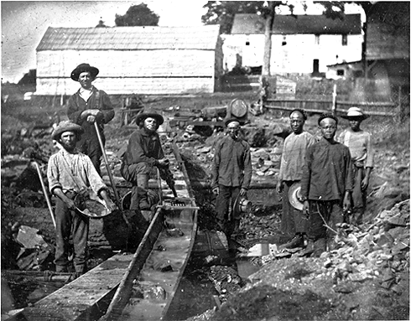
3.2 White and Chinese miners hoping to strike it rich during the California Gold Rush at Auburn Ravine in 1852.
(California State Library [Daguerreotype collection #912])http://www.pbs.org/weta/thewest/resources/archives/three/63_02.htm
Railroad, showing method of splicing rails. National Archive.

arge-scale Chinese immigration to the United States began in the late 1840s, when news of the discovery of gold in California reached the Far East. In 1851, nearly 3,000 Chinese traveled to California. In 1852, more than 20,000 arrived. For the next twenty years, Chinese immigrants arrived at a rate of more than 9,000 per year. After the Gold Rush, Chinese communities sprang up in urban areas not only in California, but in Oregon, Nevada, Idaho, Washington, and Montana. By 1883, the year in which FRONTIER HOUSE is set, there were over 100,000 Chinese men and 6,000 Chinese women living West of the Mississippi.
Initially, the U.S. welcomed the Chinese. An early governor of California proclaimed the Chinese, "one of the most worthy classes of our newly adopted citizens." Many of the early Chinese in the West intended to quickly return to their native country. Like others who headed to the gold fields of California, Chinese immigrants believed they would "strike it rich," and return to their homes and families in China to live out their lives in luxury. Their goal of returning home, and an adherence to their native language and culture, distanced the Chinese from other immigrants who came as permanent residents, and provided a rhetorical weapon used to exclude them from other rights and privileges.
In 1871, 20 Chinese immigrants were killed in a single riot in Los Angeles. In 1885, 28 were killed in a riot in Rock Springs, Wyoming.

Soon, Americans of European descent viewed the Chinese as competing for the California gold. Hostility grew. The state began imposing a "foreign miner's tax" of more than $20 a month to Chinese workers. Mining camps posted notices threatening the Chinese with beatings and death unless they abandoned their claims. A popular miner's song of the day summarizes the naked racism of the Gold Rush:
"John Chinaman, John Chinaman, but five short years ago,
I welcomed you from Canton,
and I wish I hadn't so.
I imagined that the truth, John,
you'd speak while under oath.
But I find you lie and steal and cheat.
Yes, John, you're up to boat.
I thought of rats and puppies, John,
you'd eaten your last fill;
But on such slimy pot pies
I'm told you dinner still.
Yes, John, I've been deceived by you,
and all your thieving clan,
for our gold is all your after, John,
to get it as you can."
Chinese immigrants found themselves forced into low-paying service trades. In California, with its incredibly small population of females, Chinese immigrants took jobs considered to be "women's work," such as doing laundry, cooking, and working as servants. In the clearly defined sex roles of the mid-19th century, Chinese men were seen as an weaklings, failures, and aberrations.
In 1865, the slowly progressing Central Pacific Railroad decided to employ Chinese workers to assist in the completion of the transcontinental railroad. Crew chiefs assigned Chinese workers to the most dangerous tasks, including boring tunnels and blasting mountainsides, and paid them lower wages than other workers. To the surprise and delight of railroad executives, the Chinese proved themselves to be remarkably good laborers. One journalist commented, "They do not drink or fight or strike É and it is always said of them that they are very cleanly in their habits. It is the custom among them, after they have had their suppers every evening, to bathe with the help of small tubs. I doubt if the white laborers do as much."
At the height of construction, more than 90 percent of the Central Pacific's workforce -- over 12,000 workers -- were Chinese. When the railroad was completed, and stood as one of the greatest engineering feats of its time, almost none of the Chinese workers were invited to participate in the opening ceremonies. Yet, for every new railroad built in the West, including the Northern Pacific, companies recruited and utilized Chinese workers.
During the 1860s and 1870s, Chinese immigration increased as labor contractors brought workers to the United States for specific projects, the most common being railroad building. These immigrants often bought their tickets on credit, and agreed to a sort of indentured servitude, where they had to work to pay off their debts. Railroad work appealed to merchant creditors by providing their indentured immigrants steady, guaranteed employment. By placing Chinese immigrants in railroad jobs, creditors received a constant return on their investments. Historian Gunther Barth noted that this arrangement "furnished the mass of [Chinese] sojourners with compensation high enough to perpetuate their dreams of success, yet small enough to secure continuing dependence."
Anti-Chinese sentiment continued to grow throughout the 1870s and 1880s. The Panic of 1873 stirred discontent among the working classes, and the Chinese, who worked for low wages and refused to unionize with non-Chinese workers, became perfect scapegoats for the slumping economy. Enraged workers killed Chinese immigrants in riots across the West. State legislatures in Oregon and California opposed the 15th Amendment, which gave African-Americans the right to vote, because they feared it would also protect the Chinese. Boycotts and threats forced Chinese business owners to abandon their shops. In 1882, Congress passed the Chinese Exclusion Act, which gave Chinese immigrants permanent alien status, and barred them from becoming American citizens. Immigration from China ceased, and immigrants already in the United States had to prove their worth to prevent deportation.
And what of the railroads, which the Chinese worked so laboriously to complete? While they certainly linked the West to the more civilized parts of the country, increased migration, and stimulated business, they did not necessarily prove to be the saviors settlers expected. The bumper crops promised in Jay Cooke's "Banana Belt" never materialized, land sales decreased, and in 1893, the company that built the Northern Pacific declared bankruptcy. Though later reorganized, the Northern Pacific -- and many other railroads -- faced the same cycles of boom and bust confronted by all those who attempted to conquer the West.

Documents on Anti-Chinese Immigration Policy

I.

Treaty Regulating Immigration from China
November 17, 1880
(Malloy, ed. Treaties, Conventions, etc. Vol. I, p. 237 ff.)
. . . Whereas the Government of the United States, because of the constantly increasing immigration of Chinese laborers to the territory of the United States, and the embarrassments consequent upon such immigration, now desires to negotiate a modification of the existing Treaties which shall not be in direct contravention of their spirit: . . .
ART. I. Whenever in the opinion of the Government of the United States, the coming of Chinese laborers to the United States, or their residence therein, affects or threatens to affect the interests of that country, or to endanger the good order of the said country or of any locality within the territory thereof, the Government of China agrees that the Government of the United States may regulate, limit, or suspend such coming or residence, buy may not absolutely prohibit it. The limitation or suspension shall be reasonable and shall apply only to Chinese who may go to the United States as laborers, other classes not being included in the limitations. Legislation taken in regard to Chinese laborers will be of such a character only as is necessary to enforce the regulation, limitation or suspension of immigration, and immigrants shall not be subject to personal maltreatment or abuse.
ART. II. Chinese subjects, whether proceeding to the United States as teachers, students, merchants, or from curiosity, together with their body and household servants, and Chinese laborers who are now in the United States, shall be allowed to go and come of their own free will and accord, and shall be accorded all the rights, privileges, immunities and exemptions which are accorded to the citizens and subjects of the most favored nation.
ART. III. If Chinese laborers, or Chinese of any other class, now either permanently or temporarily residing in the territory of the United States, meet with ill treatment at the hands of nay other persons, the Government of the United States will exert all its power to devise measures for their protection and to secure to them the same rights, privileges, immunities and exemptions as may be enjoyed by the citizens or subjects of the most favored nation, and to which they are entitled by treaty . . .
II.

Chinese Exclusion Act
May 6, 1882
(U. S. Statutes at Large, Vol. XXII, p. 58 ff.)
An act to execute certain treaty stipulations relating to Chinese.
WHEREAS, in the opinion of the Government of the United States the coming of Chinese laborers to this country endangers the good order of certain localities within the territory thereof: Therefore,
Be it enacted, That from and after the expiration of ninety days next after the passage of this act, and until the expiration of ten years next after the passage of this act, the coming of Chinese laborers to the Untied States be, . . . suspended; and during such suspension it shall not be lawful for any Chinese laborer to come, or, having so come after the expiration of said ninety days, to remain within the United States.
SEC. 2. That the master of any vessel who shall knowingly bring within the United States on such vessel, and land or permit to be landed, any Chinese laborer, from any foreign port or place, shall be deemed guilty of a misdemeanor, and on conviction thereof shall be punished by a fine of not more than five hundred dollars for each and every such Chinese laborer so brought, and may be also imprisoned for a term not exceeding one year.
SEC. 3. That the two foregoing sections shall not apply to Chinese laborers who were in the United States on the seventeenth day of November, eighteen hundred and eighty, or who shall have come into the same before the expiration of ninety days next after the passage of this act, . . .
SEC. 6. That in order to the faithful execution of articles one and two of the treaty in this act before mentioned, every Chinese person other than a laborer who may be entitled by said treaty and this act to come within the United States, and who shall be about to come to the United States, shall be identified as so entitled by the Chinese Government in each case, such identity to be evidenced by a certificate issued under the authority of said government, which certificate shall be in the English language or (if not in the English language) accompanied by a translation into English, stating such right to come, and which certificate shall state the name, title, or official rank, if any, the age, height, and all physical peculiarities former and present occupation or profession and place of residence in China of the person to whom the certificate is issued and that such person is entitled conformably to the treaty in this act mentioned to come within the Untied States. . . .
SEC. 12. That no Chinese person shall be permitted to enter the United States by land without producing to the proper office of customs the certificate in this act required of Chinese persons seeking to land from a vessel. Any any Chinese person found unlawfully within the United States shall be caused to be removed therefrom to the country from whence he came, by direction of the President of the United States, and at the cost of the United States, after being brought before some justice, judge, or commissioner of a court of the United States and found to be one not lawfully entitled to be or remain in the United States.
SEC. 13. That this act shall not apply to diplomatic and other officers of the Chinese Government traveling upon the business of that government, whose credentials shall be taken as equivalent to the certificate in this act mentioned, and shall exempt them and their body and household servants from the provisions of this act as to other Chinese persons.
SEC. 14. That hereafter no State court or court of the United States shall admit Chinese to citizenship; and all laws in conflict with this act are hereby repealed.
SEC. 15. That the words "Chinese laborers," whenever used in this act, shall be construed to mean both skilled and unskilled laborers and Chinese employed in mining.

Document Set G: Pioneer Images

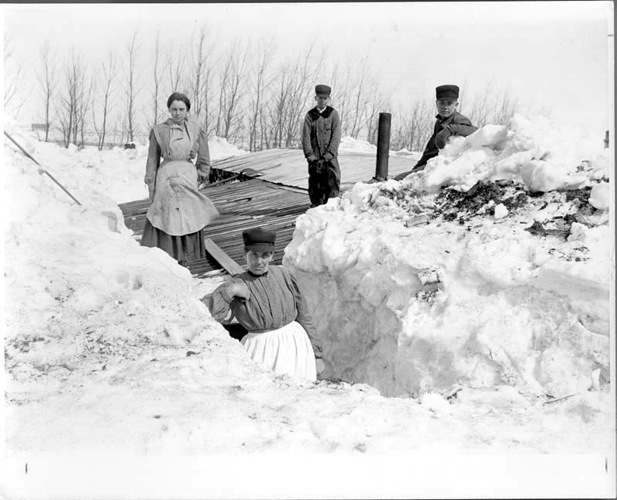
Digging out after a three-day snowstorm about 1913. McCarthy, John, 1861- photographer. CREATED/PUBLISHED
[1913?] SUMMARY
Two women and two men on roof of wooden house of James Ward of Milton, N.D., having dug out from entrance after snowstorm. Snow is higher than roof of house. A shovel and stovepipe are visible. In the background is a line of trees.
http://memory.loc.gov/cgi-bin/query/D?ngp:10:./temp/~ammem_Hrfn::
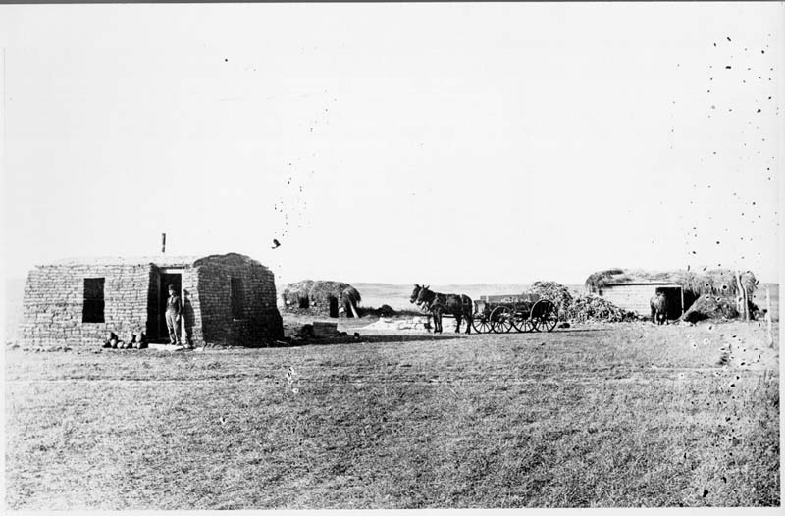
Sullivan homestead, 2 miles n.w. of Dog Ear Lake, Winner, South Dakota : fall of 1909. CREATED/PUBLISHED 1909. SUMMARY
Homestead showing sod house with man in doorway, sod outbuilding with hay on roof, stable with hay on roof and horse outside. Also shows two mules (?) hitched to wagon. Sod outbuilding appears to have weights tied to rope to hold hay down on roof. Sod house has stove pipe and two windows.
http://memory.loc.gov/cgi-bin/query/D?ngp:5:./temp/~ammem_4oEo::
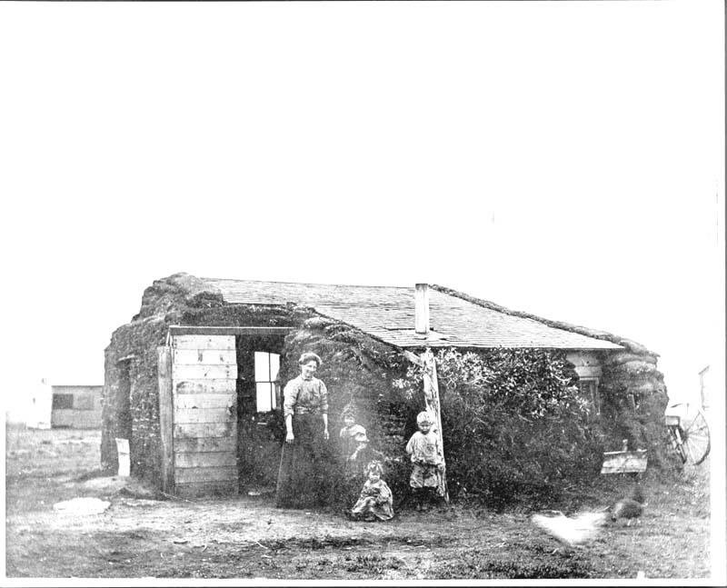
By their sod house on the homestead in Bottineau County, near Westhope, North Dakota. CREATED/PUBLISHED[190-?] SUMMARY
Mrs. John Talcott (Annie Carlson) and daughter Ruth (now Mrs. George Sandy, Park River, N.D.), unidentified son, and daughter Hope (Mrs. Ted Vedvig, Carpio, N.D.). Homestead is 9 miles west and 2 miles south of Westhope in Bentinck Township. Sod house with a shingled roof, and wooden walls with sod stacked up against the sides. Three windows, a doorway, and a stovepipe are visible. A heavy wooden beam is a support for the roof. There is a wooden building in the background, (a barn?). Image is blurry in areas.
http://memory.loc.gov/cgi-bin/query/D?ngp:7:./temp/~ammem_4oEo::
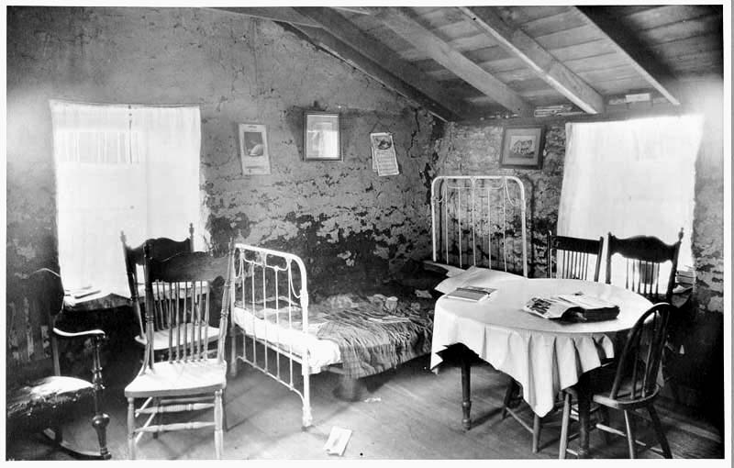
Interior of Elling O[h]nstad sod house, Fairdale, North Dakota, June 24, 1923. CREATED/PUBLISHED[1923] SUMMARY
Interior of a sod house, with two curtained windows showing, and a patch-work quilt on a metal frame bed. There is a book (face down) and a mail-order catalog on a round table with a tablecloth. There are also books in and above (in the rafters) a window, and a calendar. There are six wooden chairs, a wooden floor, and three pictures on the wall. http://memory.loc.gov/cgi-bin/query/D?ngp:11:./temp/~ammem_Hrfn::
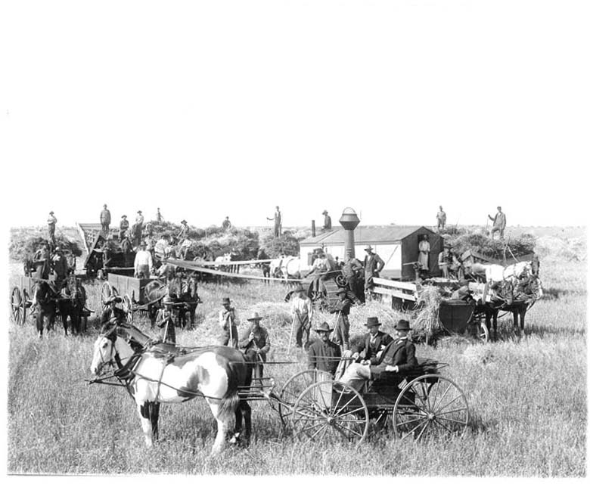
John McKay threshing outfit, Milton, North Dakota : showing the threshing rig, the crew, the cook car, the man cook, and visitors, halting long enough to have their pictures taken. McCarthy, John, 1861- photographer.
CREATED/PUBLISHED [190-?]
SUMMARY A threshing scene with about thirty-six men and eighteen horses pictured. In the foreground there are two well-dressed men in a buggy. Behind them are men standing with pitchforks, men standing in grain wagons, a steam engine, cook car, threshing machine, and several hay racks
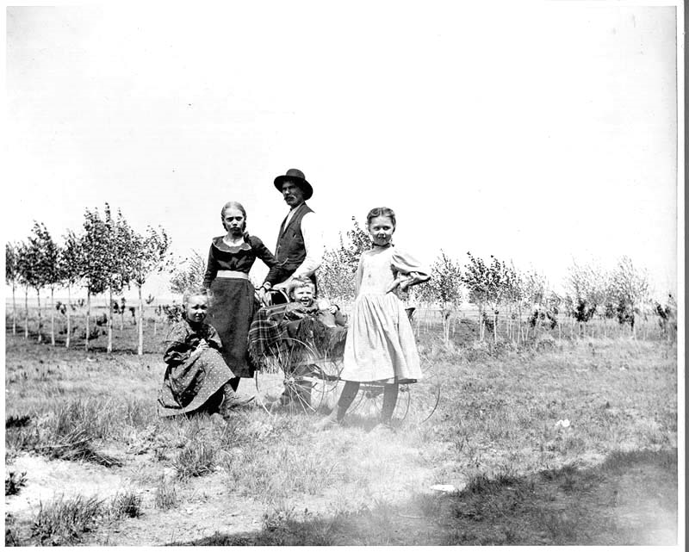
Building for the future CREATED/PUBLISHED[190-?]
SUMMARY Three girls and a man around a baby carriage with a small child seated in it. Behind them are newly planted trees, likely taken on a farm.
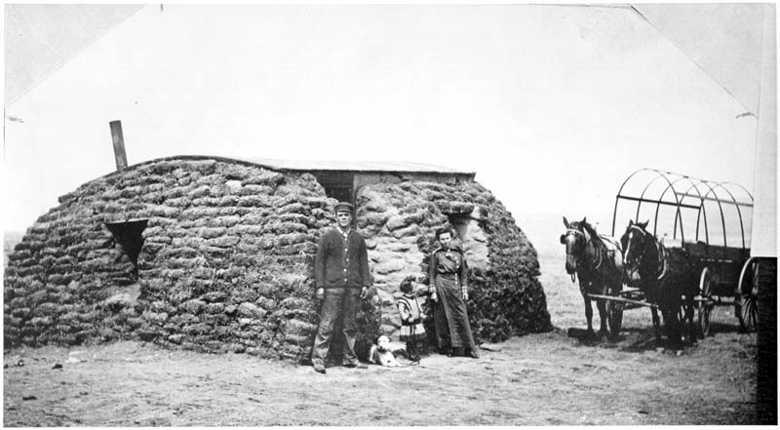
Mr. & Mrs. David Vincent and daughter, Martha, by their sod house : near White River, South Dakota.
CREATED/PUBLISHED [191-?]
SUMMARY Man, woman and small child standing outside door of sod house with dog. Sod house shows curved roof, stove pipe and two windows. House may be of wood construction and covered with sod. To right side are two horses hitched to a covered wagon, without canvas on frame.
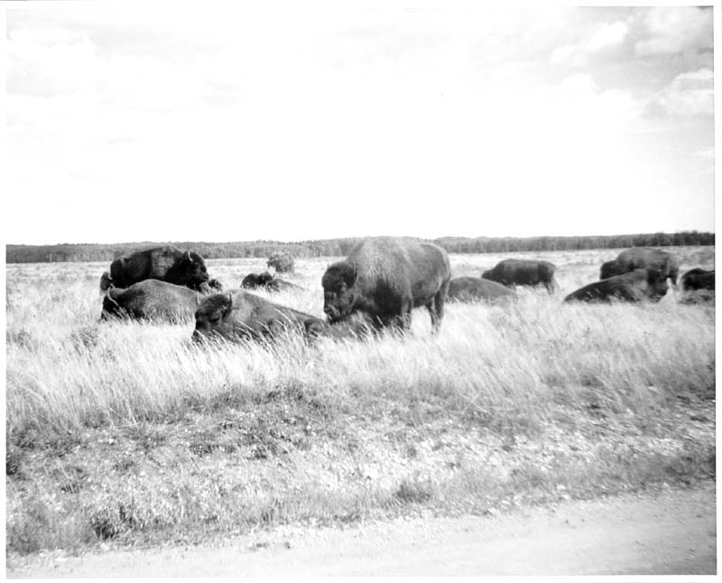
A Herd of buffalo. CREATED/PUBLISHED [196-?]
SUMMARY Buffalo standing and lying in grass. Trees in far background.
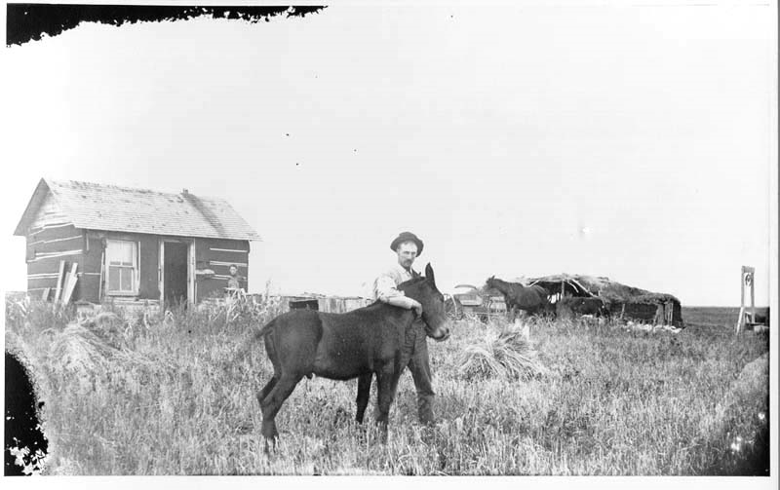
A Man with a mule on his homesteadCREATED/PUBLISHED[190-?]
SUMMARY An unidentified man in the foreground with a hand around the neck of a mule. In the background is a tarpaper shack with a pitched roof. A stovepipe, shingles, window and door are showing. There is a woman standing in front of the house. In the background on the right is a well, a sod barn, two horses, and a buggy. Likely taken in North Dakota
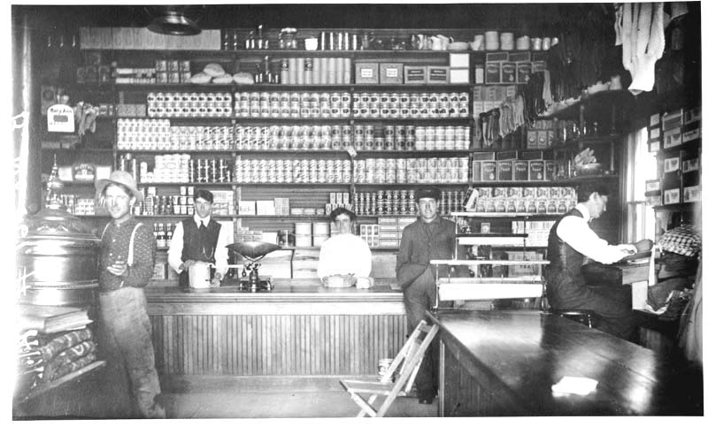
A Fine example of a general store in pioneer days. CREATED/PUBLISHED [190-?]
SUMMARY Interior of general store with men and a woman behind the counter. Other men in front of counter and by stove. Behind counter is shelving going to ceiling, full of goods. People not identified, likely in North Dakota.

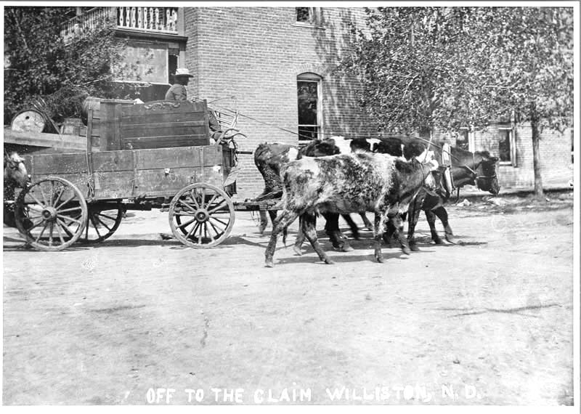
Off to the claim, Williston, N.D.. OTHER TITLES
Title on label with color print: John O. Pederson, Bonetraill, North Dakota, May 21, 1906 CREATED/PUBLISHED [1906]
SUMMARY John O. Pederson leaving Williston, N.D. for his homestead in Bonetraill, N.D. Pederson's wagon is drawn down a Williston street by a cow with two calves beside it. In the wagon is a pitchfork, a bed headboard, lumber, plow, and a barrel.
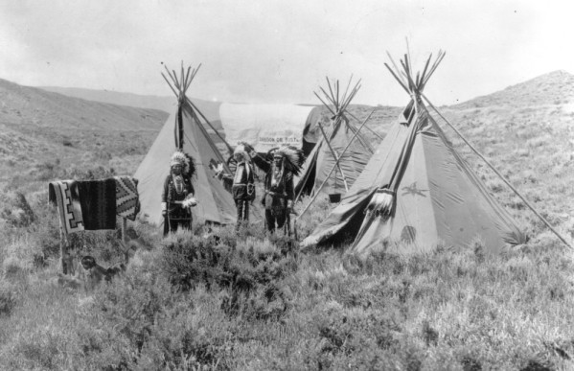
Arapahoe camp : Near Casper, Wyo. On the site of the old Oregon Trail CREATED/PUBLISHED [between 1880 and 1910?].
SUMMARY Native American (Arapaho) men in leggings, beaded gauntlets, and beaded feather headdresses, pose near a group of tepees and a covered wagon near Casper, Wyoming. The tepees are painted and depict humans on horses and shields; a sign on the covered wagon reads: "Oregon or Bust". A blanket is draped over a wooden frame.
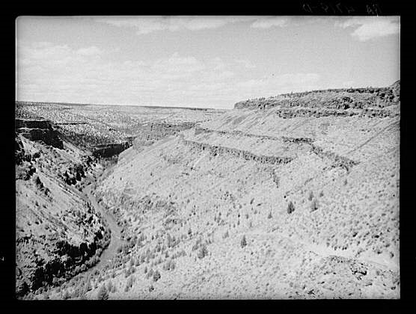
The Deschutes River, like many of the other rivers in the arid portion of central Oregon, is at the bottom of a steep canyon. Stock trails have been built by Resettlement Administration workers to make the water available to cattle. Rothstein, Arthur, 1915-1985, photographer.
CREATED/PUBLISHED 1936 June.

