Sources for Investigating Slavery in the United States
US History, Miss Natalie Kainz
John W. Fields, Age 89
"In most of us colored folks was the great desire to [be] able to read and write. We took advantage of every opportunity to educate ourselves. The greater part of the plantation owners were very harsh if we were caught trying to learn or write. It was the law that if a white man was caught trying to educate a negro slave, he was liable to prosecution entailing a fine of fifty dollars and a jail sentence. We were never allowed to go to town and it was not until after I ran away that I knew that they sold anything but slaves, tobacco, and wiskey. Our ignorance was the greatest hold the South had on us. We knew we could run away, but what then? An offender guilty of this crime was subjected to very harsh punishment."
Sarah Frances Shaw Graves, Age 87
"I was born March 23, 1850 in Kentucky, somewhere near Louisville. I am goin' on 88 years right now. (1937). I was brought to Missouri when I was six months old, along with my mama, who was a slave owned by a man named Shaw, who had allotted her to a man named Jimmie Graves, who came to Missouri to live with his daughter Emily Graves Crowdes. I always lived with Emily Crowdes."
The matter of allotment was confusing to the interviewer and Aunt Sally endeavored to explain.
"Yes'm. Allotted? Yes'm. I'm goin' to explain that, " she replied. "You see there was slave traders in those days, jes' like you got horse and mule an' auto traders now. They bought and sold slaves and hired 'em out. Yes'm, rented 'em out. Allotted means somethin' like hired out. But the slave never got no wages. That all went to the master. The man they was allotted to paid the master."
"I was never sold. My mama was sold only once, but she was hired out many times. Yes'm when a slave was allotted, somebody made a down payment and gave a mortgage for the rest. A chattel mortgage. . . ."
"Allotments made a lot of grief for the slaves," Aunt Sally asserted. "We left my papa in Kentucky, 'cause he was allotted to another man. My papa never knew where my mama went, an' my mama never knew where papa went." Aunt Sally paused a moment, then went on bitterly. "They never wanted mama to know, 'cause they knowed she would never marry so long she knew where he was. Our master wanted her to marry again and raise more children to be slaves. They never wanted mama to know where papa was, an' she never did," sighed Aunt Sally.
Tempie Cummins, Age Unknown
"The white chillun tries teach me to read and write but I didn' larn much, 'cause I allus workin'. Mother was workin' in the house, and she cooked too. She say she used to hide in the chimney corner and listen to what the white folks say. When freedom was 'clared, marster wouldn' tell 'em, but mother she hear him tellin' mistus that the slaves was free but they didn' know it and he's not gwineter tell 'em till he makes another crop or two. When mother hear that she say she slip out the chimney corner and crack her heels together four times and shouts, 'I's free, I's free.' Then she runs to the field, 'gainst marster's will and tol' all the other slaves and they quit work. Then she run away and in the night she slip into a big ravine near the house and have them bring me to her. Marster, he come out with his gun and shot at mother but she run down the ravine and gits away with me.

Walter Rimm, Age 80
"My pappy wasn't 'fraid of nothin'. He am light cullud from de white blood, and he runs away sev'ral times. Dere am big woods all round and we sees lots of run-awayers. One old fellow name John been a run-awayer for four years and de patterrollers* tries all dey tricks, but dey can't cotch him. Dey wants him bad, 'cause it 'spire other slaves to run away if he stays a-loose. Dey sots de trap for him. Dey knows he like good eats, so dey 'ranges for a quiltin' and gives chitlin's and lye hominey. John comes and am inside when de patterrollers rides up to de door. Everybody gits quiet and John stands near de door, and when dey starts to come in he grabs de shovel full of hot ashes and throws dem into de patterrollers faces. He gits through and runs off, hollerin', 'Bird in de air!'
"One woman name Rhodie runs off for long spell. De hounds won't hunt her. She steals hot light bread** when dey puts it in de window to cool, and lives on dat. She told my mammy how to keep de hounds from followin' you is to take black pepper and put it in you socks and run without you shoes. It make de hounds sneeze.
"One day I's in de woods and meets de runawayer. He comes to de cabin and mammy makes him a bacon and egg sandwich and we never seed him again. Maybe he done got clear to Mexico, where a lot of de slaves runs to.
*"Patterrollers" (patrollers) were white men who served on local patrols organized throughout the South to control the movement of slaves outside their home plantations. Patrollers policed their neighborhoods by challenging any slave whom they suspected of being away from home to produce a written "pass," or authorization, from his or her master. Slaves found without a pass were subject to arrests, beatings, or other forms of violence, some of which led to death.
**"Light bread" is leavened bread made with wheat flour. Where the rest of the country simply says bread, Southerners often say light bread or, less commonly, loaf bread, to refer to bread made of wheat flour and leavened with yeast. Contrary to what Northerners might think, light bread is not a synonym for white bread. "Light" refers not to the color of the bread but to the yeast that "lightens" it, so light bread can be whole wheat or white. Light bread or loaf bread contrasts instead with pone or cornpone, bread made with corn meal and usually unleavened. Source: American Heritage Dictionary of the English Language, Fourth Edition (New York: Houghton Mifflin, 2000)
Accessed from: http://lcweb2.loc.gov/ammem/snhtml/snvoices00.html
Runaway notices
From the South Carolina Gazette, Oct 28, 1732
RUN away from his Master's Plantation, in the Parish of St. James's Goose Creek, a lusty Negro Man named Hercules, he formerly used to wait on his Master in Charlestown, and is now by Trade a Cooper [barrel maker]. He had on when he went away a blue Duffils Jacket, a pair of ozenbrig Breeches, and speaks very good English. Whoever apprehends and brings him either to the said Plantation in Goose-Creek, or to his Master Robert Hume on Charlestown Neck, shall receive 5 [lb] reward, besides the usual Allowance for Mileage.
Robert Hume.
From the South Carolina Gazette, August 13, 1737
RUN AWAY from the Plantation of Isaac Porcher on Wassamsaw, a new Angola Negro Man, named Clawss, he is a small Fellow, and very black, he had on when he went away a Breeches, Jacket and Cap of white Plains, pretty much worn and dirty, any Person who shall apprehend the said Negro Man, and bring him to his Master, or to Goal in Charlestown, or give Information so as he may be had again, shall receive 2 [lb] reward and all Charges paid by Isaac Porcher.
N.B. As there is abundance of Negroes in the Province of that Nation, he may chance to be harbour'd among some of them, therefore all Masters are desire to give notice ot their Slaves who shall receive the same reward, if they take up the said Run-away.
From the South Carolina Gazette,
October 28, 1732,
August 13, 1737
http://www.pbs.org/wgbh/aia/part1/1h309t.html
Fugitive Slave Act of 1793
Although Article IV, Section 2 of the United States Constitution guaranteed the right to repossess any "person held to service or labor" (a euphemism for slaves), it did not set up a mechanism for executing the law.
On February 12, 1793, the Second Congress passed "An act respecting fugitives from justice, and persons escaping from the service of their masters," that authorized the arrest or seizure of fugitives and empowered "any magistrate of a county, city or town" to rule on the matter. The act further established a fine of $500 against any person who aided a fugitive.
The act was no doubt a response to the proliferation of anti-slavery societies and to the emergence of the Underground Railroad. Like the Constitution itself, this act does not include a single mention of the words "slave" or "slavery."
Art.4:
For the better security of the peace and friendship now entered into by the
contracting parties, against all infractions of the same, by the citizens of either party, to the prejudice of the other, neither party shall proceed to the infliction of punishments on the
citizens of the other, otherwise than by securing the offender, or offenders, by imprisonment,
or any other competent means, till a fair and impartial trial can be had by judges or juries of
both parties, as near as can be, to the laws, customs, and usage's of the contracting parties,
and natural justice: the mode of such trials to be hereafter fixed by the wise men of the
United States, in congress assembled, with the assistance of such deputies of the Delaware
nation, as may be appointed to act in concert with them in adjusting this matter to their
mutual liking. And it is further agreed between the parties aforesaid, that neither shall
entertain, or give countenance to, the enemies of the other, or protect, in their respective
states, criminal fugitives, servants, or slaves, but the same to apprehend and secure, and
deliver to the state or states, to which such enemies, criminals, servants, or slaves,
respectively below.
http://www.pbs.org/wgbh/aia/part2/2h62t.html

Slave quarters on St. Georges Island

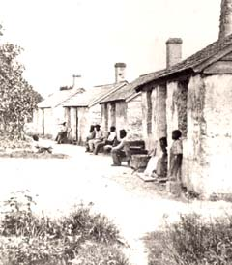 | These dwellings, located on Florida's St Georges Island in the Gulf of Mexico, are typical plantation slave quarters. Although Fanny Kemble never visited this island, one can imagine that she was describing these buildings when she wrote about the slaves' homes on Butler Island. . .  Such of these dwellings as I visited today were filthy and wretched in the extreme, and exhibited that most deplorable consequence of ignorance and an abject condition, the inability of the inhabitants to secure and improve even such pitiful comfort as might yet be achieved by them. . . . The moss with which the chinks and crannies of their ill-protecting dwelling might have been stuffed was trailing in dirt and dust about the ground, while the back door of the huts, opening upon a most unsightly ditch, was left wide open for the fowls and ducks, which they are allowed to raise, to travel in and out, increasing the filth of the cabin by what they brought and left in every direction.  Image Credit: Collection of the New-York Historical Society

Plan of a ship for transporting slaves
1789
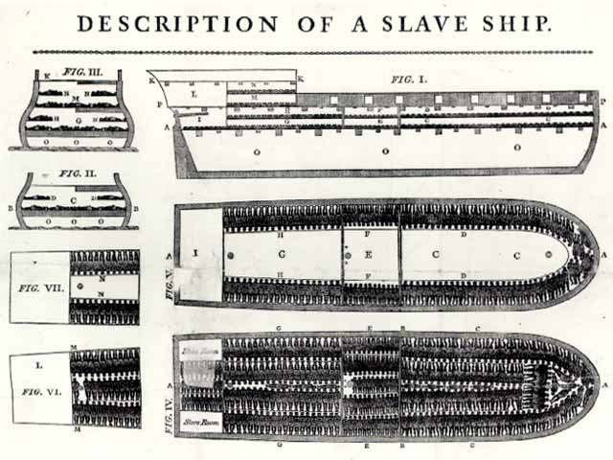
Only two images were ever officially sponsored by England's Abolitionist Society. One was the Society's emblem. The other was this plan of the Liverpool slave ship, the Brookes.
Below the plan was a detailed description of the Brookes and information about the ship's trading history. Copies of the plan were distributed widely, including to members of England's Parliament. The illustration showed 482 men, women, and children tightly packed into the Brooke's hold. The accompanying description stated that, according to records, as many as 609 slaves had been transported within the same space on the same ship.

