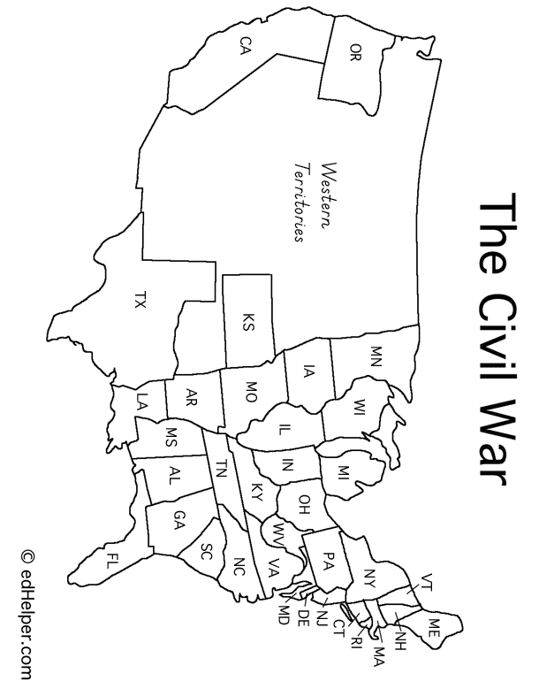

Please color or somehow mark each state and territory as either Union (fighting for the North) or Confederate (fighting for the South).

**Union States/Territories**

**Confederate States/Territories** 

Name:

Class Period: