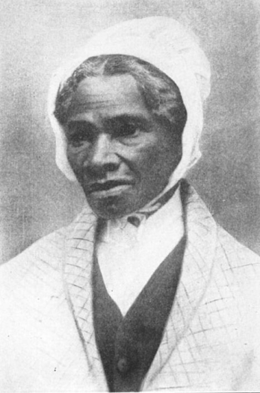
- Sojourner Truth
Sojourner Truth (ca. 1797-1883) was a black American freedom fighter and orator. She believed herself chosen by God to preach His word and to help with the abolitionist effort to free her people.
Sojourner Truth was born Isabella Baumfree in Ulster County, N.Y., the daughter of an African named Baumfree (after his Dutch owner) and a woman called Elizabeth. About the age of 9 she was auctioned off to an Englishman named John Nealy. The Nealys understood very little of her Dutch jargon and, as a result, she was often brutally punished for no real reason.
Eventually Nealy sold her to a fisherman who owned a tavern in Kingston, N.Y. Here she acquired the idiomatic expressions which came to mark her speech. John J. Dumont, a nearby plantation owner, purchased her next. During her tenure with his family she married and had five children. In 1827, after New York had passed an emancipation act freeing its slaves, she prepared to take her family away. But Dumont began to show reluctance to this, so she ran away with only her youngest child.
She finally wound up in New York City. She worked at a menial job and through some friends came under the sway of a religious fanatic named Mathias. Eventually disillusioned by her life in New York and by Mathias, in 1843 she left on what she termed a pilgrimage to spread the truth of God's word. She assumed the name Sojourner Truth, which she believed God had given her as a symbolic representation of her mission in life. Soon her reputation as an orator spread, and large crowds greeted her wherever she spoke.
A controversial figure for most of the rest of her life, Truth engaged the courts in two rather unusual cases, winning them both and establishing precedents. Thus, she became the first black to win a slander suit against prominent whites, and the first black woman to test the legality of segregation of Washington, D.C., streetcars.
During the Civil War, Truth bought gifts for the soldiers with money raised from her lectures and helped fugitive slaves find work and housing. After the war she continued her tirade for the Lord and against racial injustice, even when old age and ill health restricted her activities to the confines of a Battle Creek, Mich., sanatorium. She died there on Nov. 26, 1883.

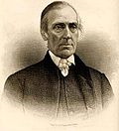
- Levi Coffin
Levi Coffin (October 28, 1798 – September 16, 1877) was an American Quaker, abolitionist, and businessman. Coffin was deeply involved in the Underground Railroad in Indiana and Ohio and his home is often called "Grand Central Station of the Underground Railroad". He was nicknamed "President of the Underground Railroad" because of the thousands of slaves that are reported to have passed through his care while escaping their masters.
Born in the Southern United States, Coffin was exposed to and developed a opposition to slavery as a child. He followed his family and immigrated to Indiana from North Carolina in 1826 following a persecution of the Quakers by the slave-holders. In Indiana he quickly became a local business leader as a merchant and farmer. The wealth he accumulated allowed him to become a major investor in the Richmond branch of the Bank of Indiana where he served as director during the 1830s. His position in the community allowed him to provide most of the funds necessary to supply food, clothing, and transportation for the Underground Railroad operations in his region.
At the urging of friends in the anti-slavery movement, he moved to Cincinnati in 1847 to operate a warehouse selling only goods produced by free labor. Despite making considerable progress with the business, the venture was unprofitable and he was forced to abandon the enterprise in 1857. Throughout the period, he continued to assist hundreds of runaway slaves by lodging them in his Ohio home. After slavery was abolished following the American Civil War, Coffin traveled around the Midwestern United States and abroad to France and Great Britain where he was instrumental in forming aid societies to provide food, clothing, funds, and education to the freed slaves. He retired during the 1870s and wrote a autobiography that was published a year before his death.

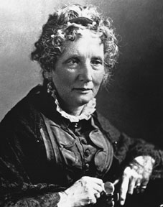
- Harriet Beecher Stowe
On June 14, 1811 a very famous abolitionist was born, Harriet Elizabeth Beecher Stowe.
Harriet was very close to her sister Carolyne who was also a writer. Stowe had 6 brothers and 1 sister. Her father was a New England Calvinist minister and influenced her beliefs in the importance of being against slavery. Her husband, whom she married 1866, was also a minister and an opponent of slavery.
As a young wife and mother living in Cincinnati, Harriet Beecher Stowe met former and fugitive enslaved people. Cincinnati, then the western frontier of the United States, was an ethnically and culturally vibrant city. On the Ohio River across from Kentucky, a slave state, the city exposed Stowe to the public face of slavery.
Stowe knew about slavery before she moved to Ohio. Her own grandmother kept African American servants who had probably originally been enslaved, and her father had preached in favor of the colonization movement, supporting the creation of Liberia as a settling point for freed people. But in Ohio, Stowe heard first hand stories from former enslaved people; witnessed slavery while visiting Kentucky; and employed fugitives in her home. When Harriet and Calvin learned that their servant was actually a runaway in danger of being returned to slavery, Calvin and Harriet's brother Henry Ward Beecher helped her escape and reach Canada and legal freedom.
Harriet Beecher Stowe's best known novel, Uncle Tom's Cabin (1852), changed forever how Americans viewed slavery, the system that treated people as property. It demanded that the United States deliver on the promise of freedom and equality, galvanized the abolition movement and contributed to the outbreak of the Civil War. The book calls on us to confront the legacy of race relations in the U.S. as the title itself became a racial slur. The results of this book led to her hatred in the South because it made readers believe that slavery was evil. Even though she described slavery in her book, Harriet Beecher Stowe never witnessed slavery in the South though she did see some slavery when she visited Kentucky. Abe Lincoln labeled her as "the little lady who started the big, bloody war"
Uncle Tom's Cabin was a runaway best-seller, selling 10,000 copies in the United States in its first week; 300,000 in the first year; and in Great Britain, 1.5 million copies in one year. It resonates with an international audience as a protest novel and literary work.
Harriet Elizabeth Beecher Stowe was a loyal and trustworthy abolitionist. She is remembered today because of her help in educating people on slavery and changing their attitudes. After readers read her book they changed their minds and were anti-slavery believers.

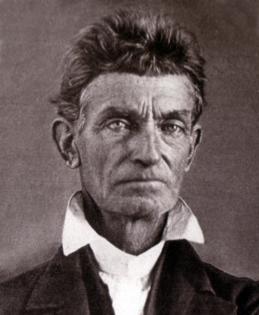
- John Brown
John Brown (May 9, 1800 – December 2, 1859) was a revolutionary abolitionist from the United States, who advocated and practiced armed insurrection as a means to abolish slavery for good. He led the Pottawatomie Massacre in which he killed 5 men dragging them out of their house in 1856 in Bleeding Kansas and made his name in the unsuccessful raid at Harpers Ferry in 1859. He was tried and executed for treason against the state of Virginia, murder, and conspiracy later that year. Brown has been called "the most controversial of all 19th-century Americans."^{[1]}
Brown's attempt in 1859 to start a liberation movement among enslaved African Americans in Harpers Ferry, Virginia (now West Virginia) electrified the nation. He was tried for treason against the state of Virginia, the murder of five pro-slavery Southerners, and inciting a slave insurrection and was subsequently hanged. Southerners alleged that his rebellion was the tip of the abolitionist iceberg and represented the wishes of the Republican Party. Historians agree that the Harpers Ferry raid in 1859 escalated tensions that, a year later, led to secession and the American Civil War.
Brown first gained attention when he led small groups of volunteers during the Bleeding Kansas crisis. Unlike most other Northerners, who advocated peaceful resistance to the pro-slavery faction, Brown demanded violent action in response to Southern aggression. Dissatisfied with the pacifism encouraged by the organized abolitionist movement, he reportedly said "These men are all talk. What we need is action—action!" ^{[2]} During the Kansas campaign he and his supporters killed five pro-slavery southerners in what became known as the Pottawatomie Massacre in May 1856 in response to the raid of the "free soil" city of Lawrence. In 1859 he led a raid on the federal armory at Harpers Ferry, Virginia (in modern-day West Virginia). During the raid, he seized the armory; seven people were killed, and ten or more were injured. He intended to arm slaves with weapons from the arsenal, but the attack failed. Within 36 hours, Brown's men had fled or been killed or captured by local farmers, militiamen, and U.S. Marines led by Robert E. Lee. Brown's subsequent capture by federal forces seized the nation's attention, as Southerners feared it was just the first of many Northern plots to cause a slave rebellion that would kill millions, while Republicans ridiculed the notion and said they would not interfere with slavery in the South.^{[3]}
Historians agree John Brown played a major role in the start of the Civil War. David Potter (1976) said the emotional effect of Brown's raid was greater than the philosophical effect of the Lincoln-Douglas debates, and that his raid revealed a deep division between North and South.^{[4]} - Brown's actions prior to the Civil War as an abolitionist, and the tactics he chose, still make him a controversial figure today. He is sometimes memorialized as a heroic martyr and a visionary and sometimes vilified as a madman and a terrorist. Some writers, such as Bruce Olds, describe him as a monomaniacal zealot, others, such as Stephen B. Oates, regard him as "one of the most perceptive human beings of his generation." David S. Reynolds hails the man who "killed slavery, sparked the civil war, and seeded civil rights" and Richard Owen Boyer emphasizes that Brown was "an American who gave his life that millions of other Americans might be free." For Ken Chowder he is "at certain times, a great man", but also "the father of American terrorism."^{[5]} The song "John Brown's Body" became a Union marching song during the Civil War.
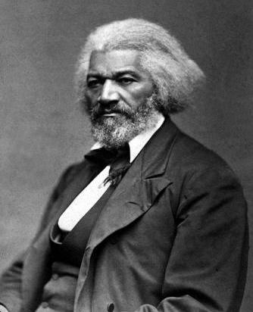
- Frederick Douglass
The son of a slave woman and an unknown white man, "Frederick Augustus Washington Bailey" was born in February of 1818 on Maryland's eastern shore. He spent his early years with his grandparents and with an aunt, seeing his mother only four or five times before her death when he was seven. (All Douglass knew of his father was that he was white.) During this time he was exposed to the degradations of slavery, witnessing firsthand brutal whippings and spending much time cold and hungry. When he was eight he was sent to Baltimore to live with a ship carpenter named Hugh Auld. There he learned to read and first heard the words abolition and abolitionists. "Going to live at Baltimore," Douglass would later say, "laid the foundation, and opened the gateway, to all my subsequent prosperity."
Douglass spent seven relatively comfortable years in Baltimore before being sent back to the country, where he was hired out to a farm run by a notoriously brutal "slavebreaker" named Edward Covey. And the treatment he received was indeed brutal. Whipped daily and barely fed, Douglass was "broken in body, soul, and spirit."
On January 1, 1836, Douglass made a resolution that he would be free by the end of the year. He planned an escape. But early in April he was jailed after his plan was discovered. Two years later, while living in Baltimore and working at a shipyard, Douglass would finally realize his dream: he fled the city on September 3, 1838. Travelling by train, then steamboat, then train, he arrived in New York City the following day. Several weeks later he had settled in New Bedford, Massachusetts, living with his newlywed bride (whom he met in Baltimore and married in New York) under his new name, Frederick Douglass.
Always striving to educate himself, Douglass continued his reading. He joined various organizations in New Bedford, including a black church. He attended Abolitionists' meetings. He subscribed to William Lloyd Garrison's weekly journal, the Liberator. In 1841, he saw Garrison speak at the Bristol Anti-Slavery Society's annual meeting. Douglass was inspired by the speaker, later stating, "no face and form ever impressed me with such sentiments [the hatred of slavery] as did those of William Lloyd Garrison." Garrison, too, was impressed with Douglass, mentioning him in the Liberator. Several days later Douglass gave his speech at the Massachusetts Anti-Slavery Society's annual convention in Nantucket-- the speech described at the top of this page. Of the speech, one correspondent reported, "Flinty hearts were pierced, and cold ones melted by his eloquence." Before leaving the island, Douglass was asked to become a lecturer for the Society for three years. It was the launch of a career that would continue throughout Douglass' long life.
Despite apprehensions that the information might endanger his freedom, Douglass published his autobiography, Narrative of the Life of Frederick Douglass, an American Slave, Written By Himself. The year was 1845. Three years later, after a speaking tour of England, Ireland, and Scotland, Douglass published the first issue of the North Star, a four-page weekly, out of Rochester, New York.
Ever since he first met Garrison in 1841, the white abolitionist leader had been Douglass' mentor. But the views of Garrison and Douglass ultimately diverged. Garrison represented the radical end of the abolitionist spectrum. He denounced churches, political parties, even voting. He believed in the dissolution (break up) of the Union. He also believed that the U.S. Constitution was a pro-slavery document. After his tour of Europe and the establishment of his paper, Douglass' views began to change; he was becoming more of an independent thinker, more pragmatic. In 1851 Douglass announced at a meeting in Syracuse, New York, that he did not assume the Constitution was a pro-slavery document, and that it could even "be wielded in behalf of emancipation," especially where the federal government had exclusive jurisdiction. Douglass also did not advocate the dissolution of the Union, since it would isolate slaves in the South. This led to a bitter dispute between Garrison and Douglass that, despite the efforts of others such as Harriet Beecher Stowe to reconcile the two, would last into the Civil War.
Frederick Douglass would continue his active involvement to better the lives of African Americans. He conferred with Abraham Lincoln during the Civil War and recruited northern blacks for the Union Army. After the War he fought for the rights of women and African Americans alike.

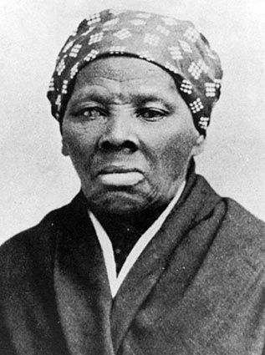
- Harriet Tubman
Harriet Tubman (born Araminta Ross; c. March 1822 – March 10, 1913) was an African-American abolitionist, humanitarian, and Union spy during the American Civil War. After escaping from slavery, into which she was born, she made thirteen missions to rescue more than 70 slaves^{[1]} using the network of antislavery activists and safe houses known as the Underground Railroad. She later helped John Brown recruit men for his raid on Harpers Ferry, and in the post-war era struggled for women's suffrage.
As a child in Dorchester County, Maryland, Tubman was beaten by various masters to whom she was hired out. Early in her life, she suffered a head wound when hit by a heavy metal weight. The injury caused disabling seizures, narcoleptic attacks, headaches, and powerful visionary and dream activity, which occurred throughout her entire life. A devout Christian, Tubman ascribed the visions and vivid dreams to revelations from God.
In 1849, Tubman escaped to Philadelphia, then immediately returned to Maryland to rescue her family. Slowly, one group at a time, she brought relatives out of the state, and eventually guided dozens of other slaves to freedom. Traveling by night, Tubman (or "Moses", as she was called) "never lost a passenger".^{[2]} Large rewards were offered for the return of many of the fugitive slaves, but no one then knew that Tubman was the one helping them. When the Southern-dominated Congress passed the Fugitive Slave Law of 1850, requiring law officials in free states to aid efforts to recapture slaves, she helped guide fugitives farther north into Canada, where slavery was prohibited.
When the American Civil War began, Tubman worked for the Union Army, first as a cook and nurse, and then as an armed scout and spy. The first woman to lead an armed expedition in the war, she guided the Combahee River Raid, which liberated more than 700 slaves in South Carolina. After the war, she retired to the family home in Auburn, New York, where she cared for her aging parents. She became active in the women's suffrage movement in New York until illness overtook her. Near the end of her life, she lived in a home for elderly African-Americans which she had helped found years earlier.

